

**Presents**

## A 2 Up and Solo 25 Mile Event Time Trial

### 9th September 2017

#### Course F14/25

##### **Solo off at 2.01pm, Tandem at 2.40pm, 2UP at 2.48pm**

**Promoted under Cycling Time Trials Rules and Regulations**

###### Timekeepers: Mike Bannister , Mrs Eileen Kray

**Event Secretary: Dan Nickolay**

**105 Ely Close**

**Stevenage**

**Herts**

**SG1 4NR**

**Home 01438 723701**

**Mobile 07770 885990**

**Headquarters address: Steeple Morden Village Hall, 15 Hay Street, Royston, Hertfordshire SG8 0PD. PLEASE NOTE: APROX 4 MILES TO START - ALLOW 20MINS TO START POINT**

Awards

|  |  |  |  |
| --- | --- | --- | --- |
| Men’s Solo | 1st £20 | 2nd £15 | 3rd 10 |
| Ladies Solo | 1st £20 | 2nd £15 | 3rd 10 |
| 2UP Men’s | 1st £25 | 2nd £20 | 3rd 15 |
| 2UP Including Female | 1st £25 | 2nd £20 | 3rd 15 |

Thanks to all officials, members and friends of Stevenage CC

Without whom this could not take place, and to Emily’s Tea Room,

Whitwell for providing refreshments

**Course: f14/25 - description**

This event is being run on the f14/25 course.

START: on the Wrestlingworth-Guilden Morden road approx. 540 yds. south of Wrestlingworth  
 x-rds. and 460 yds. north of Common Farm. Proceed south to Guilden Morden where turn LEFT (M) 1.95 miles (2nd circuit 13.73 miles) into New Road leading to Shingay cum Wendy and Wendy to T junction 6.34 miles (2nd circuit 18.12 miles) with A1198. At junction bear LEFT (CAUTION) (M) to roundabout, where bear LEFT (M) onto B1042 to Tadlow and cross roads at Wrestlingworth where bear LEFT (M)11.48 miles (2nd circuit 23.26 miles) on unclassified road to Guilden Morden and pass start – Repeat circuit and pass start again and in approx. 1.5 miles to: FINISH at south of farm entrance, 50 yds. south of Water Hydrant sign and 72 yds. north of Bend sign and 149 yds. north of large 30 sign. (25 miles

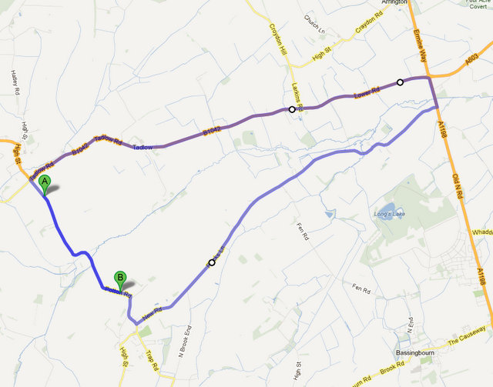

**Headquarters at Steeple Morden Village Hall  
15 Hay Street, Royston, Hertfordshire, SG8 0PD**

**PLEASE NOTE: APROX 4 MILES TO START - ALLOW 20MINS TO START POINT**