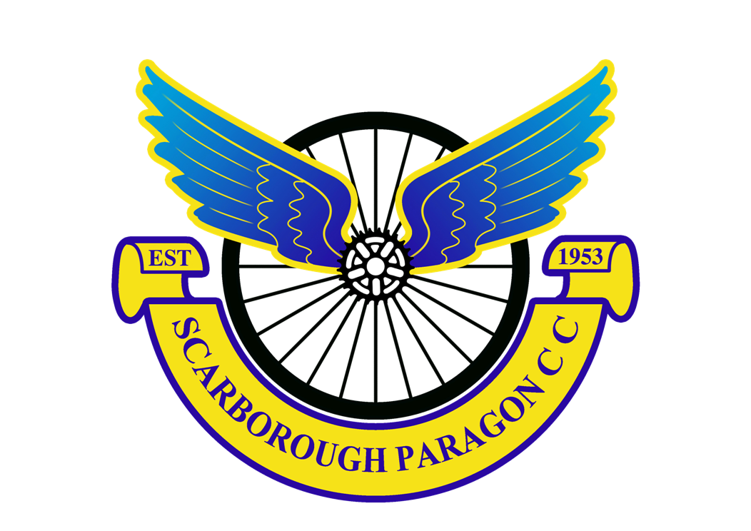

Scarborough Paragon Cycling Club present the RESULTS of their Open 10 miles Time Trial
Incorporating the Ray Flinton & John Leadley Memorial Trophy Competitions held on
Saturday 26th August 2017

“Held for and on behalf of Cycling Time Trials under their rules and regulations”

Event Organiser: Timekeepers:
Elaine Ward, 4 The Pastures, Cayton, Scarborough, YO11 3UU. Geoff Backshall
Tel: 01723 584558, mobile: 07763 969990 or email caytonracers@tiscali.co.uk Elaine Ward
www.spcc.org.uk

Note from the organiser:
MANY THANKS to the following people who made this event possible:
Our timekeepers Geoff & I, Jon & Irene, Mick & Robin, John Tillotson, Brian Stephenson, Chris Brown, Hannah, Erin & Aileen, Louise, Karl & Mavis Williamson, Mike Potter, Brian Musson, Dawn Sheehan.Last but not least, all those who donated baking for the refreshments table afterwards and Burton Fleming Village Hall. I apologise if I have omitted anyone, but it was a great team effort, thank you all.

CONGRATULATIONS to all the prize winners

PRIZE AWARDS

1st fastest £30 James Gullen – JLT Condor 19:48 *NEW COURSE RECORD*
2nd fastest £20 Graham Briggs – JLT Condor 20:51
3rd fastest £15 Cavan Walker – Prologue RT 22:45
4th fastest £10 Blair Buss – SSLL RT 23:01
5th fastest £10 Andrew Hicklin – Fusion CC Dronfield 23:19

1st Junior/Juvenile £20 Cavan Walker – Prologue RT 22:45 (age 16)
2nd Junior/Juvenile £15 Harry Butterworth - Scarborough Paragon CC 24:05 (age 14)
3rd Junior/Juvenile £10 Hannah Bayes – LIV AWOL 26:42 (age 17)

1st Woman £20 Fiona Sharp – York Cycleworks 25:50
2nd Woman £10 Hannah Bayes – LIV AWOL 26:42
3rd Woman £10 Jackie Haigh – Holme Valley Wheelers 32:44

1st Vet on Standard £30 Blair Buss – SSLL RT +3:53
2nd Vet on Standard £20 John Galway – YH Training SRC +3:46
3rd Vet on Standard £10 Andrew Hicklin – Fusion CC Dronfield +3:31
4th Vet on Standard £10 Stewart Pickard – Vive le Velo +2:25

Lanterne Rouge: £10 Christopher Fisher – Sowerby Brothers CRT 38:58

Harry Butterworth wins the John Leadley Memorial Trophy (fastest Paragon juvenile/junior in this event) * 24:05
Blair Buss wins the Ray Flinton Memorial Trophy (best plus on Vets standard in this event) * +3:53

*both trophies to be presented at Paragon’s Annual Dinner in early 2018.

Thank you for supporting our event – we hope to see you next year.

www.spcc.org.uk

