Aylesbury CC 10 mile Open Time Trial
Promoted for and on behalf of Cycling Time Trials under their Rules and Regulations
Event HQ - Longwick Village Hall, 5 Blenheim Close, Thame Road,
Princes Risborough, HP27 9SG
14th August 2016 at 10.00am HCC178 (Longwick Circuit) Course
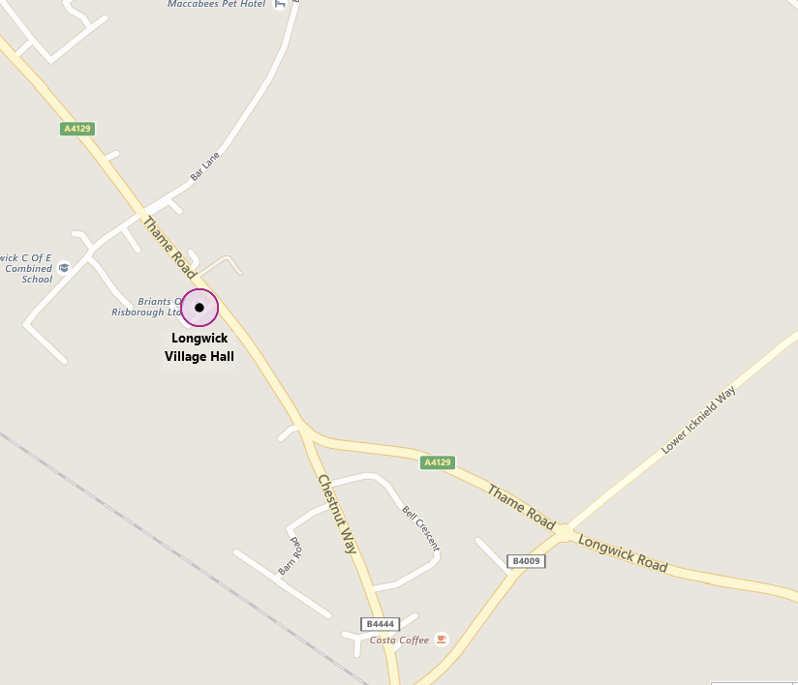
HQ Open for sign on from 8.30am
Event Secretary - Bryce Taylor, 36 Creslow Way, Stone Aylesbury, Bucks, HP17 8YW
Phone - 07889 326010 email - aylesburytt@gmail.com

Prizes
1st (Men) £25 2nd (Men) £15
1st (Women) £25 2nd (Women) £15
Fastest Vet (on Standard) £25

All prize-winners will also receive a SIS Sports Nutrition Kit (rrp £14.99), kindly donated by

3-4 Villiers Buildings, Buckingham Street, Aylesbury, HP20 2LE
www.buckinghambikes.com 01296 482077

The Course
O.S. Ref | Description | Distance
782058 | Start on the A4129 at the southern end of the first lay-by on the east side of the road, north of Longwick
794046 | Go south on the A4129 to the roundabout at the junction with the B4009 at the Sportsman's Garage | 1.07
807056 | Take the first exit onto the B4009 and proceed to the second turning on the left | 2.09
772100 | Turn left and go through Ford to the Haddenham-Aylesbury crossroads | 5.89
747088 | Turn left to the first junction at Haddenham | 7.66
768065 | Turn left for 0.77 mile to take the first turning left to the junction with the A4129 | 9.85
 | Turn left for 270 yards to a point 70 yards beyond a farm entrance, 13 yards short of the next farm gate where finish | 10

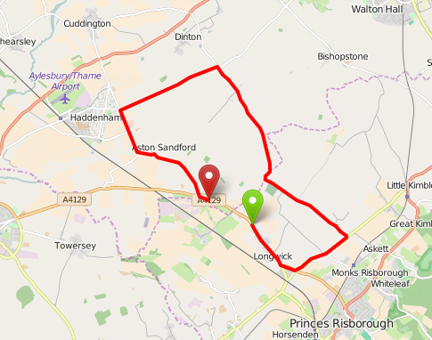

Directions from HQ to the Start and from the finish to HQ

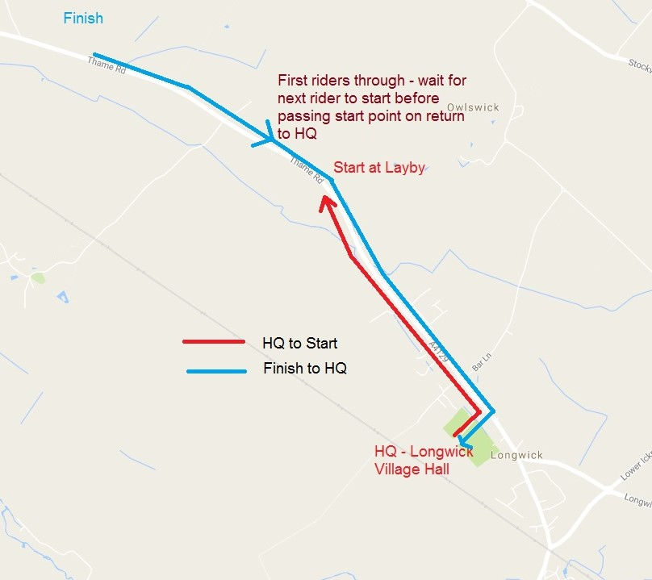
Park in the Village Hall Car Park. If the car park is full, please avoid parking on the course. There is limited additional parking in the lay-by north of the village of Longwick. This is the start lay-by so avoid parking near the south exit onto Thame Road where the race starts. If parking in the village please ensure you park considerately and do not obstruct entrances or driveways.
There are toilet facilities at HQ. Please use these and do not urinate elsewhere.
There is a pedestrian traffic-light crossing in Longwick Village. A marshal will be present to discourage its use but if used, riders must stop on the red light. Riders failing to stop will be disqualified.
The club will endeavour to provide marshals to indicate direction at all relevant junctions. In addition, CTT direction signage will be placed at all junctions. Marshals are for indicating direction only and we cannot absolutely guarantee to have a marshal at every junction so please look out for signage and familiarise yourself with the course.
The course uses some minor rural roads - please be aware of possible agricultural traffic and some unevenness of the surface, particularly between miles 3 and 6. Further information will be provided at sign-on.
In the interests of your own safety, Cycling Time Trials strongly advise you to wear a hard shell helmet that meets an internationally accepted safety standard and to have a rear light intermittently flashing.
NOTE - The return route to HQ passes the start point so earlier riders will encounter racers waiting to start. Please wait until the next rider has started and ride behind them until you reach the right turn into HQ.

