NORTH LANCS TIME TRIAL ASSOCIATION - OPEN 100 MILES TIME TRIAL L1009E
MONDAY 28TH AUGUST 2017 - START SHEET
Pomoted on behalf of Cycling Time Trials under their rules and regulations
Event Secretary: Nigel Clementson: 80 Shevington Moor, Standish, Wigan. WN60SE. 07862289430.
Time Keeper: Richard Taylor
Headquarters: Braithwaite Institute, Keswick CA12 5RY. (On the A66) It is perfectly located on the course.
First rider off 7:04am
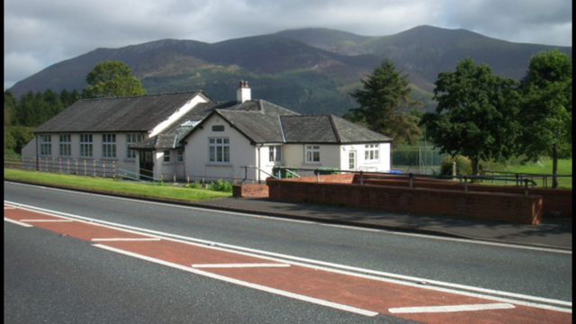
HQ opens from 6am.
CTT Regulation 17: Signing-on & signing-out sheet
a) The competitors in all types of events must make themselves aware of any special instructions for the event and sign the official signing on sheet when collecting their number.
b) In type A events a competitor must return to the HQ either during the event or within a reasonable time after the last rider has finished the event and must (i) return their number and (ii) sign the official signing out sheet.
There will be a copy of the risk assessment for viewing.

Results will be displayed at the HQ.
Please allow 10 minutes to ride to the start. From the HQ out of the gate and turn left onto the A66 for approx. 1 mile.
There is a large car park at HQ
There will be a HQ sign indicating the entrance to the car park.
Course L1009E
Start at the eastern side of the junction of the old road with the northern side of the A66, 0.36 miles east of Braithwaite Village Hall. Proceed in an easterly direction along A66 to encircle the RAB at the junction of A591/A66 Keswick/Bothel road (1.95 miles). Retrace along A66 in a westerly direction to encircle the RAB at the junction with the A5086 near Cockermouth (14.80 miles). Proceed in an easterly direction through the start point to the RAB near Keswick (27.65 miles) and retrace to the Cockermouth RAB (40.50 miles). Retrace through start to Keswick RAB (53.35 mls) and on to Cockermouth RAB (66..20 mls). Retrace through start to Keswick RAB (79.05 mls) and on to Cockermouth RAB (91.90 mls). On this occasion retrace along A66 to FINISH at the entrance to Hursthole Point which is directly opposite a footpath with wooden stairway from car park on south west side of the A66 (100 miles) Riders must continue along A66 to HQ (clearway).
Remember to keep count as its 4 laps (almost)
If you intend to feed a rider on the course, you MUST complete a riders support vehicle form and hand it in upon signing on.
Riders support vehicle form can be found on the CTT web site under forms (Strangely).
PRIZES:
Fastest Gentleman: £80 2nd£50 3rd£40 4th£30 5th£25 6th£20 7th £15 8th £10
Fastest Lady: £60 2nd£40 3rd£30 4th£20
First novice rider: Paul Hewitt vouchers £20
Overall place results: 10th, 20th, 30th, 40th, 50th, 60th will receive £20
Last place: Lanterne Rouge (please don’t make an effort to win this as Richard [timekeeper] would like to go home)
Paul Hewitt voucher £20 to the rider closest to 4:4:50 which was the women’s Comp record set in 1967 by B Burton
Team of 3: Mixed or men Paul Hewitt vouchers £20 each
(One rider one prize apart from team prize)
Association members only:
To the fastest man who can break Steve Irwin course record set in 2016- 3:33:32 will receive £100 from the NLTTA.
To the fastest lady who breaks the NLTTA record which stands at 4:19:00 from 2007 set by Lyn Hamel (course unknown)

The following Local Regulations have been approved by the National Committee in accordance with
Regulation 38. Any breaches may lead to disciplinary action being taken.
Local Reg No. 5 In all events, competitors prior to starting are not permitted to ride past the finishing timekeeper during the duration of the event.
Local Reg No.6 Any competitors making a U turn in the vicinity of the start or finish will be disqualified from the event.
Local Reg No.9 No parking on the A66 except in a designated layby.
Local Reg No.15 Riders must keep to the left hand side of the road except when overtaking. Failure to comply with the above may lead to disqualification. Riders must give their number at the finish and elsewhere on the course where requested.
Riders MUST NOT STAND in the road at the start or finish. (This constitutes obstruction and is a breach of regulations.)
Riders must NOT ride with their heads down.
Rider Safety Helmets:
All competitors under the age of 18 and/or juniors must wear a HELMET of HARD/SOFT SHELL construction that conforms to a recognised Standard (See Regulation 15). Cycling Time Trials strongly recommends ALL competitors to wear such a helmet.
Competitor Machines - Lights:
CTT recommends that a working rear light, either flashing or constant, is fitted to the machine in a position clearly visible to following road users and is active whilst the machine is in use.
This event may be subject to a Doping Control
It is your responsibility to check As soon as you have finished you should return to the event HQ as it is your responsibility to check if you are required for Doping Control Race numbers required for Doping Control will be displayed at the HQ adjacent to the result board If your number is displayed you should report immediately to Doping Control which will be nearby Remember, it is up to you to check and ensure that you comply If required you must report to Doping Control after finishing without delay
Free cup of tea when you SIGN OFF. REFRESHEMENTS available.
Big THANK YOU to today’s sponsors Truline of Wigan and Paul Hewitt cycles
Big THANK YOU to ALL the marshals. It’s a long day out there. Thankyou to the admin/kitchen helpers too.
Have a great day and a safe ride. Remember to keep your HEAD UP and all the best from the NLTTA.
Organiser on the day: Nigel - Mobile: 07862 289430

