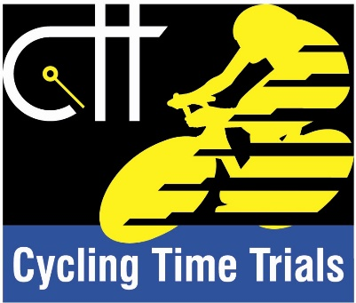

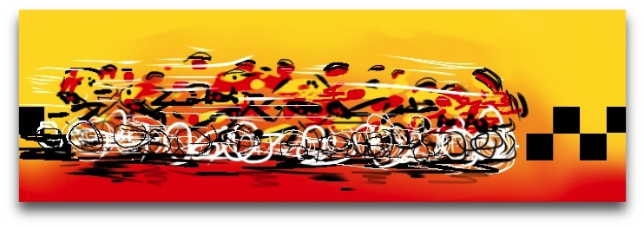
Dumfries Cycling Club
Loch Ken Open Time Trial
Saturday 19th August 2017
Promoted for and on behalf of Cycling Time Trials under their rules & regulations

Organiser: Cameron Scade, 29 Beck Avenue, Dumfries DG2 7BJ
racedumfriescc@gmail.com Mob: 0797961906
Timekeeper: Mr Gordon Johnston
Assistant Timekeeper: Mrs Helen Acklam
Observer: Mr John Sturgeon
FIRST RIDER OFF AT 09:01. List of competitors is below.

- Race HQ (Sign on/out) and changing/shower/parking facilities: Stewartry Rugby Club, Hobdell Pavilion Greenlaw, Castle Douglas DG7 2LH, DG7 2LH

- HQ will be open from 07:30. Refreshments will be available after the event.

- A copy of the CTT Risk Assessment will be displayed at the event HQ.

Course details: The start point is around half a mile north along the A713 from HQ so plan to give yourself enough time to reach the start on time without having to wait for too long.

Course: WS25/01 - one Lap of Loch Ken (24.82 miles)
Start at Townhead of Greenlaw on A713 at point just before junction left to B795.
Follow A713 through villages of Crossmichael and Parton and on to Ken Bridge.
Left turn at Ken Bridge Hotel to join A712
Bear left in New Galloway to join A762. Proceed through New Galloway and Mossdale towards Lauriston.
Left turn in Lauriston to join B795 and proceed to finish at Townhead of Greenlaw.

*Care should be taken in and around the villages the course passes through, particularly Crossmichael and New Galloway, where there may be an increased likelihood of parked vehicles and pedestrians. Extra care must also be taken on the descent after New Galloway and the descent down to Glenlochar as you approach the finish. Great care must be taken at the finish which is close to the junction onto the A713. Riders will rejoin the A713 to return to HQ.*

Set in one of the most picturesque areas of Dumfries and Galloway, the Loch Ken course (WS25/01) is a circular, anti-clockwise course, hugging the shores of the Loch with light traffic and some very fast sections. While by no means a hilly course, there is 1000ft of climbing spread across its length. The two main climbs are in New Galloway at approximately half distance and after the Lauriston turn at about mile 21. Gradients stay under 4% and peak around 6% on a few short sections.
Total elevation for the course is approx. 1076ft

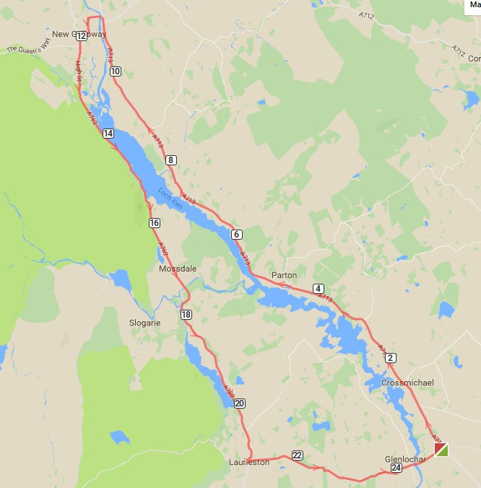

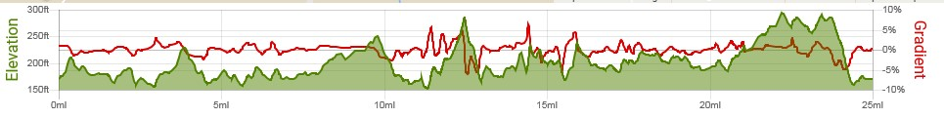

Course profile and gradient

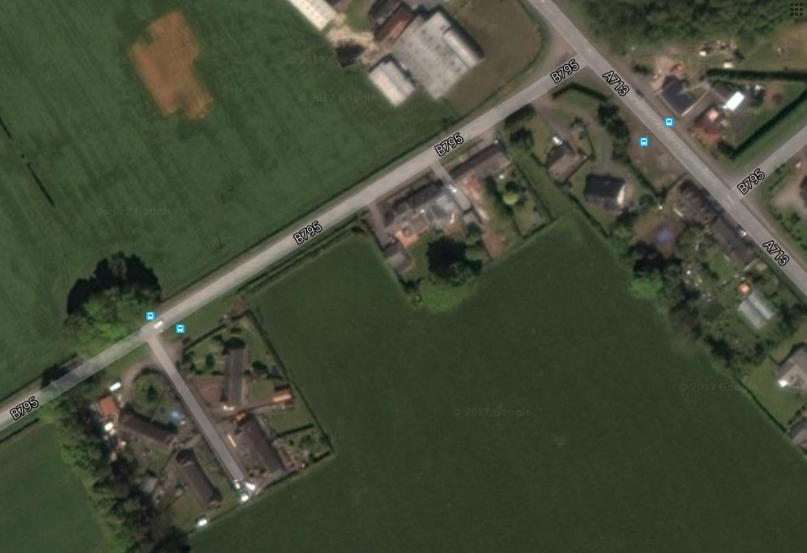
Start

Finish

Start and finish area

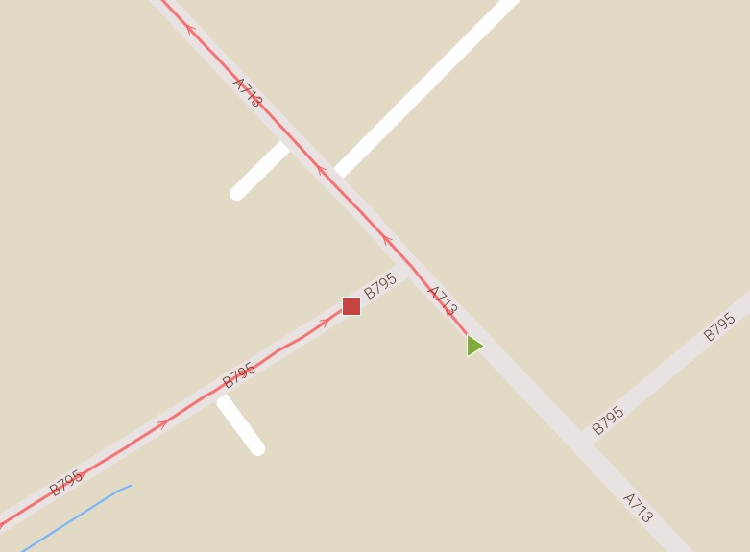

Start and finish area

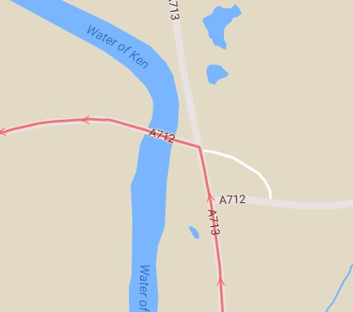

Left turn at Ken Bridge for New Galloway

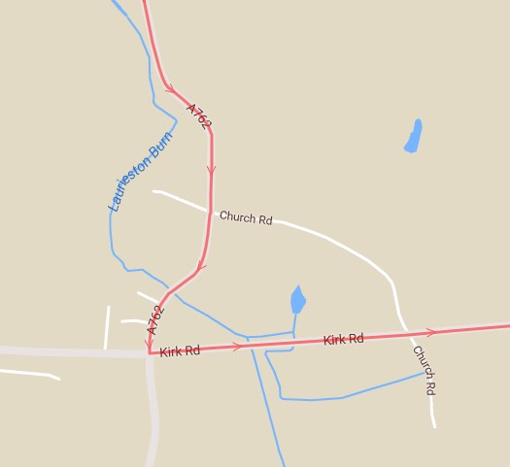

Left turn at Lauriston towards finish

Cars are parked at owners’ risk. Vehicles of competitors / officials / marshals / helpers to be parked safely and without hindrance to other road users. Ample parking is available at Stewartry Rugby Club. Please do not park in the vicinity of the start/finish area.
Take extra care on descents and at junctions.
Particular caution must be taken at the finish area where riders meet a T Junction with the A713 soon after finishing.
- Please note that all competitors are required to sign the signing out sheet in person when returning their number. Failure to do will result in the competitor being recorded as DNF.
- Competitors prior to starting are not permitted to ride past the finish timekeeper during the duration of the event.
- Warming up on the course is not permitted during the duration of the event.
- Any competitor making a ‘U’ turn in the vicinity of the start or finish will be disqualified from the event.
- Riders must keep to the left-hand side of the road except when overtaking.
- Riders must NOT ride with their heads down.
- Riders must not take pace from faster riders passing (drafting). It is the responsibility of the rider who has been passed to drop back.
Failure to comply with the above may lead to disqualification.
In addition to the above Riders must give their number at the finish. Please position your body number centrally below the waist to ensure it is visible from the rear whilst in normal riding position
HELMETS: All competitors under the age of 18 and/or Juniors must wear a HELMET of HARD/SOFT SHELL construction that conforms to a recognised Standard (See regulation 15). Cycling Time Trials strongly recommends ALL competitors wear such a helmet. Cycling Time Trials recommends that a working rear light, either constant or flashing, is fitted to the machine in a position clearly visible to following road users and is active while the machine is in use.

AWARDS (provisional) One rider, one prize:
Overall: 1st £15 2nd £10 3rd £8
Vets 60+ 1st £15 2nd £10 3rd £8
Vets 50 – 59 1st £15 2nd £10 3rd £8
Vets 40 – 49 1st £15 2nd £10 3rd £8
Women 1st £15 2nd £10 3rd £8
Junior 1st £10

Start sheet follows…

Dumfries CC Loch Ken Open TT – 19 August 2017
Start  Number | Start Time | Rider | Club | Gender | Category
1 | 09:01:00 | Emma Westmancott | Dumfries CC | Female | Senior
2 | 09:02:00 | Hannah Dines | Storey Racing | Female | Senior
3 | 09:03:00 | Brian Morrell | Dumfries CC | Male | Vet
4 | 09:04:00 | William Ramsay | Loudoun Road  Club | Male | Vet
5 | 09:05:00 | Lewis Martin | Classic Racing  Team | Male | Junior
6 | 09:06:00 | Dan Kendall | Rock to Roll CC | Male | Senior
7 | 09:07:00 | Thomas Gooding-Hill | Ayr Roads CC | Male | Vet
8 | 09:08:00 | Deirdre O'Reilly | Glasgow  Wheelers | Female | Vet
9 | 09:09:00 | David Robinson | Loudoun Road  Club | Male | Vet
10 | 09:10:00 | Mark Skilling | Carrick CC | Male | Vet
11 | 09:11:00 | Joe Hands | Velo Club Vitesse | Male | Senior
12 | 09:12:00 | Stewart McGregor | Fechan flyers | Male | Vet
13 | 09:13:00 | Ewen MacRury | Knutsford Tri Club | Male
14 | 09:14:00 | Donald McCalley | Dumfries CC | Male | Vet
15 | 09:15:00 | Ewen MacGillivray | RT 23 | Male | Senior
16 | 09:16:00 | Calum MacDonald | Ayr Roads CC | Male | Senior
17 | 09:17:00 | Jamie Little | Classic Racing  Team | Male | Senior
18 | 09:18:00 | Robert Clements | Law Wheelers | Male | Vet
19 | 09:19:00 | Margaret McPhillips | Stockport Clarion  CC | Female | Vet
20 | 09:20:00 | Morgan Anderson | Pro Vision Cycle  Clothing | Male | Espoir
21 | 09:21:00 | Neil Withington | Beacon Wheelers | Male | Senior
22 | 09:22:00 | Pamela Craig | RT 23 | Female | Senior
23 | 09:23:00 | David Keenan | Dumfries CC | Male | Senior
24 | 09:24:00 | Owen Ross | Carrick CC | Male | Senior
25 | 09:25:00 | Chris Stewart | Dooley’s RT | Male | Vet
26 | 09:26:00 | Jim Sutherland | Loudoun Road  Club | Male | Vet
27 | 09:27:00 | Joe McFadyen | Dundee  Wheelers CC | Male | Vet
28 | 09:28:00 | Stephen Makin | Falkirk B C | Male | Vet
29 | 09:29:00 | Jason McCulloch | Loudoun Road  Club | Male | Espoir
30 | 09:30:00 | Eddie Addis | RT 23 | Male | Senior
31 | 09:31:00 | Ian Sim | GTR | Male | Senior
32 | 09:32:00 | Stuart Garner | Dumfries CC | Male | Senior
33 | 09:33:00 | Scott-Alexander McKendrick | Fullarton  Wheelers | Male | Vet
34 | 09:34:00 | Les Stephenson | Border City Whs  CC | Male | Vet
35 | 09:35:00 | Mark McPhillips | Stockport Clarion  CC | Male | Vet
36 | 09:36:00 | Derek Skinner | Fullarton  Wheelers | Male | Vet
37 | 09:37:00 | Alan Fraser Robinson | Velo Club  Cumbria | Male | Vet
38 | 09:38:00 | Garry Collins | Dumfries CC | Male | Vet
40 | 09:40:00 | Gavin Shirley | Dooley’s RT | Male | Senior
41 | 09:41:00 | Sean Quinn | Law Wheelers | Male | Vet
42 | 09:42:00 | Stevie Watters | Fullarton  Wheelers | Male | Vet
43 | 09:43:00 | Glenn Marland | Dumfries CC | Male | Vet
44 | 09:44:00 | Ally Hume | Loudoun Road  Club | Male | Senior
45 | 09:45:00 | Michael Robb | Carrick CC | Male | Senior
46 | 09:46:00 | Paul Robinson | Loudoun Road  Club | Male | Vet
47 | 09:47:00 | Willie Stephen | Velo Club Vitesse | Male | Vet
48 | 09:48:00 | David Jordan | Dumfries CC | Male | Vet
50 | 09:50:00 | Kenneth Armstrong | Carrick CC | Male | Senior
51 | 09:51:00 | Stephen Spellacy | Dumfries CC | Male | Vet
52 | 09:52:00 | David Fulton | Carrick CC | Male | Vet
53 | 09:53:00 | Colin Sinclair | Royal Albert CC | Male | Vet
54 | 09:54:00 | Craig Kirkpatrick | Dumfries CC | Male | Senior
55 | 09:55:00 | John Dunlop | Loudoun Road  Club | Male | Senior
56 | 09:56:00 | Alastair McGibbon | Ayr Roads CC | Male | Senior
57 | 09:57:00 | Andrew McKinlay | Velo Club Vitesse | Male | Vet
58 | 09:58:00 | Darren Carruthers | Glasgow Green  CC | Male | Senior
59 | 09:59:00 | Esther Hamill | Dumfries CC | Female | Vet
60 | 10:00:00 | Douglas Watson | Icarus Racing | Male | Vet
61 | 10:01:00 | Mark Warters | Ayr Roads CC | Male | Vet

62 | 10:02:00 | Michael Allen | Fullarton  Wheelers | Male | Vet
63 | 10:03:00 | Ross Strachan | Loudoun Road  Club | Male | Vet
64 | 10:04:00 | Kevin Jamieson | Dumfries CC | Male | Vet
65 | 10:05:00 | Gordon Murdoch | Icarus Racing | Male | Vet
66 | 10:06:00 | Brian MacRury | Congleton CC | Male | Vet
67 | 10:07:00 | Alex McAllister | Ayr Roads CC | Male | Vet
68 | 10:08:00 | Mike Ferguson | Johnstone  Wheelers | Male | Vet
69 | 10:09:00 | Lindsay Foster | Hitchin Nomads  CC | Male | Vet
70 | 10:10:00 | Chris Smart | GTR | Male | Senior

