Promoted for and on behalf of Cycling Time Trials under their Rules and Regulations
2017 Welsh 10 Miles Time Trial Championship
promoted by
Pontypool Road Cycling Club
on behalf of
Welsh Cycling Association
Sunday 13th August 2017
Event Sponsors –

Event Secretary – Dax Jenkins, Tel: 07941487785
Timekeepers – Phyllis Harradine (start) & Robin Field (finish)
Event Headquarters: St. Michaels Centre, Pen-Y-Pound, Abergavenny, NP7 5UD

www.stmichaelscentre.org.uk

HQ opens at 7.14am

Awards (one rider/one prize)
Mens Championship
1st Championship Medal & Sunwise Eyewear
2nd Championship Medal & Sunwise Eyewear
3rd Championship Medal
Ladies Championship
1st Championship Medal & Sunwise Eyewear
2nd Championship Medal & Sunwise Eyewear
3rd Championship Medal
Junior Championship
1st Championship Medal & Sunwise Eyewear
2nd Championship Medal & Sunwise Eyewear
3rd Championship Medal
1st Girl Championship Medal & Sunwise Eyewear
1st Juvenile Championship Medal & Sunwise Eyewear
1st Juvenile Girl Championship Medal & Sunwise Eyewear
Also
1st Vet on Std Championship Medal
Awards will also be given by the Welsh Cycling Association

Course Description for R10/17

O.S. References: Sheet 161 – Start and Finish 333100
Start at the first drain cover in 3rd lay-by east of Hardwick Roundabout, Abergavenny, on A40, 25 yards east of kilo post 97 and 400 yards east of bridge over road. Proceed on A40 to Raglan Roundabout (4.94 miles) and turn by circling roundabout and retrace on A40 to finish at road joint 136 at western end of lay-by opposite start (10 miles). District Regulations: No cars connected with riders are to travel on the A40 during the event. Competitors observed crossing the dual carriageway will be disqualified.

There should be enough parking at the HQ, as long as everyone parks considerately, but extra parking is available at the nearby Fairfields car park. The ride to the start involves navigating through Abergavenny town centre and a busy roundabout – please take care and allow at least 20 minutes.

Important Notice to all Riders
The WCA, CTT and South Wales Police all recommend the use of a good hard shell helmet manufactured to internationally recognised standards. For ALL Riders under the age of 18 these helmets are COMPULSORY.
Marshalls will be positioned around the course - they are there to show you the way but have no authority over the traffic. Please be familiar with the course, so there are no surprises. It is the Riders responsibility to ride within the laws of the road and with consideration to other road users.

There will be a short presentation immediately following confirmation of the results. All medals and Sunwise prizes need to be collected on the day of the event and will not be posted after the event. Please stay to applaud the Welsh 10 Miles T/T Champions for 2017!

Welsh Cycling Association awards will be presented by the WCA at a later date to be confirmed.

This event may be subject to Doping Control - It is your responsibility to check!
As soon as you have finished you should return to the event HQ as it is your responsibility to check if you are required for Doping Control.
Race numbers required for Doping Control will be displayed at the HQ adjacent to the result board, if your number is displayed you should report immediately to Doping Control which will be nearby.
Remember, it is up to you to check and ensure that you comply.
If required you must report to Doping Control after finishing without delay.

Any complaints or protests must be made to the Event Secretary in writing, within 24 hours of the finish of the event.

Have a good, fast & safe ride!

This event is sponsored by:
Sunwise is a unique British brand of sunglasses offering high
performance sports and fashion eyewear at affordable prices.
Each pair of Sunwise sunglasses are precisely designed to be
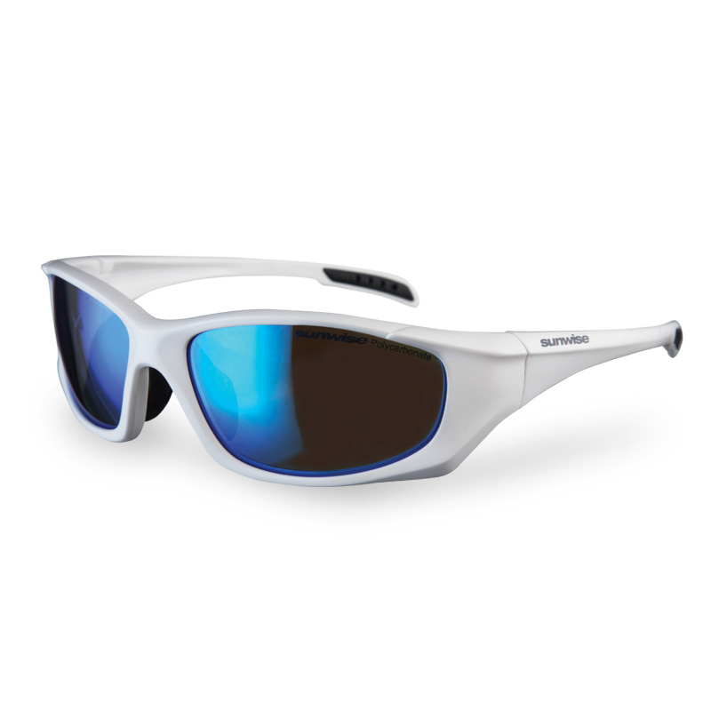lightweight, comfortable and fashionable, while featuring the
latest in optical technology. Multi-layered coatings, graduated
tints and glare-blocking polarised lenses reduce eyestrain and
provide 100% UV protection.
www.sunwise.co.uk Great British Eyewear!

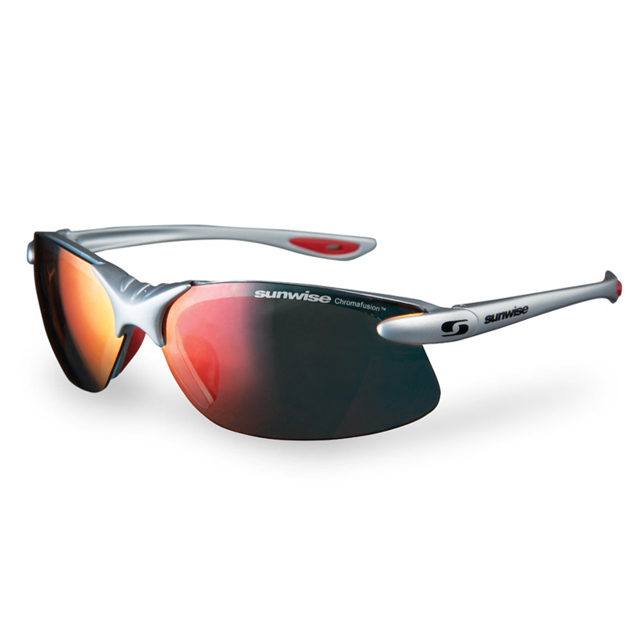Dax Jenkins BSc(HONS) Optom. 13 New Street, Pontnewydd, Cwmbran.
Caroline Jenkins BSc(HONS) Optom. Tel: 01633 869777

13 New Street, Pontnewydd, Cwmbran, NP44 1EF Tel: 01633 869777

For all your eyecare needs:
Eye Examinations
Contact Lenses
Glaucoma and Diabetic Screening with Digital Retinal Imaging
Sports Vision Correction (Official Sunwise Rx Partner)

Official Stockist of:
Calvin Klein, Ted Baker, Nike, Joules, Bench, Storm, Cubik, TitanFlex, Sunwise & more
www.rjdjenkinsopticians.co.uk

2017 Welsh 10 Miles TT Championships
Tandem, Junior, Ladies and Overflow Event

No. | First Name | Last Name | Club | Age/Std | Start
14 | Tanis | Hand | Leamington C & AC | TANDEM | 8.14
14 | Roger | Gardner | Leamington C & AC | TANDEM | 8.14
16 | Eden Rae | Davies | Port Talbot Whs CC | 13/F | 8.16
17 | Aimee | Lane | Wyre Forest Cycle Racing Club | 13/F | 8.17
18 | Carys | Jeffreys | Bynea Cycling Club | 14/F | 8.18
19 | Oliver | Rowlands | Newport Phoenix CC | 15/M | 8.19
20 | Kyle | Jones | Maindy Flyers Youth Cycling | 12/M | 8.20
21 | Joshua | Tarling | West Wales Cycle Racing Team | 13/M | 8.21
22 | Pfeiffer | Georgi | Liv CC - Epic Coaching | 16/F | 8.22
23 | Samuel | Reakes | Bynea Cycling Club | 16/M | 8.23
24 | Ollie | Morgan | Worcester St. Johns CC | 17/M | 8.24
25 | Twm | Bryn | Marsh Tracks Race Team | 16/M | 8.25
26 | Ellie | Russell | SportCity Velo | 17/F | 8.26
27 | Josh | Griffiths | Bristol South Cycling Club | 17/M | 8.27
28 | Lewis | Donovan | Bike Doctor | 18/M | 8.28
29 | Jessica | Roberts | Liv CC - Epic Coaching | 18/F | 8.29
30 | Ieuan | Woods | Banks/Catford CC Equipe | 16/M | 8.30
31 | Katie | Bowler | Bynea Cycling Club | 32 | 8.31
32 | Nadine | Cannon | VeloSistas TT Team | 37 | 8.32
33 | Arja | Scarsbrook | Team Echelon | 69/31.12 | 8.33
34 | Danielle | Flawn | Tredz Bikes | 26 | 8.34
35 | Helen | Priest | Cardiff Ajax CC | 42/28.13 | 8.35
36 | Anna | Morris | Loughborough Students Cycling Club | 22 | 8.36
37 | Michelle | Fishbourne | Abercynon Road Club | 50/28.53 | 8.37
38 | Louise | Georgi | Giant CC - Halo Films | 50/28.53 | 8.38
39 | Claire | Bird | Pontypool Road Cycling Club | 37 | 8.39
40 | Nicki | Carr | VC Equipe - Flix Oral Hygiene | 35 | 8.40
41 | Jasmine | Bowyer | Cardiff Ajax CC | 23 | 8.41
42 | Shona | Bennett | Sportzmad | 34 | 8.42
43 | Annamarie | Miles | Salt and Sham Cycle Club | 39 | 8.43
44 | Christie | Jones | Hereford & Dist Whs CC | 24 | 8.44
45 | Diane | Wilson-Evans | Bynea Cycling Club | 57/29.32 | 8.45
46 | Amanda | Davies | Bynea Cycling Club | 48/28.43 | 8.46
47 | Jennifer | Lemen-Hogarth | Velo Club St Raphael | 29 | 8.47
48 | Andrea | Parish | VeloSistas TT Team | 49/28.48 | 8.48
49 | Kirsty | Murray | Pembrokeshire Velo | 44/28.24 | 8.49
50 | Jo | Buckland | Velo Club St Raphael | 50/28.53 | 8.50
51 | Ali | Charles | Gloucester City Cycling Club | 52/29.03 | 8.51
52 | Tina | Reid | Trainsharp | 52/29.03 | 8.52
53 | Kari | Jones | VeloSistas TT Team | 38 | 8.53
54 | Lucy | Davies | Arctic Tacx RT | 24 | 8.54
55 | Julie | Stephens | Ross on Wye & Dist CC | 52/29.03 | 8.55
56 | Stephanie | Post | VeloSistas TT Team | 31 | 8.56
61 | Brian | Newton | Team Echelon | 78/30.58 | 9.01
62 | David | Singleton | Acme Whs (Rhondda) CC | 53/26.59 | 9.02
63 | Kevin | Grant | Frome and District Wheelers | 60/27.38 | 9.03
64 | Terry | Harradine | CC Topp | 70/29.02 | 9.04
65 | Russell | Boon | Avonlea/Treasure RT | 52/26.54 | 9.05
66 | Ed | Hadley | Hereford & Dist Whs CC | 61/27.44 | 9.06
67 | Michael | Williams | Hereford & Dist Whs CC | 60/27.38 | 9.07
68 | Kevin | Bessant | Bynea Cycling Club | 54/27.04 | 9.08
69 | Ken | Evans | Salt and Sham Cycle Club | 61/27.44 | 9.09
70 | Robin | Fox | Dursley Road Club | 59/27.32 | 9.10
71 | Steve | Summerhayes | Somerset Road Club | 63/27.59 | 9.11
72 | Kevin | Fiander | VTTA (South Wales) | 5427.04 | 9.12
73 | Bob | Symons | Salt and Sham Cycle Club | 63/27.59 | 9.13
74 | Roger | Wakeling | Antelope Racing Team | 71/29.14 | 9.14
75 | Robert | Jones | Cardiff 100 Miles RCC | 65/28.14 | 9.15
76 | Jon | Airey | Ross on Wye & Dist CC | 64/28.06 | 9.16
77 | Derek | Morgan | Gannet CC | 77/30.40 | 9.17
78 | David | Steel | Hereford & Dist Whs CC | 70/29.02 | 9.18
79 | Patrick | Jerome | Ride Bike Wales | 70/29.02 | 9.19
80 | Ron | boast | Ogmore Valley Wheelers CC | 66/28.23 | 9.20
81 | Tony | Emery | Dursley Road Club | 70/29.02 | 9.21
82 | Robert | Smith | Pembrokeshire Velo | 41/26.04 | 9.22

Mens Event

No. | First Name | Last Name | Club | Age/Std | Start
1 | Steve | Potts | Velo Club St Raphael | 59/27.32 | 9.31
2 | Philip | Sims | Newport Phoenix CC | 41/26.04 | 9.32
3 | Paul | Stephens | Ross on Wye & Dist CC | 52/26.54 | 9.33
4 | Gareth | Hill | Abercynon Road Club | 45/26.23 | 9.34
5 | Steven | Cottington | Bath Cycling Club | 55/27.09 | 9.35
6 | Niall | Foster | Cardiff Ajax CC | 41/26.04 | 9.36
7 | Steven | Madeley | Ogmore Valley Wheelers CC | 56/27.14 | 9.37
8 | Chris | Hughes | Hereford & Dist Whs CC | 57/27.20 | 9.38
9 | Anthony | Mansell | Ogmore Valley Wheelers CC | 55/27.09 | 9.39
10 | Adrian | Lane | 1st Chard Wheelers | 18 | 9.40
11 | Emyr | Griffiths | Towy Racing Cycling Club (TRCC) | 50/26.45 | 9.41
12 | Mike | Amery | VC Sevale (Malvern) | 59/27.32 | 9.42
13 | Jeffrey | Rees | Acme Whs (Rhondda) CC | 54/27.04 | 9.43
14 | Robert | Finch | Arctic Tacx RT | 59/27.32 | 9.44
15 | Graeme | Boswell | Cardiff Ajax CC | 42/26.09 | 9.45
16 | Mike | Lindsay | Pembrokeshire Velo | 50/26.45 | 9.46
17 | Ian | Lindsay | Royal Navy & Royal Marines CA | 44/26.18 | 9.47
18 | Guy | Evans | Hereford & Dist Whs CC | 58/27.26 | 9.48
19 | Steven | Brown | Gloucester City Cycling Club | 44/26.18 | 9.49
20 | Simon | Garrett | Worcester St. Johns CC | 43/26.13 | 9.50
21 | Stuart | Evans | Port Talbot Whs CC | 71/29.14 | 9.51
22 | Edward | Dursley | Worcester St. Johns CC | 43/26.13 | 9.52
23 | Luke | Bradford | Hereford Triathlon Club | 39 | 9.53
24 | Stephen | Ratcliffe | Brecon Wheelers | 49/26.41 | 9.54
25 | Danny Glyn | Roberts | Anglesey Cycling Group | 36 | 9.55
26 | Paul | Winchcombe | Chippenham & District Wheelers | 57/27.20 | 9.56
27 | Dave | Williams | Anglesey Cycling Group | 42/26.09 | 9.57
28 | Terry | Anthony | Ogmore Valley Wheelers CC | 65/28.14 | 9.58
29 | Neil | Meredith | Abercynon Road Club | 31 | 9.59
30 | Mark | Woolford | Trainsharp | 51/26.50 | 10.00
31 | Joe | Rees | Wyre Forest Cycle Racing Club | 20 | 10.01
32 | Chris | Fishbourne | Abercynon Road Club | 43/26.13 | 10.02
33 | Garry | Shuker | Walsall Roads Cycling Club | 62/27.51 | 10.03
34 | Nicholas | Forbes | Bynea Cycling Club | 46/26.27 | 10.04
35 | Ben | Phillips | Towy Racing Cycling Club (TRCC) | 28 | 10.05
36 | Julian | Harper | Revo Racing | 48/26.36 | 10.06
37 | Mitch | Russell | Energy Cycling Club/Clwb Beicio Egni | 30 | 10.07
38 | Matt | Heaman | Severn Valley Cycles | 51/26.50 | 10.08
39 | Alistair | Morgan | Pontypool Road Cycling Club | 55/27.09 | 10.09
40 | Anthony | Jones | Towy Racing Cycling Club (TRCC) | 45/26.23 | 10.10
41 | Colin | Pritchard | Anglesey Cycling Group | 37 | 10.11
42 | Stephen | Taylor | Pembrokeshire Velo | 52/26.54 | 10.12
43 | Dean | Prosser | Hereford & Dist Whs CC | 48/26.36 | 10.13
44 | Jason | Cole | Milford Tritons Cycling Club | 31 | 10.14
45 | Michael | Davis | Dursley Road Club | 35 | 10.15
46 | David | Bucknall | Royal Dean Forest Cycle Club | 43/26.13 | 10.16
47 | Adam | Taylor | Royal Dean Forest Cycle Club | 39 | 10.17
48 | Andrew | Hayward | Cwmcarn Paragon Road Club | 45/26.23 | 10.18
49 | Brad | Davies | Bynea Cycling Club | 51/26.50 | 10.19
50 | Ben | Anstie | 73Degrees CC | 40/25.59 | 10.20
51 | Tom | Bowering | PMR @ Toachim House | 22 | 10.21
52 | Mark | Rosser | Ogmore Valley Wheelers CC | 47/26.32 | 10.22
53 | Andrew | Milner | Evesham & District Wheelers | 45/26.23 | 10.23
54 | Ray | Perkins | Clevedon & District Road Club | 53/26.59 | 10.24
55 | Michael | Lewis | Rhyl CC | 30 | 10.25
56 | Michael | Portlock | Merthyr CC | 47/26.32 | 10.26
57 | Andrew | Derrick | Severn Road Club | 38 | 10.27
58 | John | O'Dwyer | Dursley Road Club | 36 | 10.28
59 | Craig | Hopkins | Pontypool Road Cycling Club | 41/26.04 | 10.29
60 | Liam | Bard | Revo Racing | 28 | 10.30
61 | Jason | Streather | Velo Club St Raphael | 43/26.13 | 10.31
62 | Rob | Jones | Cardiff Ajax CC | 40/25.59 | 10.32
63 | Scott | Nash | Pembrokeshire Velo | 48/26.36 | 10.33
64 | Simon | Kinsey | Acme Whs (Rhondda) CC | 47/26.32 | 10.34
65 | Chris | Massey | Team Bottrill / HSS Hire | 45/26.23 | 10.35
66 | Nathan | Leaves | NFTO Race Club | 19 | 10.36
67 | Rob | Hall | Salt and Sham Cycle Club | 44/26.18 | 10.37
68 | Andy | Hunt | Ystwyth CC | 39 | 10.38
69 | Steve | Curry | Ogmore Valley Wheelers CC | 53/26.59 | 10.39
70 | Ben | Skinner | Bath Cycling Club | 34 | 10.40
71 | Jeremy | Pile | VC Sevale (Malvern) | 4326.13 | 10.41
72 | Daryl | Godden | Gloucester City Cycling Club | 58/27.26 | 10.42
73 | Jonathan | Barnes | Herefordshire Cycling Club | 25 | 10.43
74 | Alan | Cooper | Avonlea/Treasure RT | 60/27.38 | 10.44
75 | Matt | Slater | Revo Racing | 42/26.09 | 10.45
76 | Earl | Smith | Severn Valley Cycles | 47/26.32 | 10.46
77 | Ben | Connelly | Severn Road Club | 41/26.04 | 10.47
78 | Vincent | Jenkins | LeisureLakesBikes.com | 77/30.40 | 10.48
79 | Paul | Freegard | Chippenham & District Wheelers | 60/27.38 | 10.49
80 | William | Perrett | Langdale Lightweights R T | 20 | 10.50
81 | Paul | Hayward | Cwmcarn Paragon Road Club | 45/26.23 | 10.51
82 | Gary | Flower | Acme Whs (Rhondda) CC | 48/26.36 | 10.52
83 | Stuart | Day | City Cycle Centre.com | 47/26.32 | 10.53
84 | John | Shehan | Bynea Cycling Club | 71/29.14 | 10.54
85 | Tom | Ward | Langdale Lightweights R T | 23 | 10.55
86 | Grant | Arnold | Pembrokeshire Velo | 32 | 10.56
87 | Nick | Brown | Team NBCC | 59/27.32 | 10.57
88 | Michael | Stephens | Hereford Triathlon Club | 57/27.20 | 10.58
89 | Paul | Jones | Ystwyth CC | 42/26.09 | 10.59
90 | David | Janes | Veloton | 35 | 11.00
91 | Paul | Coles | 73Degrees CC | 44/26.18 | 11.01
92 | Robert | Hughes | Ride Bike Wales | 53/26.59 | 11.02
93 | Michael | Tarling | West Wales Cycle Racing Team | 41/26.04 | 11.03
94 | Josh | Townsend | Bynea Cycling Club | 19 | 11.04
95 | Christopher | Jones | Port Talbot Whs CC | 48/26.36 | 11.05
96 | David | Wilson-Evans | Bynea Cycling Club | 60/27.38 | 11.06
97 | Richard | Coleman | Stourbridge Velo | 63/27.59 | 11.07
98 | Matthew | Phillips | Towy Racing Cycling Club (TRCC) | 30 | 11.08
99 | Lee | Gaughan | Climb on Bikes RT | 47/26.32 | 11.09
100 | Aled | Roberts | Team Elite/Paul Bethell Electrical | 38 | 11.10
101 | Mike | Appleyard | Lancashire RC | 51/26.50 | 11.11
102 | Arwel | Davies | Towy Racing Cycling Club (TRCC) | 44/26.18 | 11.12
103 | Gary | Jones | Pontypool Road Cycling Club | 55/27.09 | 11.13
104 | Rob | Allen | Milford Tritons Cycling Club | 32 | 11.14
105 | James | Rix | Crawley Wheelers | 41/26.04 | 11.15
106 | Andy | Davies | Cardiff Jif | 35 | 11.16
107 | Derek | Dowdeswell | Gloucester City Cycling Club | 63/27.59 | 11.17
108 | Morgan | Davies | Pedalcover Insurance | 23 | 11.18
109 | Mike | Parry | Hereford Triathlon Club | 51/26.50 | 11.19
110 | George | Evans | Team Bottrill / HSS Hire | 19 | 11.20
111 | Andy | Stuart | Velo Club St Raphael | 42/26.09 | 11.21
112 | Nathan | Preece | Worcester St. Johns CC | 46/26.27 | 11.22
113 | Owain | Roberts | Port Talbot Whs CC | 34 | 11.23
114 | Grant | Whiteside | Pontypool Road Cycling Club | 43/26.13 | 11.24
115 | Dan | Evans | ASSOS Equipe UK | 36 | 11.25
116 | Carwyn | Davies | Cwmcarn Paragon Road Club | 39 | 11.26
117 | Andrew | Rowles | Cardiff Ajax CC | 38 | 11.27
118 | Andy | Kelly | Bristol South Cycling Club | 52/26.54 | 11.28
119 | Jonathan | Webb | Gannet CC | 46/26.27 | 11.29
120 | Kieron | Davies | DRAG2ZERO | 30 | 11.30

