EPSOM CC 10 Mile Time Trial
To be held on 29th July 2017 at 06:30
Promoted for and on behalf of Cycling Time Trials under their rules and regulations
HQ: Broadbridge Heath Village Centre, Wickhurst Lane, Broadbridge Heath, Horsham RH12 3LY
Organiser: Richard Gill 16 Beaufort Way Epsom KT17 2PS 079803519441 (race day only)
Email open10@epsomcc.co.uk or quercus.gill@ntlworld.com
Timekeepers: Principal Timekeeper: Mick Irons
Assistant Timekeeper: Peter Delve
Official Observers will be stationed around the course

Numbers to be collected from the HQ where you must sign on and under new CTT regulation SIGN OFF failure to sign off will result in a DNF result. The HQ is in a residential area, please be considerate to the people who live there & keep noise to a minimum
Route from HQ to Start. You can also go straight down the A24. 15 minutes to ride from the HQ to the Start
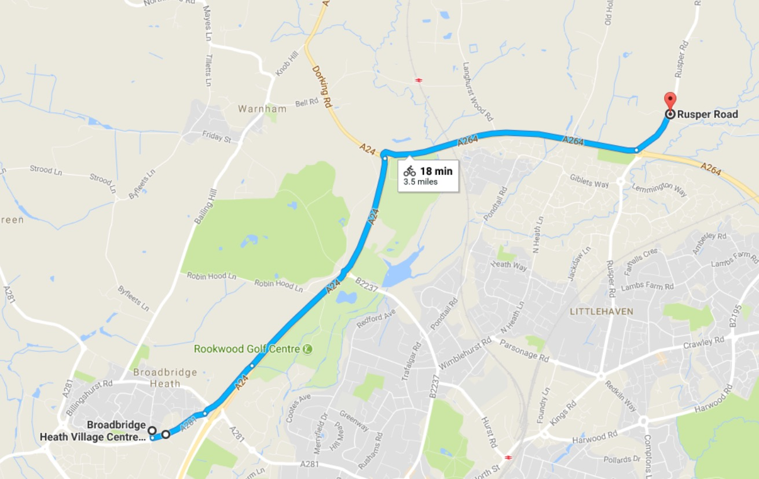

COURSE – G10/57 description:
 | Detail: | Distances
 | START (OS Ref 191337) in Rusper Road opposite Farm Shop sign at entrance to Moat Farm approximately 350 yards north of Rusper Road RBT (roundabout) Proceed south to Rusper Road RBT. LEFT 1st exit and follow A264 to Moorhead RBT | 0.00 0.00
 | LEFT 1st exit and continue on A264 via Faygate and Kilnwood Vale RBTs to Bewbush Manor RBT.
 | STRAIGHT ON 2nd exit and follow A2220 via Breezehurst RBT to Broadfield RBT where TURN. (CHECK) | 4.87 4.87
 | 4th exit to retrace on A2220 via Breezehurst RBT to Bewbush Manor RBT. STRAIGHT ON 2nd exit and follow A264 via Kilnwood Vale and Faygate RBTs to Moorhead RBT. RIGHT 2nd exit.  Continue on A264 via Rusper Road RBT  FINISH at white paint mark at 4th drain cover in kerbstones from eastern end of lay-by where edge of lay-by becomes parallel to A264 and 0.44 miles west of Rusper Road RBT. | 5.16 10.03

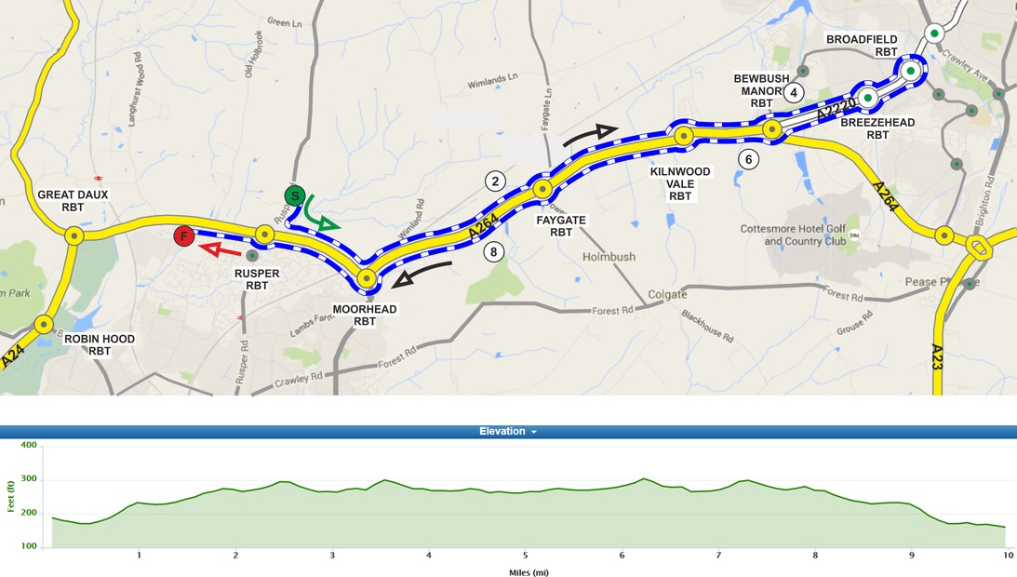

Instructions
- Riders must sign in and SIGN OUT. Failure to sign out will result in a DNF result
- Competitors are requested not to warm up on the course after the first competitor has started.
- London South District Regulation: No vehicles, except those of the timekeepers and event officials, shall be parked in the vicinity of the start and finish areas.
- No times will be given at the finish.
- CTT regulations require the compulsory use of helmets for the under 18’s. In the interests of your own safety, Cycling Time Trials and the event promoters strongly advise all competitors to wear a hard/soft shell helmet that meets internationally accepted safety standards.
- Competitor’s machines: it is recommended that a working rear light, either flashing or constant, is fitted to the machine in a position clearly visible to following road users and is active while the machine is in use
- Competitors must exercise extra care when negotiating all roundabouts, particularly at Breezehurst roundabout on the outward leg where the sight line to the right is poor and on the return leg when turning right at Moorhead roundabout.
- Competitors are advised that there is a regular Saturday morning car boot sale at the Faygate Roundabout. Vehicles normally park in the lay-by on the side of the road immediately after the roundabout on the return route and pedestrians can be expected to walk along the carriageway in both directions at this point.
- Details of any additional hazards not listed on the Start Sheet will be displayed or advised at the Signing On point. All Competitors must take note of these details when they sign on
- If pinning your number please only use the eyelets, and please do not use additional pins as it tears the numbers.
NUMBERS MUST BE FIXED BELOW WAIST. No time may be recorded if number is not correctly positioned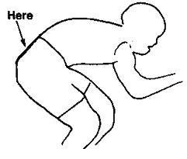

Prizes
All prizes will be awarded on time. – Standards will not be applied for veteran riders
With the exception of the team prize, no rider can win more than one award.
Fastest Rider £40 2nd £30 3rd £25 4th £20 5th 10
Women: 1st £40 2nd £30
Under 30 1st £10
30-39 1st £10
40-49 1st £10
50-59 1st £10
60 plus 1st £10
1st Team of 3 riders £15 each rider 2nd Team of 3 riders £10 each rider

Epsom Cycling Club Open 10 mile time trial. Sunday July 29th @ 6:30
Promoted for and on behalf of Cycling Time Trials under their rules and regulations
Bib | Start Time | First Name | Last Name | Club | Gender | Cat
4 | 06:34:00 | Caroline | Beirne | Epsom CC | Female | Veteran
5 | 06:35:00 | Jesse | Yates | In-Gear Quickvit Trainsharp RT | Male | Espoir
6 | 06:36:00 | Jose | Espinosa | Pinoy Cycling Club UK | Male | Veteran
7 | 06:37:00 | Mike | Anderson | Velo Club St Raphael | Male | Veteran
8 | 06:38:00 | Stuart | Payne | Central Sussex CC | Male | Veteran
9 | 06:39:00 | Clive | Noel | Paceline RT | Male | Veteran
10 | 06:40:00 | Ryan | Smith | Morvelo Basso RT | Male | Senior
11 | 06:41:00 | Carl | Richardson | Trainsharp | Male | Veteran
12 | 06:42:00 | Chris | Jolliffe | Crawley Wheelers | Male | Veteran
13 | 06:43:00 | Colin | CROCKER | Sotonia CC | Male | Veteran
14 | 06:44:00 | Philip | Burgin | Newbury RC | Male | Veteran
15 | 06:45:00 | Mark | Bashford | East Grinstead CC | Male | Senior
16 | 06:46:00 | Jason | Hunter | Pearson Cycling Club | Male | Veteran
17 | 06:47:00 | Colin | Gray | Norwood Paragon CC | Male | Veteran
18 | 06:48:00 | Robert | Royle-Evatt | Addiscombe CC | Male | Veteran
19 | 06:49:00 | chris | summers | Sotonia CC | Male | Veteran
20 | 06:50:00 | Andrew | Bradbury | Paceline RT | Male | Senior
21 | 06:51:00 | Tim | Peters | Horsham Cycling | Male | Veteran
22 | 06:52:00 | Bruce | English | Eastbourne Rovers CC | Male | Veteran
23 | 06:53:00 | Thierry | Huser | Dulwich Paragon CC | Male | Veteran
24 | 06:54:00 | Richard | Bushell | Oxted Cycle Club | Male | Veteran
25 | 06:55:00 | Michael | Davey | Eastbourne Rovers CC | Male | Senior
26 | 06:56:00 | Fabien | Large | Direct Power Cycling Team | Male | Juvenile
27 | 06:57:00 | James | Cheeseman | Crawley Wheelers | Male | Senior
28 | 06:58:00 | Martin | Naylor | Brighton Excelsior CC | Male | Veteran
29 | 06:59:00 | clive | jackson | Central Sussex CC | Male | Veteran
30 | 07:00:00 | Colin | McDermott | Festival Road Club | Male | Veteran
31 | 07:01:00 | Michael | Draper | Charlotteville Cycling Club | Male | Veteran
32 | 07:02:00 | Gavin | Francis | London Dynamo | Male | Veteran
33 | 07:03:00 | David | Clements | Eastbourne Rovers CC | Male | Veteran
34 | 07:04:00 | Chris | Cowlard | De Laune CC | Male | Veteran
35 | 07:05:00 | Richard | Weatherstone | GS Stella | Male | Veteran
36 | 07:06:00 | Jon | Fry | Horsham Cycling | Male | Veteran
37 | 07:07:00 | Aidan | Culhane | Kingston Wheelers CC | Male | Veteran
38 | 07:08:00 | Barry | Packman | Epsom CC | Male | Veteran
39 | 07:09:00 | keith | white | Epsom CC | Male | Veteran
40 | 07:10:00 | Jamie | Pine | Nuun-Sigma Sport-London RT | Male | Veteran
41 | 07:11:00 | stuart | stow | Twickenham CC | Male | Veteran
42 | 07:12:00 | Tobias | Bunyan | Eastbourne Rovers CC | Male | Veteran
43 | 07:13:00 | David | Haggart | De Laune CC | Male | Veteran
44 | 07:14:00 | Steve | Grout | Epsom CC | Male | Veteran
45 | 07:15:00 | Christian | Yates | East Grinstead CC | Male | Veteran
46 | 07:16:00 | Richard | Miles | Bognor Regis CC | Male | Veteran
47 | 07:17:00 | Paul | Winkley | East Grinstead CC | Male | Veteran
48 | 07:18:00 | Christopher, | Rosam | Epsom CC | Male | Veteran
49 | 07:19:00 | Michael | Daniels | Southborough & Dist. Whs | Male | Veteran
50 | 07:20:00 | Simon | McNamara | South Downs Bikes / Casco Europe | Male | Veteran
51 | 07:21:00 | Peter | Baker | Lewes Wanderers CC | Male | Veteran
52 | 07:22:00 | Julie | Chasin | Twickenham CC | Female | Veteran
53 | 07:23:00 | Richard | Woodward | East Grinstead CC | Male | Veteran
54 | 07:24:00 | Abigail | Carter | Loughborough Students Cycling Club | Female | Espoir
55 | 07:25:00 | Phil | Allen | South Downs Bikes / Casco Europe | Male | Senior
56 | 07:26:00 | Michael | Porter | 34 Nomads CC | Male | Veteran
57 | 07:27:00 | Nigel | Perry | San Fairy Ann CC | Male | Veteran
58 | 07:28:00 | Gemma | Hayes | East Grinstead CC | Female | Senior
59 | 07:29:00 | barrie | foster | Anerley BC | Male | Veteran
60 | 07:30:00 | Ben | Elliott | Paceline RT | Male | Senior
61 | 07:31:00 | Richard | Birtwhistle | Sydenham Whs | Male | Veteran
62 | 07:32:00 | Katie | Crowe | Dulwich Paragon CC | Female | Veteran
63 | 07:33:00 | Alan | Robinson | Central Sussex CC | Male | Veteran
64 | 07:34:00 | Natasha | Jarman | Southborough & Dist. Whs | Female | Senior
65 | 07:35:00 | Dale | Lush | Kingston Phoenix RC | Male | Senior
66 | 07:36:00 | Tom | Houghton | Brighton Excelsior CC | Male | Veteran
67 | 07:37:00 | Hugh | Pelling | Old Portlians CC | Male | Veteran
68 | 07:38:00 | Dan | Wallace | South Western Road Club/Evans Cycles | Male | Senior
69 | 07:39:00 | Colin | Derrick | South Eastern RC | Male | Veteran
70 | 07:40:00 | Pat | Wright | Paceline RT | Male | Senior
71 | 07:41:00 | Simon | Church | In-Gear Quickvit Trainsharp RT | Male | Veteran
72 | 07:42:00 | Mark | Bixley | Festival Road Club | Male | Veteran
73 | 07:43:00 | Peter | Owen | Norwood Paragon CC | Male | Veteran
74 | 07:44:00 | Johan | Stegers | Lewes Wanderers CC | Male | Veteran
75 | 07:45:00 | Joshua | Haasz | Banks/Catford CC Equipe | Male | Espoir
76 | 07:46:00 | Colin | Barton | Worthing Excelsior CC | Male | Veteran
77 | 07:47:00 | mark | vowells | CC Bexley | Male | Veteran
78 | 07:48:00 | Benoit | Ramsay | Paceline RT | Male | Senior
79 | 07:49:00 | les | Humphrey | South Eastern RC | Male | Veteran
80 | 07:50:00 | James | Rix | Crawley Wheelers | Male | Veteran
81 | 07:51:00 | Jon | Elliott | Maidenhead & District CC | Male | Senior
82 | 07:52:00 | ian | Graver | Bec CC | Male | Veteran
83 | 07:53:00 | David | Powis | Dorking Cycling Club | Male | Senior
84 | 07:54:00 | Tim | Lynch | Aspire Velo Racing Team | Male | Espoir
85 | 07:55:00 | Lee | Turner | Sigma Sport.co.uk | Male | Veteran
86 | 07:56:00 | Nolan | Heather | Worthing Excelsior CC | Male | Veteran
87 | 07:57:00 | Mike | Stephens | Epsom CC | Male | Veteran
88 | 07:58:00 | Tony | Longhurst | Oxted Cycle Club | Male | Senior
89 | 07:59:00 | Colin | Jarman | Southborough & Dist. Whs | Male | Veteran
90 | 08:00:00 | James | Boyman | Hoops Velo | Male | Senior

