Addiscombe Cycling Club
Open 10 mile Time Trial
For the Arthur Rayner Trophy
(Promoted for and on behalf of Cycling Time Trials under their Rules and Regulations)
14:00 Saturday July 22nd 2017 – Course G10/42
Event Record: 19:51 W Sybrandy 2010
HQ: North Holmwood Village Hall
Spook Hill, North Holmwood, Surrey, RH5 4JP
Promoter Name: Ian Bray
Address: 61 Woodman Road, Coulsdon, Surrey, CR5 3HQ
Tel: 07940346263
Email: open10@addiscombe.org
Timekeepers: Peter Delve & Mike Labram
Course Details:
OS Ref | Details | Distance
167469 | START in Spook Hill, North Holmwood at PO Telephone Inspection Cover 30 yards from junction with A24  Proceed to A24 where LEFT (care). Proceed South | 0.0
177428 | Take 2nd exit at Beare Green roundabout and follow Capel bypass (A24) | 2.67
171397 | TURN Take 5th exit on Clark’s Green roundabout (check) | 4.91
177428 | Take 2nd exit straight on at Beare Green Roundabout | 7.15
166472 | FINISH at drain at North end of penultimate crash barrier 634 yards from North Holmwood roundabout | 10.00

Live timings: To check live timings please use this link, pass to family and friends if required.
http://www.addiscombe.org/TimeTrialResults/ttresults.php?eventcode=170722
SAFETY INSTRUCTIONS
- Competitors are requested not to warm up on the course after the first competitor has started.
- Details of any additional hazards not listed on the start sheet will be displayed or advised at the Signing On point. All competitors must take note of these details when they sign on.
- Competitors must exercise extra care when negotiating all roundabouts.
- No times will be given at the finish.
- CTT regulations require the compulsory use of helmets for the under 18’s. In the interests of your own safety, Cycling Time Trials and the event promoters strongly advise all competitors to wear a hard/soft shell helmet that meets internationally accepted safety standards.
- Competitor’s machines: it is recommended that a working rear light, either flashing or constant, is fitted to the machine in a position clearly visible to following road users and is active while the machine is in use.
- Any participants under the age of 18 are required to present their completed parental consent form at the sign-on desk. No helmet, no parental consent then no ride.
HEADS UP, RIDE SAFELY!
Prizes
Scratch: 1st £30 2nd £20 3rd £10
Lady’s: 1st £30 2nd £20 3rd £10
Veterans: 1st £30 2nd £20 3rd £10
Team: 1st £30

The scratch winner will also receive two tickets to the club dinner where the trophy will be awarded.
For final results and prizes check:
http://www.addiscombe.org/TimeTrialResults/ttresultsfinal.php?eventcode=170722
Notes on prizes:
- One prize per rider except for the Team prize the highest value prize being paid.
- A Team is the fastest 3 riders from a single club / team.
- Any prizes not awarded on the day will be sent out with the results sheet.
Start sheet page 1:

Start  No. | Start  Time | First  Nam | Last  Name | Club | Gender | Cat
1 | 14:01 | Denise | Bray | Anerley BC | Female | Veteran
2 | 14:02 | Esme | Cole | London Women's Racing CC | Female | Senior
3 | 14:03 | Emily | Chong | Serpentine Running Club | Female | Senior
4 | 14:04 | Charlotte | Matthews | Brighton Mitre CC | Female | Junior
5 | 14:05 | Joscelin | Lowden | APRIRE Bicycles/HSS Hire | Female | Senior
6 | 14:06 | Julie | Chasin | Twickenham CC | Female | Veteran
7 | 14:07 | Vicki | Solly | ONE Triathlon RDS | Female | Senior
8 | 14:08 | Laura | Wilkey | Crawley Wheelers | Female | Senior
9 | 14:09 | Nadia | Wilkinson | London Women's Racing CC | Female | Senior
10 | 14:10 | Katie | Crowe | Dulwich Paragon CC | Female | Veteran
11 | 14:11 | Kathryn | Morris | Dulwich Paragon CC | Female | Senior
12 | 14:12 | Robyn | Yates | Addiscombe CC | Female | Veteran
13 | 14:13 | Jane | Shrubb | Oxted Cycle Club | Female | Veteran
14 | 14:14 | Helen | Webb | Sussex Nomads CC | Female | Veteran
15 | 14:15 | Sophie | Household | Vertex Biemme RT | Female | Senior
16 | 14:16
17 | 14:17
18 | 14:18 | Peter | Horsfield | Redmon CC | Male | Veteran
19 | 14:19 | Tim | Holmes | VTTA (Surrey & Sussex) | Male | Veteran
20 | 14:20 | Ayrton | Pope | Paceline RT | Male | Espoir
21 | 14:21 | David | Clark | Eastbourne Rovers CC | Male | Veteran
22 | 14:22 | Alistair | Canning | Redhill CC | Male | Juvenile
23 | 14:23 | Tim | Moody | Addiscombe CC | Male | Senior
24 | 14:24 | Clive | Noel | Paceline RT | Male | Veteran
25 | 14:25 | Leigh | Schvartz | Team Swindon Cycles | Male | Senior
26 | 14:26 | Chris | Jones | Bynea Cycling Club | Male | Veteran
27 | 14:27 | Jim | Ford | Dorking Cycling Club | Male | Veteran
28 | 14:28 | Kaushal | Sampat | Addiscombe CC | Male | Senior
29 | 14:29 | Billy | Gilbey | London Dynamo | Male | Juvenile
30 | 14:30 | Robert | Moore | Nuun-Sigma Sport-London RT | Male | Senior
31 | 14:31 | David | Churchill | Bigfoot CC | Male | Veteran
32 | 14:32 | Ian | Bray | Addiscombe CC | Male | Senior
33 | 14:33 | Benoit | Ramsay | Paceline RT | Male | Senior
34 | 14:34 | David | Gordon | Anerley BC | Male | Veteran
35 | 14:35 | Robert | Drake | Addiscombe CC | Male | Senior
36 | 14:36 | Keith | Reed | Dorking Cycling Club | Male | Veteran
37 | 14:37 | Mark | Ellis | Addiscombe CC | Male | Senior
38 | 14:38 | Giles | Corner | Clapham Chasers | Male | Senior
39 | 14:39 | Steve | Braddick | Anerley BC | Male | Veteran
40 | 14:40 | Thomas | Whatley | Paceline RT | Male | Senior

Start sheet page 2:

Start  No. | Start  Time | First  Nam | Last  Name | Club | Gender | Cat
41 | 14:41 | Niall | Digby | Sigma Sport.co.uk | Male | Veteran
42 | 14:42 | Andrew R | Green | Bec CC | Male | Veteran
43 | 14:43 | Russell | Hicks | Oxted Cycle Club | Male | Veteran
44 | 14:44 | Richard | Hoskin | Redmon CC | Male | Veteran
45 | 14:45 | Pete | Morris | Team ASL | Male | Senior
46 | 14:46 | Rick | Gradidge | SW Rouleurs | Male | Veteran
47 | 14:47 | Ade | Fadero | Sussex Nomads CC | Male | Veteran
48 | 14:48 | Matt | Phipps-Taylor | VELOSPORT CC | Male | Senior
49 | 14:49 | Paul | Hunter | Addiscombe CC | Male | Senior
50 | 14:50 | John | Dewey | Team Bottrill / HSS Hire | Male | Senior
51 | 14:51 | Dan | Cole | Dorking Cycling Club | Male | Veteran
52 | 14:52 | Mark | Aldred | Kingston Wheelers CC | Male | Senior
53 | 14:53 | David | Powis | Dorking Cycling Club | Male | Senior
54 | 14:54 | Ajay | Hoxha | Anerley BC | Male | Senior
55 | 14:55 | Simon | Church | In-Gear Quickvit Trainsharp RT | Male | Veteran
56 | 14:56 | Colin | Barton | Worthing Excelsior CC | Male | Veteran
57 | 14:57 | Jared | Linden | Royal Dean Forest Cycle Club | Male | Senior
58 | 14:58 | Hugh | Pelling | Old Portlians CC | Male | Veteran
59 | 14:59 | Timo | Hendy | Pearson Cycling Club | Male | Senior
60 | 15:00 | Adam | Bidwell | Kingston Wheelers CC | Male | Veteran
61 | 15:01 | Jonathan | Pontin | Addiscombe CC | Male | Senior
62 | 15:02 | Dale | Baldwin | Horsham Cycling | Male | Veteran
63 | 15:03 | Craig | Lawrence | Kingston Wheelers CC | Male | Senior
64 | 15:04 | Tom | Pemberton | New Malden Velo | Male | Senior
65 | 15:05 | Andrew | Bradbury | Paceline RT | Male | Senior
66 | 15:06 | Michael | Deen | Redmon CC | Male | Veteran
67 | 15:07 | Andrew | Murray | Team Corridori | Male | Veteran
68 | 15:08 | Craig | Swatton | Crawley Wheelers | Male | Senior
69 | 15:09 | Barry | Packman | Epsom CC | Male | Veteran
70 | 15:10 | Pat | Wright | Paceline RT | Male | Senior
71 | 15:11 | David | Lovell | Addiscombe CC | Male | Veteran
72 | 15:12 | Sam | Clarke | Team Bottrill / HSS Hire | Male | Senior
73 | 15:13 | Aidan | Culhane | Kingston Wheelers CC | Male | Veteran
74 | 15:14 | Barrie | Foster | Anerley BC | Male | Veteran
75 | 15:15 | Anthony | Draper | 34 Nomads CC | Male | Veteran
76 | 15:16 | Gareth | Williams | Twickenham CC | Male | Veteran
77 | 15:17 | Matthew | Ferguson | Redhill CC | Male | Espoir
78 | 15:18 | Robert | Royle-Evatt | Addiscombe CC | Male | Veteran
79 | 15:19 | Steve | Grout | Epsom CC | Male | Veteran
80 | 15:20 | Christopher | Mcnamara | Nuun-Sigma Sport-London RT | Male | Veteran

Maps

CAR PARKING

- We have received a polite reminder from the Emergency Services that on occasion cars are parked on both sides of the road causing an obstruction and delay to Emergency vehicles in Spook Hill.
- There is a CAR PARK at the rear of the premises please encourage all your group members to use it. Please ask parents/guardians that when collecting children they park either in the CAR PARK or the opposite side of the road. Children must not be left unsupervised or unattended.
- When parking at the front of the premises please do not obstruct the Disabled Entrance or the Main Doors, as these are FIRE EXITS.
- When parking in the rear car park, to maximise the numbers of cars, please park cars in a line with their front (or back) to the rear fence. There is then room for a small number of cars side on to the wall closest to the Village Hall.

The Don'ts! (Please!)
Drivers MUST NOT, park on the Village Hall side of the road. There is both an Ambulance & Fire Station just up the road from the hall, and it is imperative that they have clear access along Spook Hill AT ALL TIMES. Additionally, it is a residential area, so we ask that drivers park considerately, and not on the curb. Directly opposite the hall is a row of Victorian terrace houses, and the residents don't have drives, so they park along the road in front of their homes. If at all possible, we would ask that this area be left free please. No one should park in the lane to the side of the Village Hall (It leads to the car park at the back of the hall & to residential homes.)

The Do's
We do have a car park at the back of the hall for about 15 cars. There is room to park further up Spook Hill after the Victorian terrace houses. Additionally, I would suggest that you make use of the National Trust Car Park in North Holmwood, which is just a bit further up from the Church, and cycle down, which they could do in a couple of minutes.
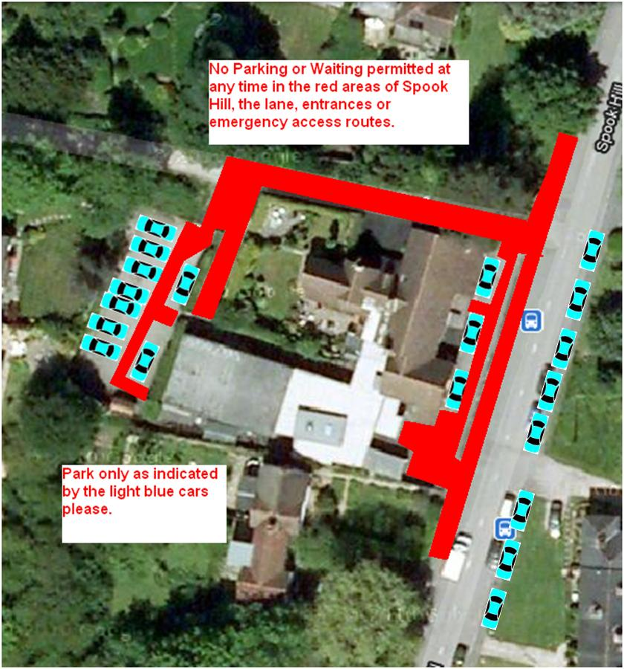

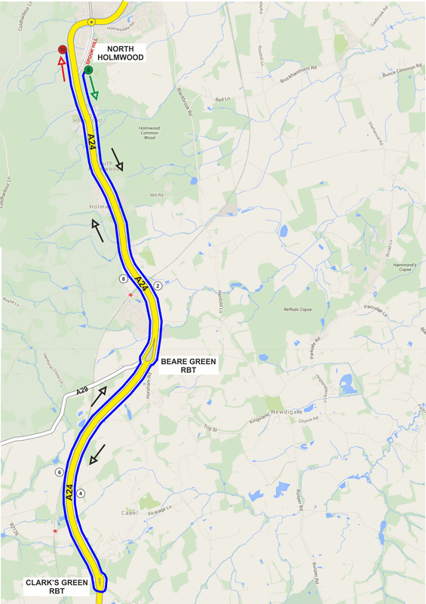
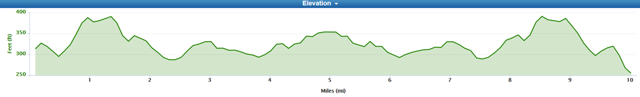

NUMBERS MUST BE FIXED BELOW WAIST

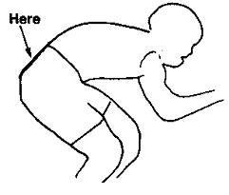

NO TIME MAY BE RECORDED IF NUMBER IS NOT CORRECTLY POSITIONED.

