BRITISH EMERGENCY SERVICES TIME TRIAL CHAMPIONSHIPS 2017

15th-16th July 2017
Ponteland, Northumberland.

Hosted by GS Metro, on behalf of Firesport UK and Tyne and Wear Fire and Rescue Service

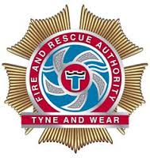

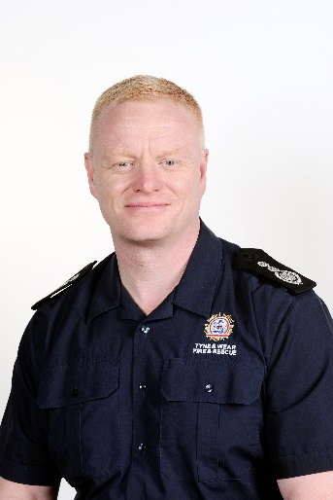
Chief Fire Officer’s welcome
We welcome teams and individuals from :
Fire and Rescue Service
Police Service
Ambulance Service
Prison Service
Mountain Rescue Service
For 2017 we welcome old friends, and hopefully new ones, from our colleagues in other blue light services. You are all particularly welcome, and I hope your visit to the North East forges great friendships and rekindles old ones.
Many FRS members, friends and family have worked tirelessly to make your stay enjoyable. Tyne and Wear is renowned for its sport and hospitality; they form an integral part of our culture. It is with immense pride that we are hosting this year’s National Emergency Services Time Trial Championships
Although all our visitors are here to enjoy their stay, essentially the weekend is about cycle time trials over ten and twenty five miles for the honour of being called the National Emergency Services Champion. In the time honoured tradition “let the competition begin”.

CFO Chris Lowther
Tyne and Wear Fire and Rescue Service

GS Metro welcome
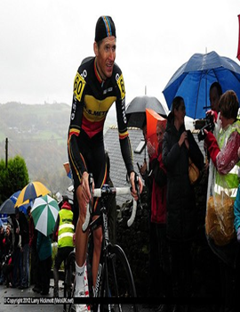

I am delighted that Andy Hall asked me to write a brief introduction to the Emergency Services Championships being held up here in Northumberland. As Chairman of the North East district committee it is fantastic to welcome all the current and previous personnel from our fabulous emergency services to our region.
I think recent events in the UK really emphasise to us all the incredible work and pressure that our services operate under. I hope that you all have a great weekend racing on two of our sporting courses. Neither of the courses would ever be sought out by folk chasing a rapid 10 or 25 – but both events will produce a fair and honest winner – good luck to you all.
I also extend the welcome from our club GS Metro whom Andy Hall and Nev Martin are active racing members. We are a small club, a close knit band of predominantly racing or ex-racing men and women whom boast amongst the membership two CTT National champions – Mick Bradshaw who won the 50 champs and Danny Grieves who is the current National 12 Hour Champion.
We’re hosting the national hill climb in October of this year so perhaps we can welcome some of you back on the last Sunday of October if there are any skinny young whippets amongst you.
Best of luck to all competing and a big thanks to Andy for pulling the championships together.

Ben Lane
GS Metro

Saturday 15th July - 10 mile Time Trial Championships

HQ – Ponteland Leisure centre, Callerton Lane, Ponteland, Northumberland, NE20 9EG
Course – M105 (Ponteland-Ogle-Belsay-Ponteland)
Sign on opens – 1300
First rider off – 1400

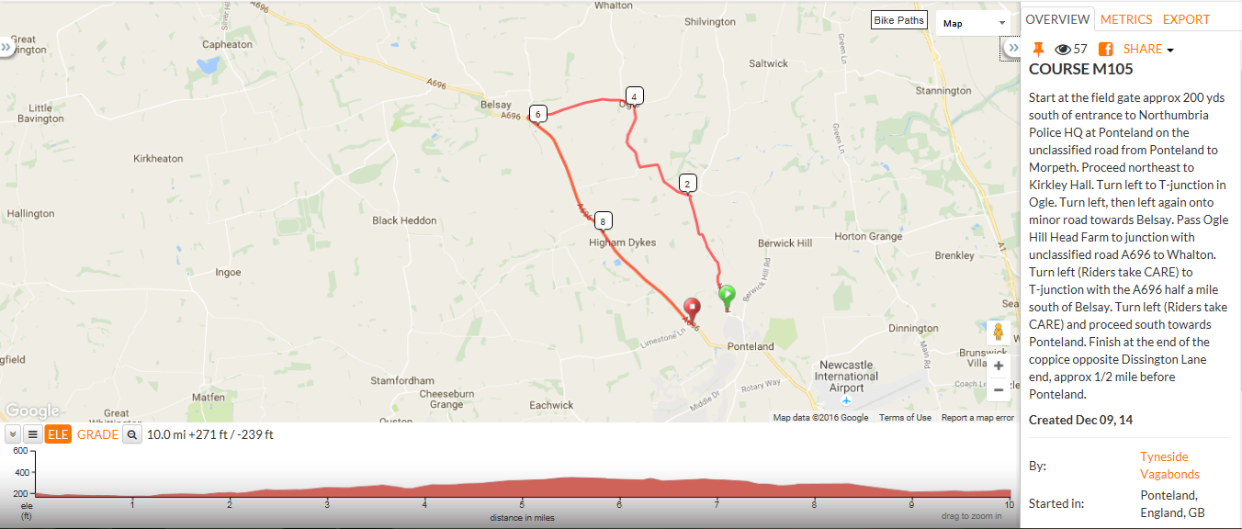
Sunday 16th July – 25 mile Time Trial Championships

HQ - Ponteland Leisure centre, Callerton Lane, Ponteland, Northumberland, NE20 9EG
Course – M254 (Ponteland – Kirkwelpington – Ponteland)
Sign on opens – 0700
First rider off - 0800

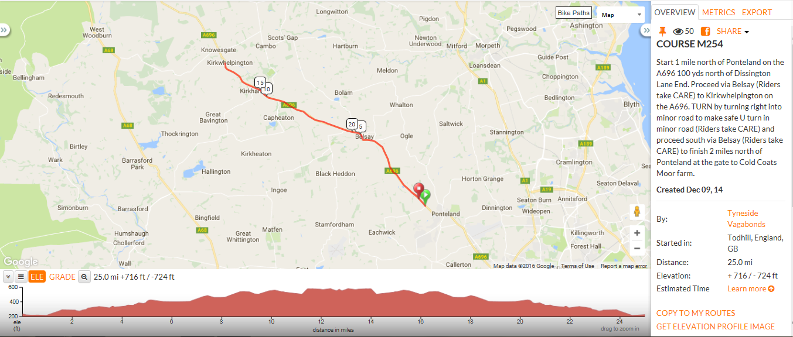

Competitors information
Event Secretary: Andy Hall, 3 Astley Gardens, Seaton Sluice, Whitley Bay, Tyne and Wear, NE26 4JJ. Tel: 07809442904. Email: Andrew.hall@twfire.gov.uk
Event Headquarters: Ponteland Leisure Centre, Callerton Lane, NE20 9EG
Directions to Headquarters from A1 : Turn off A1 at A696 Jedburgh/Airport. At roundabout follow Jedburgh/Ponteland/Airport A696. Remain on A696 until traffic lights within Ponteland Village, turn left onto Callerton Lane/B6323. Event HQ is on left.
Please park with respect for the locals within the village, an area at the HQ will be available for warming up on turbo trainers, however parking may be limited.
Shower and changing facilities will also be available within the HQ. Refreshments will be available after both races, with the awards and results following the 25 mile.
Numbers and signing on: Body numbers will be used, these are to be collected in person when signing on. Numbers are to be returned as you sign out. Failure to sign on and out will result in the rider being recorded as a DNF on the results.
At the sign on please check your details are correct, tick which service you will be representing and indicate with an ‘R’ if you wish to be considered for the Road Bike category.
All riders must personally make themselves available at the HQ following their ride, as they may be required for drug testing, if UKAD are in attendance.
Safety Matters:
In the interest of your own safety, Cycling Time Trials and the event promoters strongly advise you to wear a HARD SHELL HELMET that meets an internationally accepted safety standard. In accordance with regulation 15 all junior competitors must wear Protective Hard Shell Helmets.
It is recommended that a working rear light either flashing or constant is fitted to the machine in a position visible to following road users and is active whilst the machine is in use.
Please be aware that the marshals are there for your safety and not to control traffic. Take extra care at the Kirkwelpington U-turn on the 25 mile course, ensure you go around the marshal. Signs and marshals will be visible on the day to direct you, but please take time to familiarise yourself with the course maps I have provided.
There shall be no U turns undertaken within sight of the time keepers. The HQ is roughly 1 mile away from the start of each race, please allow ample time to arrive.
Categories and prizes: I won’t go into prizes just yet, as new prizes are arriving daily and I would not want to miss anything out!
Categories in which riders will be competing are as follows –
Overall male, female, V40, V50 and Road bike. 10 mile male, female, V40, V50 and Road bike. 25 mile male, female, V40, V50 and Road bike. Team prize for overall fastest 3 riders from a service.
Prizes will be awarded on conclusion of the 25 mile race. One prize per rider, that of the highest value.
Sponsors: We have multiple sponsors for the event, all of which have given very generously to allow the event to go ahead. Please take a moment to visit their websites. Thanks to the following -
KMC Chains http://www.kmcchain.eu/
Michelin Tyres https://bike.michelin.com/en/
Vredestein Tyres https://www.vredestein.co.uk/bicycle/tyre-finder/
Girodana http://www.myteamgiordana.co.uk/
The Badger and Bear Outdoor Adventure http://www.badgerandthebear.co.uk/
Thank you: The most important bit, without the following we might have a race but it wouldn’t be half as good! If I’ve missed you off its nowt personal…maybe, just maybe you could have done more!!!
Ben Lane, Dawn Sherrin, Chris Dixon, Peter McGrath, Ben Osborne, Dennis Fuller, Dave Linsley, Peter Stronach, Paul Hartley, Sharon Dyson, Ewa Johnson, Richy Kirby, Mark Breeze, Mac, Pete Nicholls, Jeff Crawford, Chris Smart, Sam Nicholson, Nev Martin, N&DCA, GS Metro, Great Britain Fire Service Cycling, Tyne and Wear FRS Triathlon and their odd outfits. And finally my family.

Cheers
Andy Hall
GS Metro

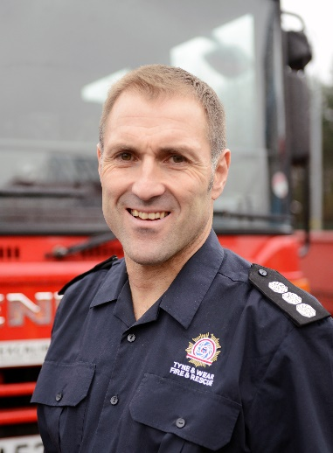
Closing words

After twelve months of preparation and planning the Emergency Services National Time Trial Championships will draw to a close on Sunday 16th July.
The Championships are all about competition, but it is also aimed at bringing as many differing emergency services together on one weekend to enjoy the competition and camaraderie that our services and region has to offer. It is also about encouraging participation for the first time at this level, and encouraging the next generation of emergency service workers to develop our sport and participate for years to come.
I hope that you have enjoyed the hospitality the region has to offer, and it has left you wanting to return again in the not too distant future.
It only remains for me, on behalf of the organiser, his support team and Tyne and Wear Fire and Rescue Service, to wish you a bon voyage and a safe journey home.

SM David Linsley
Secretary TWFRS CC Time Trial Section.

