Prize list for HCC 10m TT on Sunday the 25th of June

Part of the YCF Spoco series

1st Fastest Rider £30
2nd Fastest Rider £20
3rd Fastest Rider £10

1st Woman £30
2nd Woman £20
3rd Woman £10

1st Vet 40; Vet 50; Vet 60/70 Male and Female £10 each

1st Junior Male £15
1st Junior Female £15

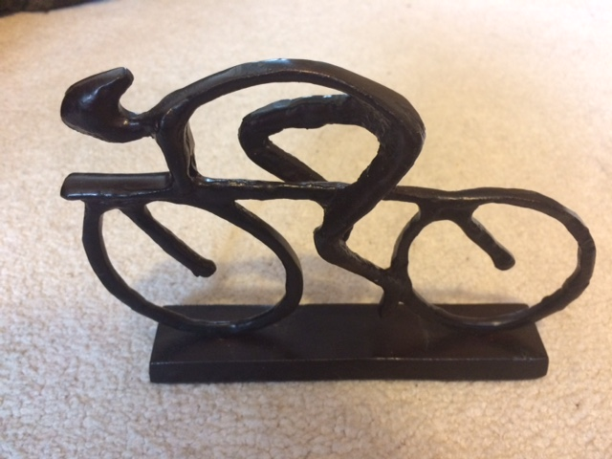
Most improved rider on the day (from their current PB) will win the following trophy which can be engraved at our expense (donated)
ONE RIDER ONE PRIZE
(Except for the trophy)

We are using all income to give out in prizes so we hope you will come along and give your best efforts to win something! See you Sunday.
HQ open from 8:30 a.m. Look for signs to TT HQ.

