CHIPPENHAM & DISTRICT WHEELERS

This event is being promoted for and on behalf of Cycling Time Trials under their Rules and Regulations.

OPEN 25 MILE TIME TRIAL
Gary Woodward Trophy Event (Chippenham & District Wheelers riders)

Sunday 25 June 2017. Time of start – 09:30 hours

Chippenham & District Wheelers riders will be competing for the Gary Woodward Trophy presented by his family in memory of Gary Woodward. The Trophy will be presented at the Chippenham & District Wheelers Annual Dinner.

EVENT OFFICIALS
Event Secretary
Paul Winchcombe Chippenham & District Wheelers
4 Farmhouse Court
Melksham
Wiltshire
SN12 6FG

Tel: 07752372309

Timekeepers
Start: Mrs S Andrews Chippenham & District Wheelers
Finish: Mrs S Edwards Chippenham & District Wheelers

Officials
Start: Mr J Tyzack Chippenham & District Wheelers
Finish: Mr M Edwards Chippenham & District Wheelers

EVENT HQ:
Little Somerford Village Hall, Mill Lane, Little Somerford, SN15 5JW
- Refreshments
- Toilets
- Numbers and Signing On
- Prize Presentation
- There are no changing facilities at the Event HQ, so please change considerately

Event HQ should be open from 0800 hrs

There is limited parking at the HQ so please park considerately in the village. Please do not obstruct the road outside the headquarters entrance.

In the interests of your own safety, Cycling Time Trials and the event promoters strongly advise you to wear a HARD SHELL HELMET that meets an internationally accepted safety standard. Riders signing the entry form state their conversance with Cycling Time Trials Rules and Regulations and agree to observe them.

COURSE DETAILS

Please note as the HQ is in Little Somerford we have had to amend the course. Please study the course carefully.

To reach start from event HQ ride north into Little Somerford, at the T-junction turn left and go towards The Hill (do not go across the road up Clay Street).

- LIMIT U TURNS TO AN ABSOLUTE MINIMUM AND QUEUE TO START IN SINGLE FILE.
- PLEASE DO NOT WARM UP PAST THE START AREA.

START: Start in Bus Stop area on The Hill, Little Somerford (OS ST966849) south of B4042

Turn left onto B4042 proceed west toward Malmesbury RAB with A429.
Circle RAB and come back east on B4042 towards Brinkworth and Royal Wotton Bassett. Proceed eastward, passing through Brinkworth and The Common to Ballards Ash junction with B4696 (just before the M4 motorway). Left onto the B4696 (sign posted Ashton Keynes, Cricklade, Cirencester). After approximately 2 miles, take the left turn at Braydon Cross (sign posted Garsdon). Towards Baydon Manor and Minety.
At X-roads on B4040 (Minety) turn left and proceed westward through Charlton to Malmesbury Watertower RAB. Turn left at RAB south on A429 towards RAB with A429/B4042. Turn left at RAB back onto B4042 east towards Brinkworth to finish eastern end of layby opposite Clay Street/B4042 Junction by Lovett Farm. (OS ST973850)

DO NOT STOP on finishing; continue along the road till you can find a safe place to stop and then turn. The route back to the HQ is down Clay Street opposite the finish.

Important Notes
1. The course is generally expected to be quiet during the event
2. There are two sharp corners:
• In Charlton: This corner is blind to oncoming traffic, so take care
• Between Charlton and A429, crossing river bridge: This corner has good visibility, however unless you brake early you will cross the line, so look out very carefully for oncoming traffic.
3. We are likely to be low on marshals, so the onus is on the rider to know the course but all turns will be signed

Please remember to sign out at the HQ after the event when returning your number

https://ridewithgps.com/routes/20370301

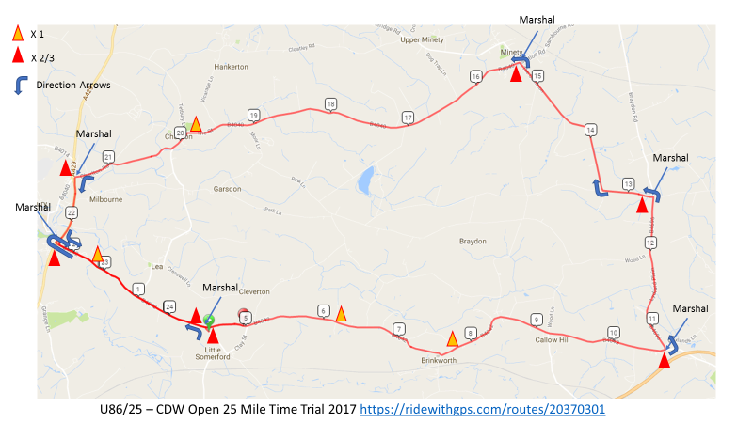

PRIZE VALUES

Overall |  | Vets |  | .
1st Place | £15.00 | 1St Vet Overall | £15.00 | 1st Prize Lady | £15
2nd Place | £10.00 | 2nd Vet Overall | £10.00 | Team Prize | £30
3rd Place | £5.00 | 1st Place V40 | £10.00
 |  | 1st Place V50 | £10.00
 |  | 1st Place V60 | £10.00

One prize per rider. In the event of a multiple claim the greater value prize will be awarded.

Prizes will be presented at the Event HQ immediately following the event.

ORDER OF START
(Riders please note your names appear as they are entered in the CTT database. I have not put capital letters for Christian and Surnames – you may wish to amend your details in the CTT database. )
Start Time | Rider Number |  | Rider | Club | Cat
09:31 | 1 | Andy | Cook | Chippenham & District Wheelers | V5
09:32 | 2 | Chris | Broad-Drake | Swindon Road Club | V6
09:33 | 3 | Joanne | Jago | Performance Cycles CC | Lady
09:34 | 4 | Robert | Hutchinson | Western Time Trails Association | V6
09:35 | 5 | Peter | Garnett | Swindon Road Club | V4
09:36 | 6 | Jonathan | Griffin | Cycology Bikes | V5
09:37 | 7 | Graham | Morrison | Newbury RC | V4
09:38 | 8 | Paul | Cann | Salt and Sham Cycle Club | V6
09:39 | 9 | Geoffrey | Baker | Velo Club Bristol - Webbs Cycles | V6
09:40 | 10 | Steven | Cottington | Bath Cycling Club | V5
09:41 | 11 | Andrew | Bradshaw | Bristol South Cycling Club | V4
09:42 | 12 | Paul | Freegard | Chippenham & District Wheelers | V6
09:43 | 13 | Tony | Emery | Dursley Road Club | V6
09:44 | 14 | Robin | Johnson | Brighton Mitre CC | V6
09:45 | 15 | Ruan | Bester | Bath Cycling Club | Senior
09:46 | 16 | Lloyd | Dobson | VeloVitesse/ALLCAP/James Barry/Johnson Controls – Hitachi | Senior
09:47 | 17 | Chris | Lowe | Swindon Road Club | V5
09:48 | 18 | simon | davis | Midlands VTTA | V4
09:49 | 19 | Mary-Jane | Hutchinson | Bristol South Cycling Club | Lady
09:50 | 20 | Josh | Griffiths | Bristol South Cycling Club | Junior
09:51 | 21 | Iain | Stuart | Bristol Road Club | Senior
09:52 | 22 | Andrew | Spearman | Chippenham & District Wheelers | V5
09:53 | 23 | Paul | O'Driscoll | Team Swindon Cycles | V4
09:54 | 24 | Jacqueline | Wadsworth | Severn Road Club | Lady
09:55 | 25 | Simon | Coles | Northover VT / Rudy Project | V4
09:56 | 26 | Leigh | Pinchen | Northover VT / Rudy Project | V4
09:57 | 27 | Simon | Martin | Bath Cycling Club | V4
09:58 | 28 | Stephen | White | Dursley Road Club | V4
09:59 | 29 | David | Summers | Bath Cycling Club | V4
10:00 | 30 | David | Janes | Veloton | Senior
10:01 | 31 | Mark | Ashurst | Northover VT / Rudy Project | V4
10:02 | 32 | Simon | Kay | Chippenham & District Wheelers | V4
10:03 | 33 | ben | eley | Frome and District Wheelers | Junior
10:04 | 34 | Steven | Barber | VTTA West Group | V4
10:05 | 35 | James | Cook | Cycology Bikes | Espoir
10:06 | 36 | Jenny | Simmonds | London Dynamo | Lady
10:07 | 37 | Casimir | Ludwig | Bristol Road Club | V4
10:08 | 38 | Jim | Beales | Dursley Road Club | V5
10:09 | 39 | Danny | Halpin | Bristol CX | V4
10:10 | 40 | Rob | Pears | Bath Cycling Club | V5

