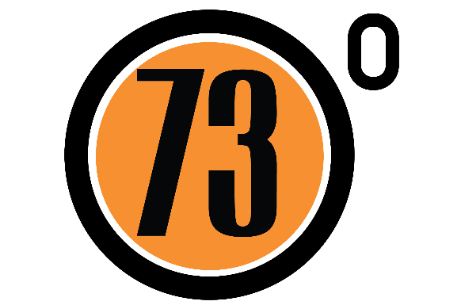

**WTTA Hardriders 2017**

**ON SUNDAY JUNE 4th 2017, STARTING AT 09:10 HOURS**

**Time Keepers: Ian Boon and Bridget Boon**

**HEADQUARTERS**

NR The Burrington Inn

Burrington Combe

NR Bristol

BS40 7AT

*Please do not park in front of the café. Signing on will be in the layby by the start . Make room for others if possible. Additional parking is available just down the hill*

*Please also remember this is a café so please be considerate of the café owners and customers.*

*Signing On/HQ is Open from 8am*

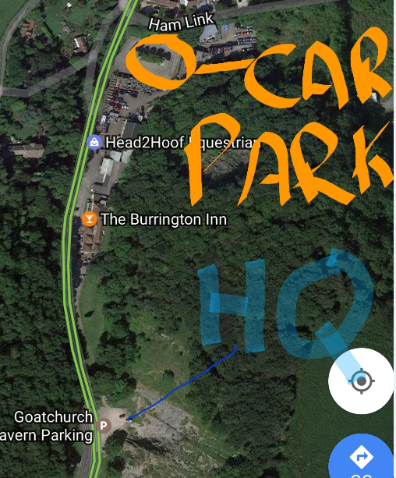

**PRIZE LIST**

**1 Prize per winner (Except Team Prize)**

**Scratch:** 1st £30 2nd £20 3rd £10

**Non Aero**  1st £30 2nd £20 3rd £10

**Vets:** 1st £20 2nd £15 3rd £10 **Women:** 1st £30

**Team:** 1st £10 per rider

**Please remember to sign out after returning your number otherwise you will be parked down as DNF**

***Cycling Time Trials Ltd recommends the use of hard shell helmets in time trials***

**Organiser (entries)** :

Glyndwr Griffiths –

Email: dggriffiths@hotmail.co.uk

Mob: 07425133091

*This event is run for and on behalf of Cycling Time Trials under their Rules and Regulations*

**U28 – Course Description**

**Start is opposite the car park**

**It is the RIDERS responsibility to know the course. This course is a hilly and therefore as well as including some climbing this also includes some fast technical descents. We advise all riders to pre ride the descent before racing in the event.**

**Please be careful and remember that your safety is important to us as a team.**

**Course Description:**

Start 20 Metres after first Cattle grid up Burrington Combe

At 3.3 km at the top of Burrington Combe carry straight on

At (5.7 Miles) 9.2 km turn sharp left onto Gibbet Brow/Old Bristol Rd/Harptree hill

**\* Caution Technical Descent \***  
At (8.2 Miles) 13.3 km turn sharp left at the bottom of Harptree hill to head onto A368  
Continue on this road through Compton Martin

At (11.8 Miles) 19 km in Blagdon turn left to head up hill on Street End to join Rodyate then Two trees

At (13 Miles) 21 km turn left at T junction to head onto the B3134.  
At (16.7 Miles) 27 km turn sharp left to turn onto Gibbet Brow/Old Bristol Rd/Harptree hill

**\* Caution Technical Descent \***  
At (19.3 Miles) 31 km turn sharp left at the bottom of Harptree hill to head onto A368  
Continue on this road through Compton Martin

At (22.9 Miles) 36.8 km in Blagdon turn left to head up hill on Street End to join Rodyate then Two trees

At (23.9 Miles) 38.4 km Finish on brow of hill next to lay by 30 metres before the Junction

**Ride with GPS link -** [**https://ridewithgps.com/routes/14651366**](https://ridewithgps.com/routes/14651366)

**CTT link - https://cyclingtimetrials.org.uk/race-details/12492**

Directions From the finish to HQ

At the T junction after the finish turn right onto B3134(caution brow of hill). Descend hill for 2 miles back to the HQ.



