Bossard Wheelers CC
Start sheet for the Bossard Wheelers Open 10 to be held on Saturday 3rd June 2017 on the F11/10 course starting at 8.01 am

To be held “ For and on behalf of Cycling Time Trials under their rules and regulations”

Event secretary: Geoff Bunyan, Kirriemuir 35 Chandos Road, Buckingham. MK18
Tel 01280822326 or 07913363296

Event HQ : Aston Clinton School, Twitchell Lane, Aston Clinton, Bucks, HP22 5JJ ( open from 7 am )

Time keepers :- Mr Tony Farmborough and Mr Vince Freeley

Course Details are: F11/10 (Tring & Aston Clinton by-passes)
Start on southbound sliproad to A41 on the Western Tring junction approx 40 yards from the start of the sliproad. Proceed along A41 to come off at first sliproad (Eastern Tring junction) to
Turn (approx 2.0 miles) by taking 4th exit out of RAB and under the A41, going around 2nd RAB to take 2nd exitback onto the A41 westbound and continue past all junctions to RAB at end of Aston Clinton by-pass to

Turn (7.87 miles) by taking 3rd exit out of RAB back along the by-pass, again ignoring College Road junction to

Finish on Buckland sliproad 9 yards south-east of manhole cover on grass verge, about 91 yards nth-west of (i.e.before) separation of slip road and main carriageway, also about 460 yards nth-west of the B489 overbridge.

Every effort will be made to have marshals at points where there is a change of direction, however the onus is on the rider to know the course.

Important Notice

The finish of the course is in the slip road. All riders must pass within 2.5 metres of the white line de-marking the left edge of the carriageway of the slip road. Failure to do this will lead to a DNF If you impede a vehicle you risk disqualification

There must be no parking of motor vehicles on any part of the A41 apart from those of the officials. All parking must be in the HQ car park. Do NOT obstruct other road users or driveways outside the school.

You must sign on in advance of your start at the headquarters where you can pick up your number and receive any last minute instructions or warnings. Please return number with all pins after you have ridden. DO NOT fold numbers at all. DO NOT use sticky tape (or other sticking methods) to secure the numbers to your clothing.

Please keep your head up at all times. At roundabouts the traffic coming from the right has priority over you, so please give way. In particular the first one at the bottom of the off slip road does not have good line of sight for traffic coming from the right so please take great care here. Be prepared to stop if need be.

Local Regulation 1. – No U Turns should be made at any time while riding on the public highway.

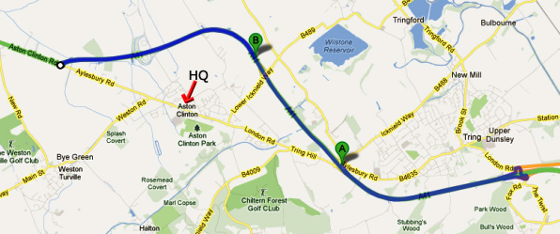

Please be aware that the first 2 miles does have a number of potholes (mainly caused by the older surface expansion joins failing) so look well ahead at all times. There are a few more after the first turn for the next 2 miles. However the remaining 6 miles are very good.

HQ to start route (blue route A to B) – please note that almost half of this is uphill so allow at least 15 minutes to get to the start from the HQ

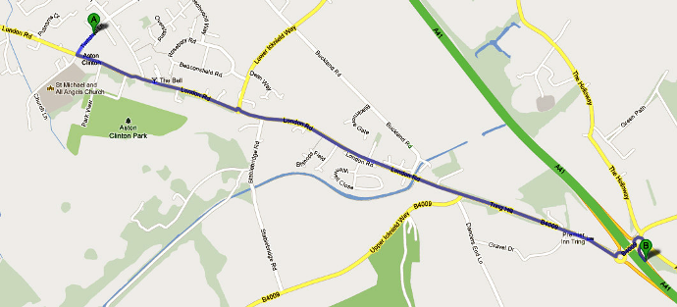

Prizes:
Men (Scratch) Ladies
1st £30 £15
2nd £25 £10
3rd £20
4th £15

London North Regulations

LOCAL REGULATION No. 1 No U turns should be made in sight of the start or finish areas while riding on the public highway.

LOCAL REGULATION No. 2 Competitors, their helpers and event officials must use the toilet facilities provided at event headquarters as required. Fields and hedgerows must NOT be used for toilet purposes. Failure to observe this regulation may result in disciplinary action against those concerned.

LOCAL REGULATION No. 3 No cars other than that of the timekeeper(s) and other event officials are to be parked in the vicinity of the start or finish points.

