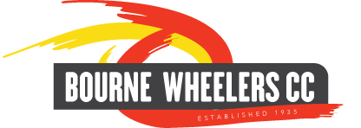

Bourne Wheelers Open 10 Mile Time Trial
(Promoted on behalf of Cycling Time Trials under their rules and regulations)

Sunday 14th May 2017 at 9am
Course C10/10

HQ- The Horseshoes, London Road Silk Willoughby, Sleaford, Lincs. NG34 8NZ

Event Secretary – Julia Kettle, School House, Edinburgh Crescent Bourne, PE10 9DU

Time Keepers: Stephen Walker & Sharon Fensom

Prize Winners | 1st | 2nd | 3rd
 | £30 | £20 | £15
 | James Gelshorpe (Peterborough CC) | Antony Gough (Velo One CT) | Simon Pitchford (Fenland Clarion)

