[**www.poolewheelers.com**](http://www.poolewheelers.com)



**POOLE WHEELERS SUMMER**

**OPEN 10 MILE TIME TRIAL**

**SUNDAY 17th July 2016**

**START SHEET**

**Timekeepers: Bev Wadsley, Poole Wheelers**

**Ros Spencer, Poole Wheelers**

**Recorder: Joan Price, Poole Wheelers**

**Event Organiser: Craig Weston, 29 Coppins Close, Ferndown, BH22 8FA**

**07866447210 CW10TT@icloud.com**

**AWARDS**

**Overall Vet On Standard**

**1st Fastest £40.00 1st Fastest £30.00**

**2nd Fastest £30.00 2nd Fastest £20.00**

**3rd Fastest £20.00 3rd Fastest £10.00**

**Seniors Ladies**

**1st Fastest £30.00 1st Fastest £20.00**

**2nd Fastest £20.00 2nd Fastest £10.00**

**3rd Fastest £10.00**

**Fastest Team of Three £10.00 each Fastest Junior £15.00**

**New Course Record £50.00 (Current course record: Chris Ball 18.51)**

**COURSE P415**

**START:**

**At the entrance to the Ryvita Factory on Old Wareham Road approximately 300 yards east of the roundabout at the junction with the A3049 (Dorset Way). Proceed west and take first exit at the roundabout then proceed along the A3049 via Fleetsbridge Flyover to Holes Bay Roundabout where take second exit (straight on) along the A35 to the Bakers Arms Roundabout. Circle and retrace along the A35 and A3049 to FINISH before the white footbridge over the A3049 near the slip road to Canford Heath.**

**TAKE CARE WHEN APPROACHING THE DORSET WAY ROUNDABOUT WHICH HAS A FAST DOWNHILL APPROACH – GIVE WAY TO TRAFFIC ON THE ROUNDABOUT OR APPROACHING FROM THE RIGHT.**

**WHEN APPROACHING BAKERS ARMS ROUNDABOUT, COMPETITORS MUST KEEP TO THE LEFT UNTIL THEY HAVE PASSED THE LEFT HAND “REDUCE SPEED NOW” SIGN.**

**NOTE THAT THERE ARE EMERGENCY TRAFFIC LIGHTS AT HOLES BAY ROUNDABOUT FOR THE FIRE STATION. MARSHALS HAVE BEEN TOLD TO TAKE RIDER NUMBERS DOWN FOR DISQUALIFICATION IF THE LIGHTS ARE IGNORED.**

**DO NOT STOP AT THE FINISH BUT RETURN TO RACE HQ.**

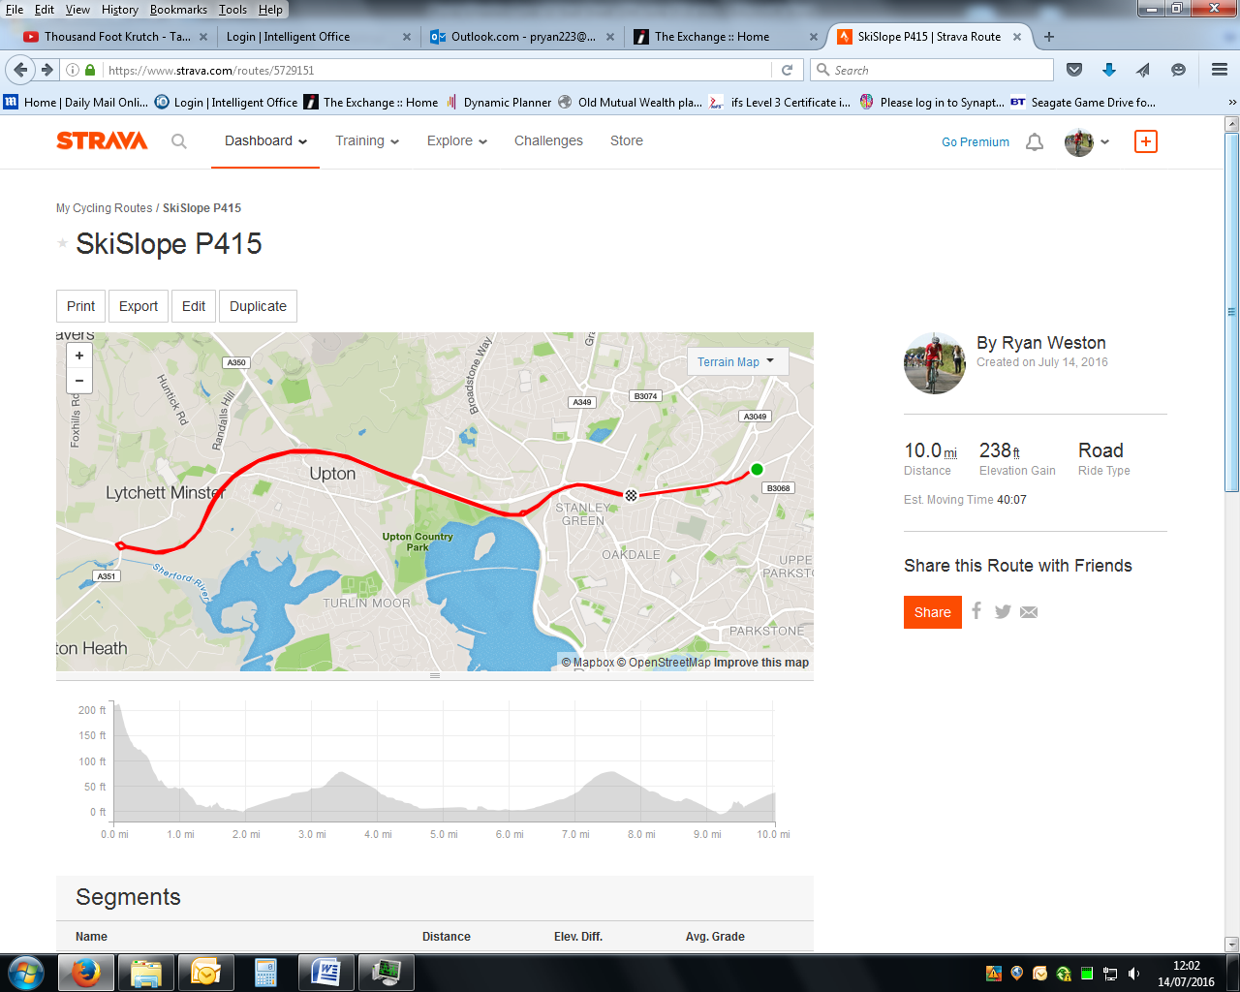

**EVENT HQ:**

**Cuddles day Nursery, Learoyd Road, Canford Heath, Poole. BH17 8PJ**

**Parking – all vehicles must be parked at the event headquarters or there is limited parking at the industrial estate just before the start. Please remember that this is a residential area so PLEASE KEEP THE NOISE DOWN. Allow enough time to get to the start as it is all uphill, remembering to continue past the start to turn at Newtown Roundabout, no U turns in the vicinity of the start please and strictly no parking in the vicinity of the start or finish. Riders must not stop or park in the Ryvita Factory entrance car park. Numbers and signing on will be at the HQ, numbers can be exchanged at the HQ for a drink.**

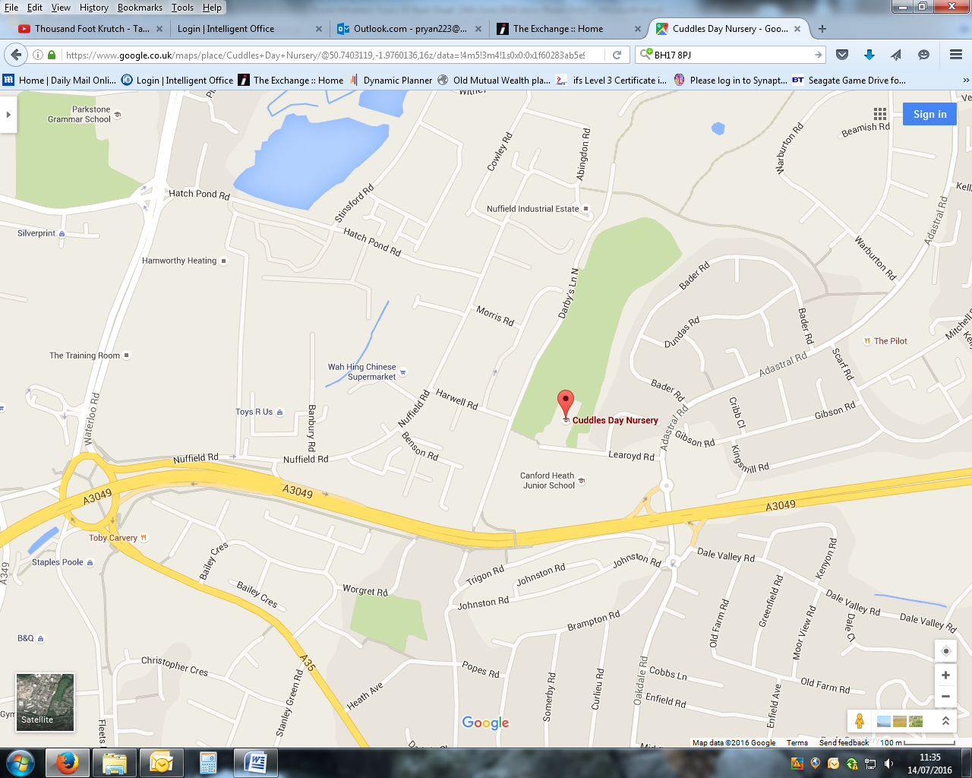

**Riders attention is drawn to CTT regulations, particularly 14, 15, 17, 18, 19, 20 and 21**

**Observers may be in attendance along the course.**

**IN THE INTERESTS OF YOU OWN SAFETY CYCLING TIME TRIALS STRONGLY ADVISE YOU TO WEAR A HARD SHELL HELMET THAT MEETS INTERNATIONAL SAFETY STANDARDS.**

**IT IS RECOMMENDED THAT A WORKING REAR LIGHT, EITHER FLASHING OR CONSTANT ARE FITTED.**

**HEADS UP – ACCIDENTS DOWN!!!!!!!**

**Promoted for and on behalf of Cycling Time Trials under their rules and regulations.**