CHESTER ROAD CLUB Open Hilly 15m Time Trial

Incorporating W.C.T.T.C.A Round 1 of 11

Saturday February 24th 2024, Time of Start 2:00pm

Promoted for and on behalf of Cycling Time Trials under their Regulations

Timekeepers
Geoff Chaplin, Alistair Wren
Event H.Q.
Farndon Community Club, Sibbersfield Lane, Farndon, Cheshire. CH3 6NX.
Please park responsibly in the club car park and leave room for access. Number collection and sign on/off from 1pm onwards.
Course Description D15/3
Start on A534 opposite grid in lay-by (marked in white paint) ¾ ml East from junction with B5130. Proceed West from Start on A534 in the direction of Wrexham to 1st Traffic Island (Llan-y-pwll) just past Waterways Garden Centre. 4.2mls. Turn Left at 1st exit towards Wrexham Industrial Estate. Proceed to Traffic Island. 5.1mls. Turn Right at third exit on to Abenbury Way to head West and encircle Wrexham Industrial Estate in an anticlockwise direction. Turn Left at Bryn Lane. 6.9mls. Proceed North to Traffic Island 8.2mls and Turn Right at third exit to retrace original course. Proceed to Llan-y-pwyll Traffic Island and bear Right back on to A534. Proceed back down the A534 to Finish at grid situated at the end of the small layby just prior to Township Close in Clutton. 15.21mls.

IMPORTANT INSTRUCTIONS TO ALL COMPETITORS
Please note CTT regulations requiring a working front as well as rear light and the compulsory use of helmets for all competitors:
In accordance with Regulation 14(i) No competitor shall be permitted to start unless such competitor has affixed to the rear of their machine a working rear red light, either flashing or constant, that is illuminated and in a position that is clearly visible to other road users.
In accordance with Regulation 14(j) No competitor shall be permitted to start unless such competitor has affixed to the front of their machine a working front white light, either flashing or constant, that is illuminated and in a position that is clearly visible to other road users
In accordance with Regulation 15 - All competitors must wear a properly affixed helmet which must be of hard/soft shell construction. Helmets should conform to a recognised Standard.
AT NO TIME SHOULD RIDERS PERFORM U-TURNS IN THE ROAD
PLEASE KEEP YOUR HEAD UP AT ALL TIMES
There will be a separate start line official checking compliance with the regulations. Any competitor not in compliance will not be allowed to start.
Route to/from Start
The start is located in the westbound layby on the A534, approximately 3/4 mile East from the junction with B5130, Sibbersfield Lane. The course uses the A534 in both directions at this point, so we advise riders to cross the A534 carefully to B5069 and use Wetreins Lane / Stretton Hall Lane and then turn left onto the A534 to reach the start layby. Note this is approximately 4 miles distance, so leave sufficient time. See below:
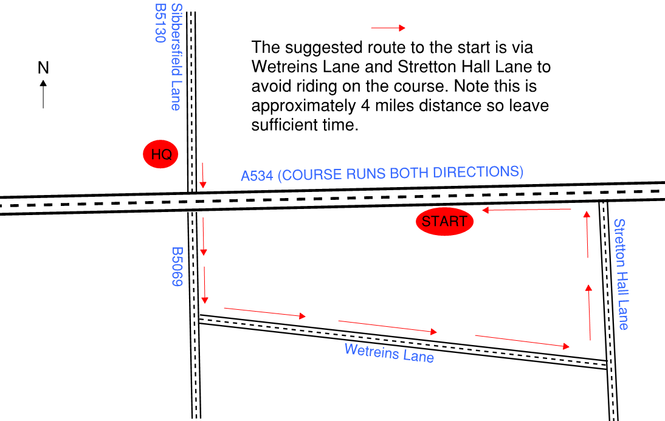
After finishing, be aware that the direct route back to HQ along the A534 passes the start. Please be courteous to riders starting their event when using this route.
Additional Course Safety Notes
Llan-y-pwll roundabout is encountered twice at 4.2 miles and 9.1 miles. This is a large and potentially busy roundabout with 5 exits. Do not use tri bar position at this junction.

Awards – to be awarded for both TT and Road Bike categories
Overall: 1st £30, 2nd £25, 3rd £20
Ladies: 1st £30, 2nd £25, 3rd £20
(2nd/3rd places awarded if 5 or more female starters)
Juniors/Juvenile: 1st £30
Veteran on standard: 1st £20, 2nd £15, 3rd £10 - using standard VTTA 15 mile times.
Team, Fastest 3: £15 each
One prize only per rider except for the team prize.

