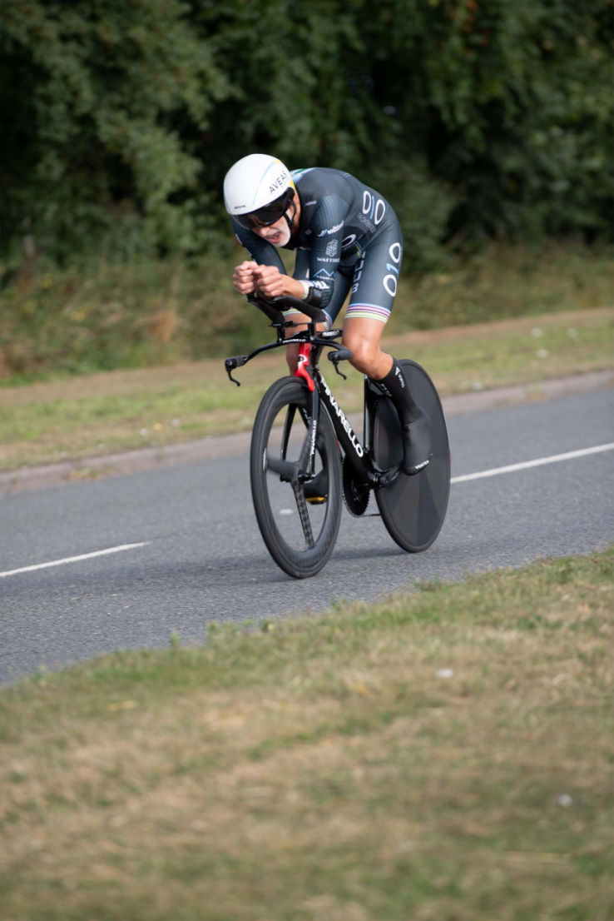
S V T T A
15 Miles Speed Family Trophy
24th September 2023
Organised by SVTTA
Promoted for and on behalf of Cycling Time Trials
under its Rules and Regulations

SCOTTISH VETERANS TIME TRIALS ASSOCIATION

15 Miles
(Speed Family Trophy)

Promoted by George McLaughlan, 151 Netherton Road, Wishaw

24th September 2023 – 8.00 am start

Course WM.15/01
Promoted for and on behalf of Cycling Time Trials
under their Rules and Regulations

Event Secretary Contact Details Timekeepers
George McLaughlan Mhairi Laffoley
151 Netherton Road Catriona Stirling
Wishaw
ML2 0AR
Email: gmclaughlan41@gmail.com

RIDERS’ NOTES
- HEADQUARTERS

Cambusbarron Community Hall, Cambusbarron, FK7 9NU (Open from 7am)

- PARKING –

Some spaces at the HQ and we have been given permission to use parking at the Bowling Club otherwise parking is on-street (please be careful not to block drives etc). There will be NO parking at either start or finish

- REFRESHMENTS
There will be some light refreshments at HQ.

- SIGNING ON AND OFF

HQ will be open from 7am for sign on/off. Numbers will be available at HQ. It is compulsory for all riders to sign on AND sign out after completing the event. Do not forget to sign out or you may be disqualified from the event.

- Start:

The start is on the A811 approximately ½ mile to the East of the Kersebonny Road end, Cambusbarron. It is approx. 1 ½ miles from the event HQ.

The start is accessed from Cambusbarron village by turning right from the HQ entrance, proceeding into the village, turning right down Mill Brae after about a quarter of a mile and left onto Mill Road, which leads to Kersebonny Road. Turn right at the end of the Kersebonny Road (please take extra care as you will be turning over the course/traffic and riders will already be underway) and head East towards Stirling Castle. Cross the motorway flyover and the start is approx. 320 m west of Clay Toll Roundabout.
Please DO NOT warm up on the course but note that you will need to cross through the finish line to make your way to the start. If you are on the way to your start DO NOT adopt a racing position as you go through the finish area to avoid confusion for the timekeeper and take care not to interfere with those racing.
- Map from HQ to Start

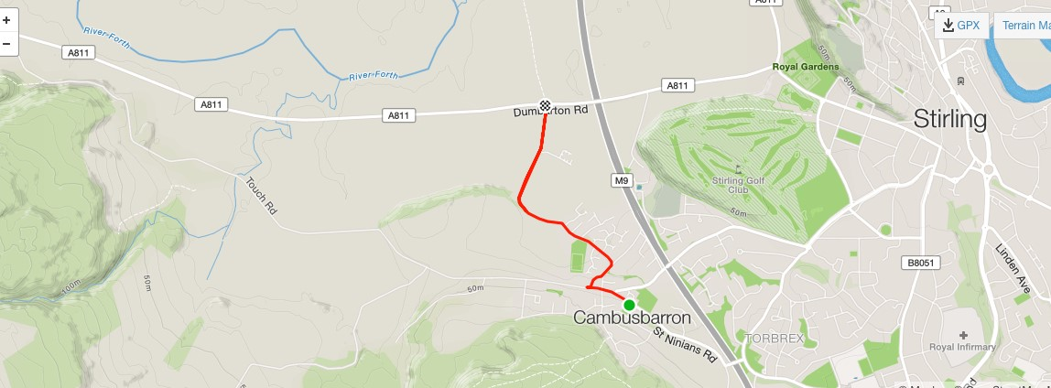

- COURSE DETAILS
The course is an out and back along the A811. From the start it heads west to turn at the Kippen roundabout. There will be Marshals at this point. They are not allowed to stop traffic so riders must adhere to highway code when negotiating the roundabout. Retrace along the A811 crossing over the motorway flyover and finish at the entrance to Falleninch Farm. On your return to the HQ please be considerate whilst riding on A811 back to Kersebonny Road as there will be other riders who have just started their race.
Please note that the event is on an “A” class road and therefore can be busy with traffic – care should be taken at all times and the Highway Code adhered to.

- SAFETY AND LOCAL REGULATIONS
Warming Up - Please DO NOT warm up on the course once the event has started but note that you will need to cross through the finish line to make your way to the start. If you are on the way to your start DO NOT adopt a racing position as you go through the finish area to avoid confusion for the timekeeper and take care not to interfere with those racing. Also on returning to HQ when you finish please make sure you do not interfere with those racing.
Cycling Time Trials now require that all riders must wear a hard shell helmet that meets an internationally accepted safety standard. (CTT regulation 15)
Working rear and front lights, either flashing or constant, must be fitted to machines in a position visible to road users and must be active whilst the machine is in use. (CTT regulations 14(i) and 14(j))

- RESULTS AND PRESENTATION - There will be a prize presentation after the event.

PRIZES
SVTTA (AAT) SVTTA Team (AAT) Tandem (AAT)
1st 1st 1st
2nd
3rd
4th
5th
Fastest Male Fastest Female
1st 1st
2nd 2nd
3rd 3rd
Spot Prize (Closest to) Lantern Rouge

- START SHEET

No | Start  Time | Name | Club | Bike (TT, Road, Trike) | Age | Age Adj
1 | 8.01 | George Adam | SVTTA | Road | 63 | 0:03:14
2 | 8.02 | Thomas Cummings | Fife Century RC | TT | 75 | 0:06:27
3 | 8.03 | George Skinner | Royal Albert | TT | 78 | 0:07:35
4 | 8.04 | Jennifer Nicol | Velo Club Vitesse | TT | 65 | 0:07:48
5 | 8.05 | Andrew Wilson | St Christopher’s CC | TT | 73 | 0:05:47
6 | 8.06 | Elizabeth Clayton | RT23 | TT | 60 | 0:06:40
7 | 8.07 | Chris White | Fife Century RC | TT | 63
8 | 8.08 | Lindsay Foster | Ayrodynamics Tri | TT | 62 | 0:03:02
9 | 8.09 | Sarah Emslie | SVTTA | TT | 45 | 0:04:18
10 | 8.10 | Paul Wynne | Kinross CC | TT | 63 | 0:03:14
11 | 8.11 | Gail Paterson | Dumfries CC | TT | 44
12 | 8.12 | James Smith | Glasgow Nightingale | TT | 71 | 0:05:11
13 | 8.13 | Rachael Maxwell | Border City Wheelers | TT | 53
14 | 8.14 | Gary Longhurst | Stirling Bike Club | TT | 63
15 | 8.15 | Liz Ball | Valley Striders | TT | 70 | 0:09:11
16 | 8.16 | Miriam Rennet | Kinross CC | TT | 61 | 0:06:53
17 | 8.17
18 | 8.18 | Lorna/John Lumley | Ayrodynamics Tri | Tandem |  | 0:04:13
19 | 8.19
20 | 8.20 | Isobel Fletcher/  Allan MacLean | VC Glasgow South | Tandem |  | 0:04:30
21 | 8.21 | Robert Holmes | Kinross CC | TT | 52
22 | 8.22 | Carol Middleton | Ythan CC | TT | 63 | 0:07:19
23 | 8.23 | Bill Maxwell | Border City Wheelers | TT | 75
24 | 8.24 | Derrick John MacNish | Inverclyde Velo | TT | 56 | 0:01:59
25 | 8.25 | Steve Donaldson | Fullarton Wheelers | TT | 61 | 0:02:50
26 | 8.26 | Robert Brown | EH Star Cycling | TT | 79 | 0:08:01
27 | 8.27 | Valerie Martin | Dooleys RT | TT | 56 | 0:05:55
28 | 8.28 | Gerard McGuire | Pentland Velo | TT | 62 | 0:03:02
29 | 8.29 | Neil McLeod | SVTTA | TT | 49 | 0:01:00
30 | 8.30 | Alex McPhee | Dooleys RT | TT | 61 | 0:02:50
31 | 8.31 | Stephen Beecher | West Lothian Clarion | TT | 40
32 | 8.32 | Iain Wilson | Musselburgh RCC | TT | 60
33 | 8.33 | Gordon Murdoch | St Christopher’s CC | TT | 50
34 | 8.34 | Margaret McMillan | Deeside Thistle | TT | 59 | 0:06:28
35 | 8.35 | John Leal | Deeside Thistle | TT | 58
36 | 8.36 | Patricia Baird | Ecosse Performance CC | TT | 58 | 0:6:17
37 | 8.37 | Bud Johnston | SVTTA | TT | 64 | 0:03:26
38 | 8.38 | Clifford Degraff | Velo Club Cumbria | TT | 58
39 | 8.39 | Alex Munro | SVTTA | TT | 90 | 0:14:45
40 | 8.40
41 | 8.41 | Michael Perkins | Eat Plants Not Pigs | TT | 48
42 | 8.42 | Jon Fairclough | Kelso Wheelers | TT | 69 | 0:04:37
43 | 8.43 | Carolyn Chambers | North Argyll CC | TT | 37
44 | 8.44 | Thomas McNulty | SVTTA | TT | 51 | 0:01:16
45 | 8.45 | Brian Nicol | Velo Club Vitesse | TT | 61 | 0:02:50
46 | 8.46 | Andrew Yule | Deeside Thistle | TT | 59 | 0:02:28
47 | 8.47 | Kevin Lackie | RT23 | TT | 61 | 0:02:50
48 | 8.48 | Ian Dobbie | West Lothian Clarion | TT | 59 | 0:02:28
49 | 8.49 | Mike Giles | Ythan CC | TT | 58 | 0:02:18
50 | 8.50 | Andrew Bruce | Vanelli Project GO | TT | 52 | 0:01:24
51 | 8.51 | Ian Elliot | Hawick CC | TT | 73 | 0:05:47
52 | 8.52 | Alastair Pell | Glasgow Nightingale | TT | 60 | 0:02:39
53 | 8.53 | James Muir | Glasgow Nightingale | TT | 60 | 0:02:39
54 | 8.54 | David Henderson | EH Star Cycling | TT | 54 | 0:01:41
55 | 8.55 | Graham Jones | Edinburgh RC | TT | 58 | 0:02:18
56 | 8.56 | Alan MacIntyre | Coatbridge Clarion | TT | 50
57 | 8.57 | Steven Purdie | Glasgow Green CC | TT | 52 | 0:01:24
58 | 8.58 | Warren Crombie | Musselburgh RCC | TT | 50
59 | 8.59 | Derek McMillan | SVTTA | TT | 63 | 0:03:14
60 | 9.00 | Carlos Riise | Shetland Wheelers | TT | 58 | 0:02:18
61 | 9.01
62 | 9.02 | Michael Curran | Ayr Roads CC | TT | 45
63 | 9.03 | Sean Quinn | Law Wheelers | TT | 50 | 0:01:08
64 | 9.04 | Stephen Spellacy | Dumfries CC | TT | 51
65 | 9.05 | James Cusick | Dooleys RT | TT | 58 | 0:02:18
66 | 9.06 | Richard Sanderson | Kinross CC | TT | 37
67 | 9.07 | Cameron Fraser | Sigma Sports/ Cannondale RT | TT | 42
68 | 9.08 | Craig O’Brien | Glasgow Wheelers | TT | 52
69 | 9.09 | Basil Monks | Edinburgh RC | TT | 35
70 | 9.10 | Angus Wilson | Dundee Thistle | TT | 54 | 0:01:41
71 | 9.11 | Sandy Waller | Edinburgh RC | TT | 26
72 | 9.12 | Marc Anderson | GTR Return to Life | TT | 45 | 0:00:32
73 | 9.13 | Robert Friel | Vanelli Project GO | TT | 42
74 | 9.14 | Alastair McNicol | Dooleys RT | TT | 33
75 | 9.15 | Douglas Watson | GTR Return to Life | TT | 50 | 0:01:08

