**The Start Care Joining Main Road!!!**

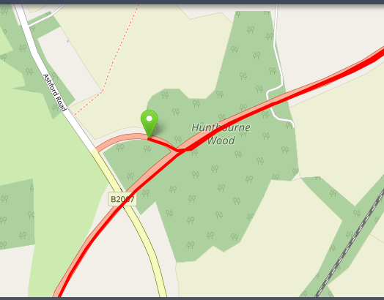

**From H.Q.**

**The Turn**

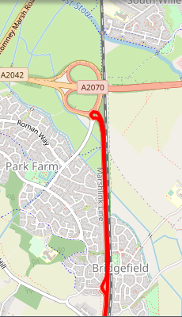 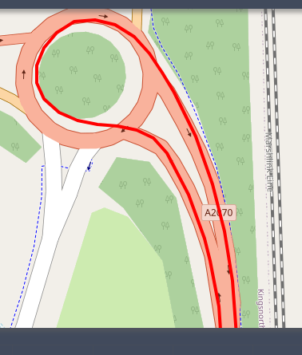

**Mini RAB Straight Over Both Ways**

**Left Turn Back Into The Village The Finish**

