

**BRIDGNORTH CYCLING CLUB**

**OPEN TIME TRIAL – 21MILE HILLY**

**Incorporating Round 2 of the SCCA Friction & Hydraulics Points Series**

Promoted for and on behalf of Cycling Time Trials under its Rules & Regulations

**Date:** 26th March 2023 **Course**: D21/22 **Start Time**: 10:00am **Timekeepers:** Dave York & Jenny York

**Event secretary**: Tim Beardmore, 42 Oaklands, Bridgnorth, Shropshire WV155DZ

Tel: 07866 726422 email: [mowermec@sky.com](mailto:mowermec@sky.com)

**Event HQ:** Morville Village Hall, Morville, Bridgnorth, WV165NB

At the Junction of A458 & B4368, take the B4368 past the rear drive entrance to Morville Hall. The Village Hall is on the left. There is parking at the village hall.

Competitor’s Notes: Each competitor must sign on when collecting AND WHEN RETURNING their race numbers at the HQ, this is a CTT Requirement. Failure to sign out will result in a DNF being recorded and no finish time given. Numbers should be pinned to the lower back area and be clearly visible.

Distance from HQ to start is 3.0 miles so allow adequate time. From the event HQ turn right, take the A458 to Bridgnorth. Do not perform a U Turn at the start, ride on past the start to the island with the B4364, encircle the island to the start approximately 100 yards on the left. Please avoid warming up on the course once the event has stated, instead use the B4364 for warm ups.

**CTT Regulation 14(i): NO LIGHT – NO RIDE**. No competitor will be allowed to start without a working front and rear light, either flashing or constant. It must be fitted to their machine in a position clearly visible to following road users and active whilst the machine is in use.

**CTT Regulation 15:** **NO HELMET- NO RIDE.** All competitors **MUST** wear a hard/soft shell helmet that meets internationally accepted safety standards.

**Liverpool District Local Regulation**: Riders must not make 'U' turns within sight of start and finish. Any rider observed making a 'U' turn in contravention of this regulation could be disqualified from the event. Any rider who makes repeated 'U' turns may be subject to disciplinary action. Competitors must not use any audio equipment except prescribed hearing aids. A competitor in breach of this regulation will be disqualified. Competitors must not use a mobile phone while mounted on their machine.

**Pusher Off**

There will be no pusher-off at the start so all riders must start with one foot on the ground.

**D21/22 COURSE DECRIPTION**

**\*DUE TO A POTENTIAL CLASH WITH A VINTAGE TRACTOR RUN THE COURSE HAS BEEN SHORTENED TO 18 MILES\***

**START:** At field gate on A4458 Bridgnorth By-Pass, just north of traffic island with B4364 (Ludlow Rd). Proceed along A458 through Morville to Much Wenlock (7.5 miles), take 1st left onto B4378. Proceed along B4378 through Bourton and Brockton to Shipton (13.9 miles), take 1st left on to B4368. Proceed along B4368 through Weston.

**FINISH:** Immediately after Monkhopton sign at entrance to Kytes Nest Farm (17.9miles).

There will be marshals positioned at the Much Wenlock turn (7.5miles) and Shipton Turn (13.9miles)

To return to the HQ continue on B4368 for 3 miles to Morville***.* Be aware there is potential for a large number of slow moving tractors to be on the road between the finish and the HQ**

**RIDER SAFETY**

This is a challenging technical course, a true test of rider and machine. There are climbs, steep descents and tight turns. It is strongly recommended that competitors familiarise themselves with the course. Please pay particular attention to:

* 7.5 miles A458 turn onto B4378. Turn is approached on a descent at speed. There is a strong possibility of stationary traffic waiting to turn right at multiple junctions on the approach to the turn. Do not attempt to overtake stationary traffic on the right.
* 10 miles B4378 at Bourton Village. Riders approach on a fast twisting decent, with junction with minor roads. Take care not to cross white line to centre of road on approach. Be aware of traffic.
* 11.9 miles B4378 at Brockton Village. Riders approach on a long fast decent to a cross roads with minor roads. Be aware of traffic.
* 13.9 miles B4378 turn onto B4368 at Shipton. Riders approach a very acute turn. Do not cross the white line to the centre of the road on approach or exit, and give way to traffic.

***HAVE A SAFE AND ENJOYABLE RIDE. KEEP YOUR HEAD UP AT ALL TIMES AND OBEY THE LAWS OF THE ROAD***

**OPEN TT AWARDS**

|  |  |
| --- | --- |
| Fastest Rider | £20 |
| Fastest Female | £20 |
| Fastest Vet on Standard | £20 |
| Fastest Junior | £20 |
| Fastest Team of 3 | £10 each |

**ROAD BIKE AWARDS**

|  |  |
| --- | --- |
| Fastest Rider | £20 |
| Fastest Female | £20 |
| Fastest Vet on Standard | £20 |

**One prize per person (except team prize)**

**ROAD BIKE CRITERIA**

• No tri bars, clip on bars or Spinaci bars

• No disc wheels. Both front and rear wheels must have a minimum of 12 spokes each. The maximum rim depth on

all wheels is 65mm

• No aero helmet or a helmet that covers the ears or a helmet with a visor is to be used

• Riders must not ride with their forearms resting on the handlebars at any time

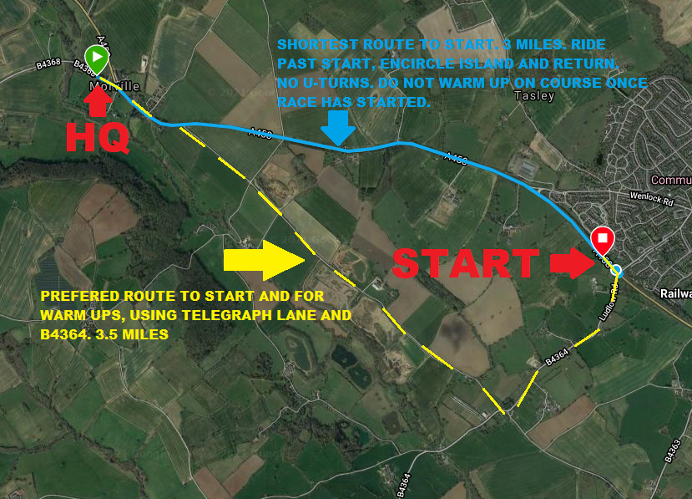**START SHEET**