Presents

MH26 Hill Climb Paradise Bank

To be held on Saturday 17th September 2022

Promoted for & on behalf of Cycling Time Trials under their Rules & Regulations

Event Secretary

John Sample
9 Thorntree Gill
Peterlee
SR8 4SP

07894964078

Timekeepers

Frances & Peter Schultz, Sharon Dyson

Event Team

HQ & Sign-on: Brian Ward, Col Humphrey, John Sample
Start area marshals: Ian Sime, Paul Ellison
On-course marshal: Paul Robson
Finish area marshal: Dave Loynes

HQ and Parking

HQ: Ludworth Community Centre, Ludworth, DH6 1NF

There will be parking available at the centre, if you need to park in the village please do so considerately.

The start of the climb is just under 1 mile from the HQ - allow yourself plenty of time to get to the start area.

Course - MH26

This event is being run on the MH26 course.

Paradise Bank, Shadforth (0.96 miles)

START on the minor Paradise Bank road and proceed south uphill, climbing for 0.4 miles before passing Ox Close Farm (on your left). The road dips before rising again for a further 0.4 miles to FINISH at marked drain cover approximately 100yds before the T-Junction with the A181.

Numbers & Results:

Sign-on will be open from 9am - All riders must sign the “signing on sheet” before collecting their numbers and must sign the sheet again when returning after their ride.
Please make sure your number is placed correctly on jerseys/skinsuits to assist time timekeepers. If the timekeepers are unable to read your number then the time may be void. There will be safety pins at the HQ.

Safety notes:

It is now compulsory to wear a helmet and have both front & rear working lights on your bike

The centre has kindly allowed us to use the toilets and the hall

Vehicles of competitors/officials/marshals/helpers to be parked safely and without hindrance to other road users.

Riders:
No U-turns to be made in the vicinity of the timekeeper.
No dismounting in the finishing area
All riders are responsible for their own safety
You must obey the rules of the road and obey all traffic signs, signage and direction
indicators
It is your responsibility to ensure that your machine is roadworthy and that you ride
safely at all times
You must look ahead and not ride with your head down
You must not take pace or shelter from any other vehicle or competitor (no drafting)
Failure to comply with the above may lead to disciplinary action being taken
No warming up on the course once the race has started - aim to arrive at the start no more than 5 minutes before your start time.
No dismounting by riders in finishing area.
Keep strictly to the correct side of the road

FARM / LITTER

Please take extra care when descending the hill climb on your way back to the HQ - an alternative loop is available which avoids this, see map below

Take your litter home, we have been in contact with the local farmers who are supportive of the event and want to retain this support.

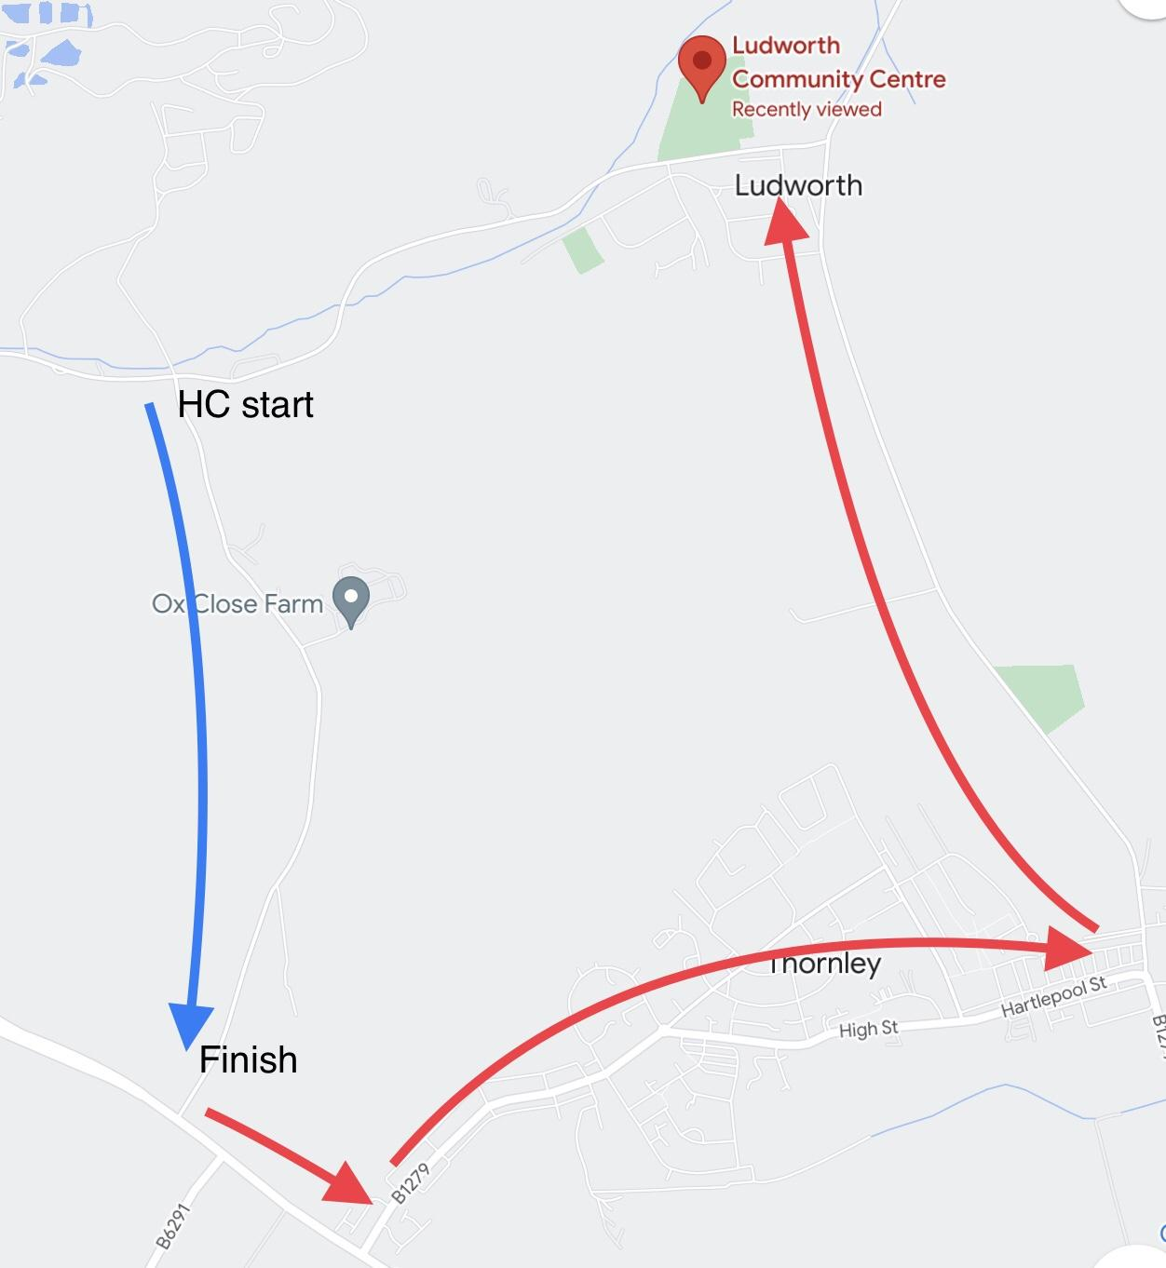

Prize list

Prize Money. One prize per person.

Mens Overall 1st £30, 2nd £20, 3rd £10
Womens Overall 1st £30, 2nd £20, 3rd £10

1st V40 / V50 / V60 £20

1st Juvenile £20
Team Category (3 team members combined) 1st £45, 2nd £15
82kg+ £20 There will be scales near sign on (shoes off) - state ‘82’ next to your name on the sign on sheet
Lantern Rouge £15

Spot prizes for places 7, 14, 21, 28, 35, 42

Fastest Protech Rider to be presented with the Steve Goodings Memorial Trophy

“It’s a hill, get over it”

