The 25/7 course
- Start on southbound side of Monmouth Road (unclassified) at approximately SO 38983 02022, opposite post between gates on right to farm buildings and to “Usk Castle Chase Natural Burial Ground”, 125 yards south west of "Bends for 1½ miles" sign on the old Usk/Raglan road.
- Proceed towards Usk. At the foot of the hill turn left and left again onto A472 and proceed to take left hand lane at Llangeview interchange to join the A449.
- Proceed via Raglan interchange where the road becomes the A40.
- Continue to pass picnic area (11.757 miles) and through tunnel (12.5 miles point is 100 yds inside the tunnel).
- After tunnel bear left and in 300 yards at garage turn left with great care onto B4293.
- Cross over tunnels and in 2/3 mile keep straight on, remaining on unclassified road (taking care at pedestrian crossing) to rejoin the A40 at Mitchel Troy. (Sign for “Mitchel Troy” at 14.367 miles)
- Retrace via Raglan interchange and at Llangeview bear left to leave A449 and proceed on A472 to finish opposite 2nd drain cover on right, 25 yards beyond telegraph pole DP63 and 350 yards beyond rear of sign reading A449/B4235 on approach to Usk.
There will be marshals stationed at key points around the course but please remember that they’re there for guidance only and have no authority to control traffic. Please take the time to familiarise yourself with the course – in particular we draw your attention to the following key points:

1.0 miles, foot of the hill, road sweeps around to the LEFT, take care
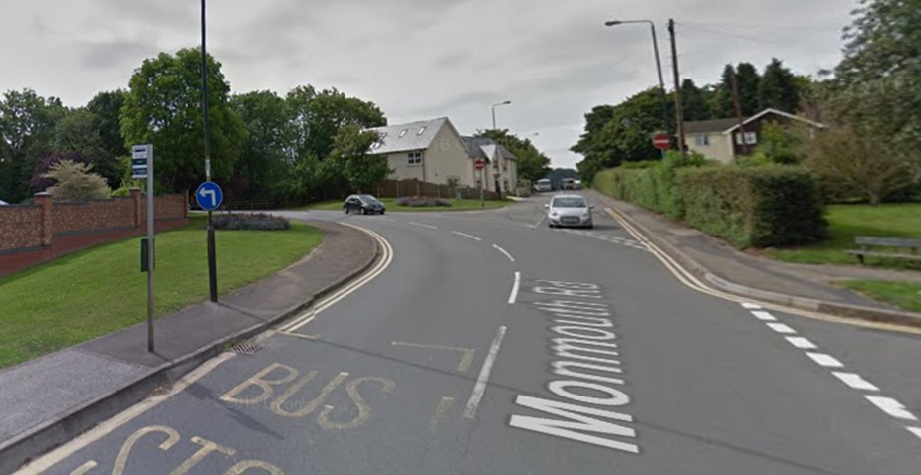

1.1 miles, junction ahead, turn LEFT but be prepared to GIVE WAY
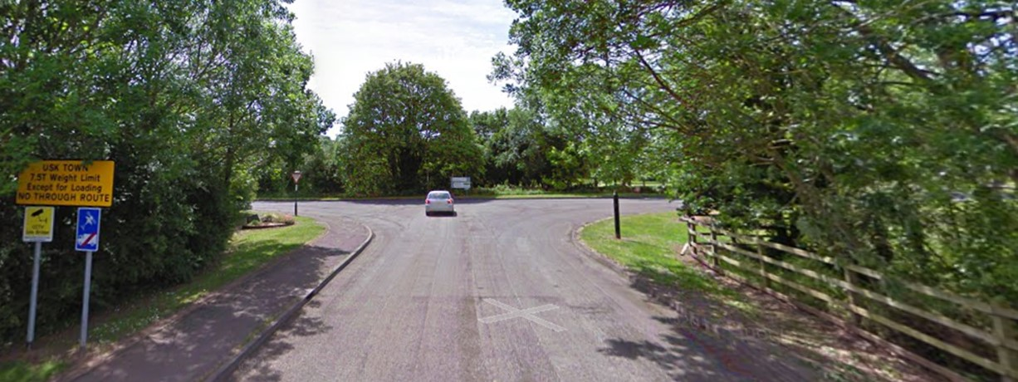

6.5 miles, REMAIN on the A449, if you took the exit ramp you wouldn’t be the first to do so but it’s not a club you want to join!
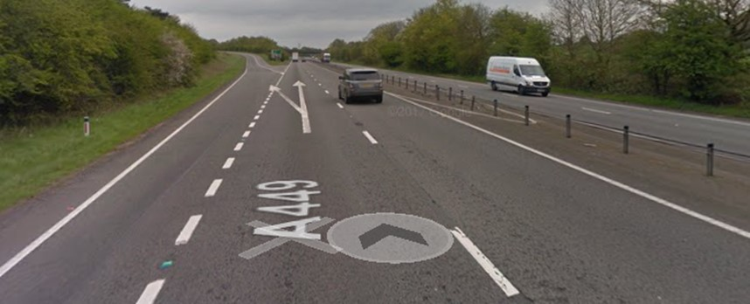

12.4 miles, approaching the tunnel, be prepared to turn LEFT on exit
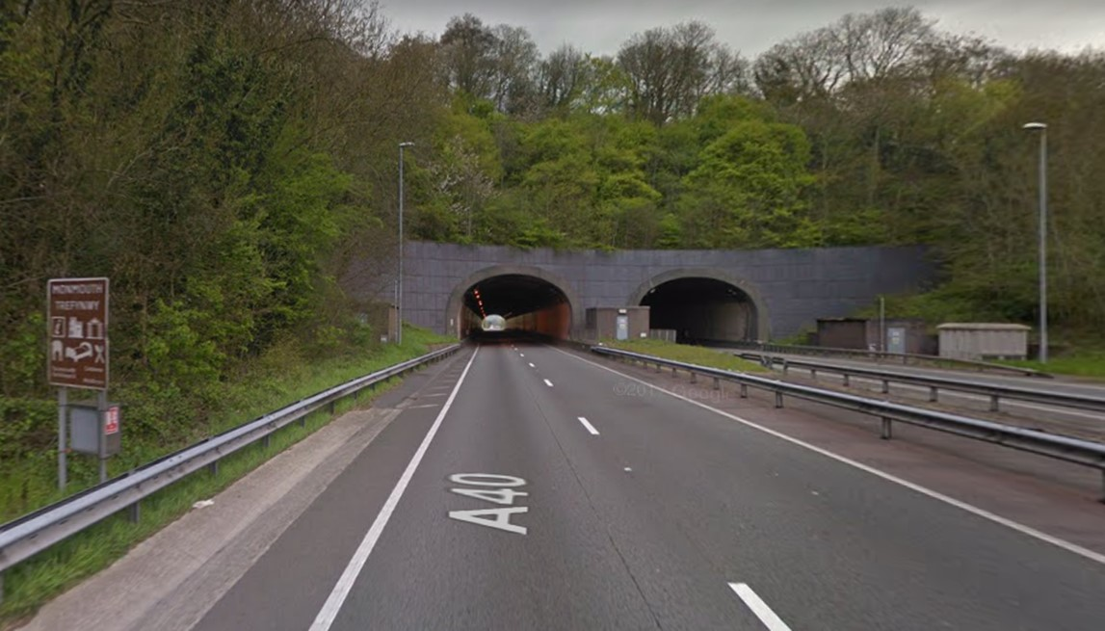

12.6 miles, emerging from tunnel, bear LEFT
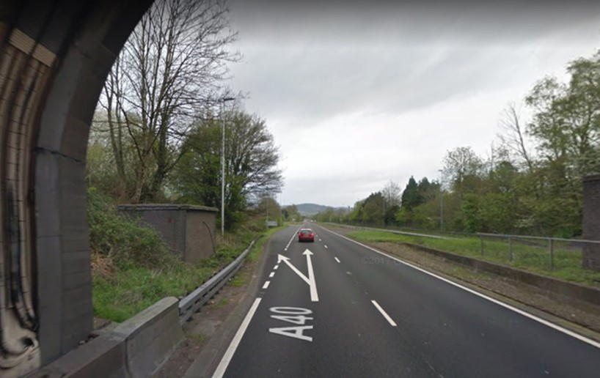

12.8 miles, passing the petrol station, then immediately turn LEFT with care at the mini-roundabout; don’t go straight on!
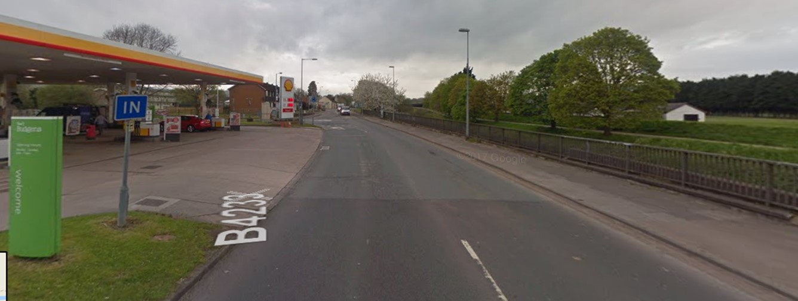

13.2 miles through to 15.0 miles, road surface on B4293 is less than ideal, pot-holes might be hard to spot under tree cover
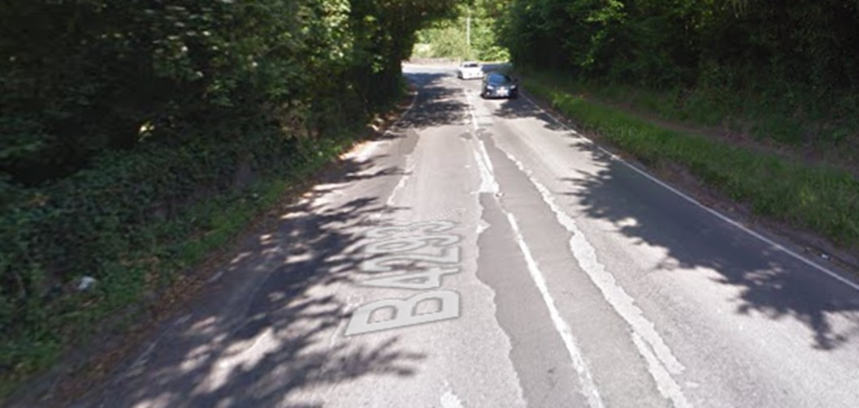

14.6 miles, keep RIGHT at the fork where the road becomes unclassified but soon merges right onto the A40; don’t go LEFT!
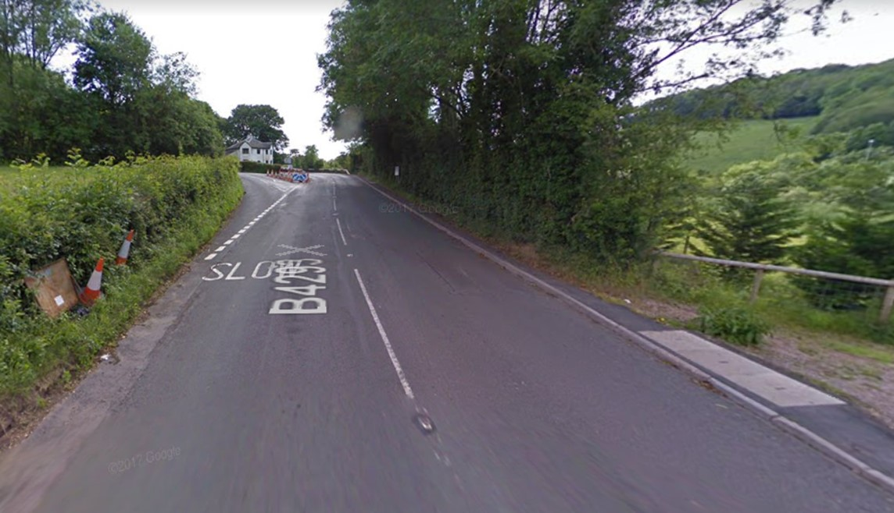

Digital readers can click here to view and download the course in Strava, GPX and TCX formats.

