LRRA 30 mile Results
(Promoted for and on behalf of CTT under their Rules & Regulations)
Sunday 4th. September 2016, Course C30/3
Event Secretary:- Martin Hedley, 18,Chapel Lane, Claypole, Newark, Notts.
Scratch Awards.
1st. Neil Palmer Velo-One Cycling Team 1 : 07 : 28
2nd. Jim Boyle Sleaford Wheelers CC 1 : 08 : 17
3rd. Antony Gough Velo-One Cycling Team 1 : 08 : 52

TEAM Award.
Velo-One Cycling Team 3 : 28 : 02
Neil Palmer, Antony Gough, Joshua Wallis

Handicap Awards
1st. John Pilgrim Witham Wheelers 0 : 56 : 50
2nd. Joshua Wallis Velo-One Cycling Team 0 : 57 : 32
3rd. Gary Symons Witham Wheelers 0 : 58 : 08

Veteran on Standard
1st. Michael Smalley Witham Wheelers + 19 : 10
2nd. Jim Boyle Sleaford Wheelers CC + 18 : 20
3rd. Peter Jones Lincoln Wheelers CC + 16 : 19

1st. Lady Louise George Witham Wheelers 1 : 22 : 06
1st. Junior Ehren Courtman Witham Wheelers 1 : 27 : 13
1st. Juvenile Samuel Howes Sleaford Wheelers CC 1 : 44 : 23

Prize for 1st Open Event Rider Michael Lamb Kiveton Park CC 1:13:40

Many thanks to all involved in making it such a fantastic Event

Bib NAME CLUB HCP TIME

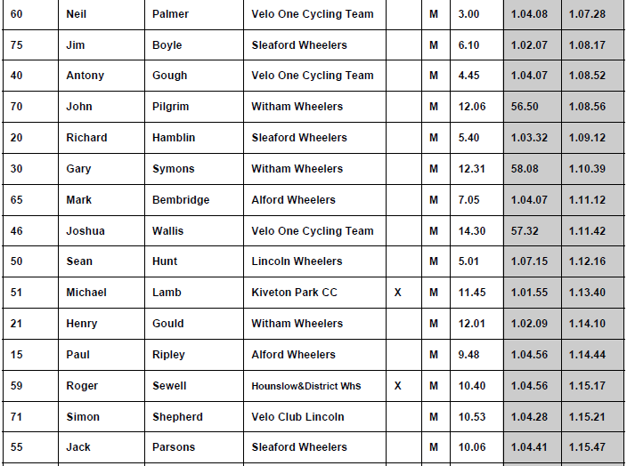
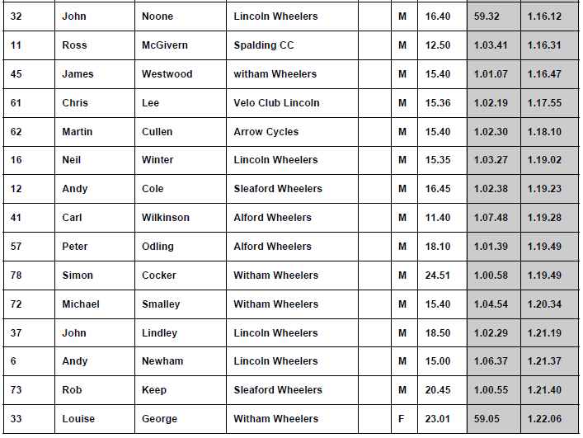

Bib NAME CLUB HCP TIME

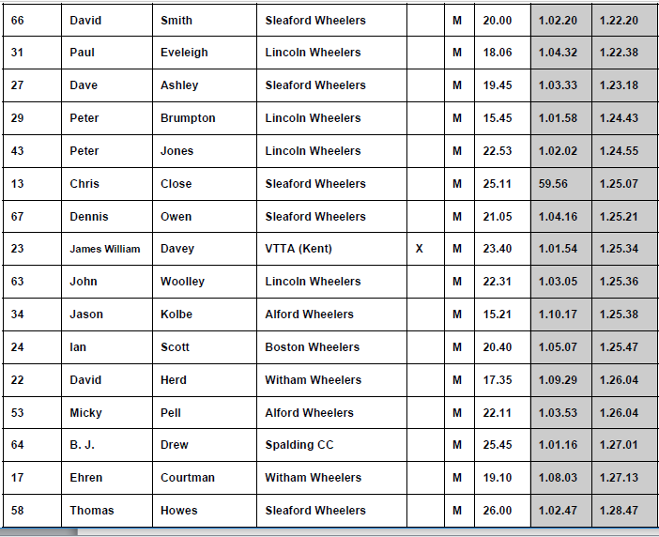
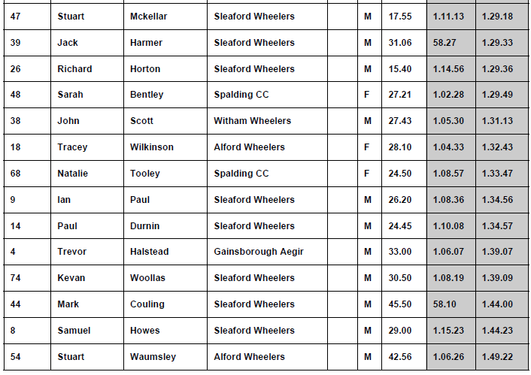
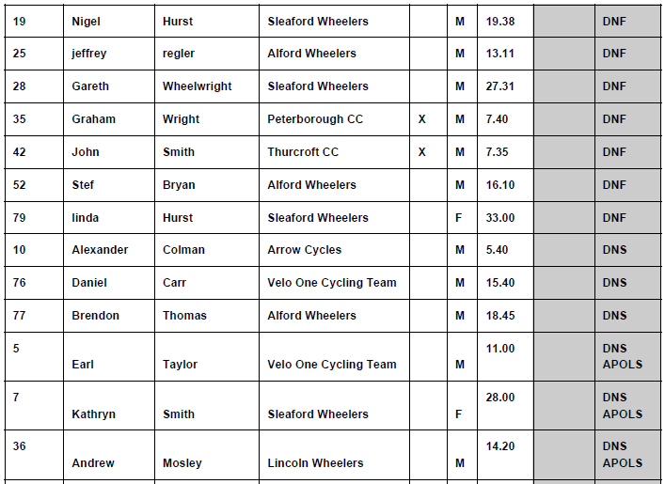
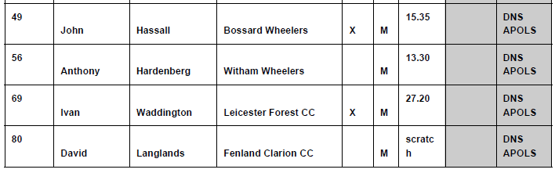
Bib | Forename | Surname | Club | Age | Vets | Act | Std
60 | Neil | Palmer | Velo-One Cycling Team(Staples Vegetables/Neil Palmer Electrical) | 45 | 1:22:13 | 1:07:28 | 0:14:45
75 | Jim | Boyle | Sleaford Wheelers CC | 52 | 1:26:37 | 1:08:17 | 0:18:20
40 | Antony | Gough | Velo-One Cycling Team(Staples Vegetables/Neil Palmer Electrical) | 42 | 1:20:24 | 1:08:52 | 0:11:32
70 | John | Pilgrim | Witham Wheelers | 33 | #N/A | 1:08:56 | #N/A
20 | Richard | Hamblin | Sleaford Wheelers CC | 38 | #N/A | 1:09:12 | #N/A
30 | Gary | Symons | Witham Wheelers | 43 | 1:21:00 | 1:10:39 | 0:10:21
65 | mark | bembridge | Alford Whs | 48 | 1:24:04 | 1:11:12 | 0:12:52
46 | Joshua | Wallis | Velo-One Cycling Team(Staples Vegetables/Neil Palmer Electrical) | 22 | #N/A | 1:11:42 | #N/A
50 | Sean | Hunt | Lincoln Whs CC | 52 | 1:26:37 | 1:12:16 | 0:14:21
51 | Michael | Lamb | Kiveton Park Cycling Club | 47 | 1:23:27 | 1:13:40 | 0:09:47
21 | Henry | Gould | Witham Wheelers | 36 | #N/A | 1:14:10 | #N/A
15 | paul | ripley | Alford Whs | 47 | 1:23:27 | 1:14:44 | 0:08:43
59 | Roger | Sewell | Hounslow & District Whs | 69 | 1:38:16 | 1:15:17 | 0:22:59
71 | Simon | Shepherd | Velo Club Lincoln (Pygott & Crone - Bang Olufsen) | 34 | #N/A | 1:15:21 | #N/A
Bib | Forename | Surname | Club | Age | Vets | Act | Std
55 | Jack | Parsons | Sleaford Wheelers CC | 23 | #N/A | 1:15:47 | #N/A
32 | John | Noone | Lincoln Whs CC | 50 | 1:25:20 | 1:16:12 | 0:09:08
11 | Ross | McGivern | Spalding CC | 38 | #N/A | 1:16:31 | #N/A
45 | James | Westwood | Witham Wheelers | 47 | 1:23:27 | 1:16:47 | 0:06:40
61 | Chris | Lee | Velo Club Lincoln (Pygott & Crone - Bang Olufsen) | 51 | 1:25:58 | 1:17:55 | 0:08:03
62 | Martin | Cullen | Arrow Cycles | 44 | 1:21:36 | 1:18:10 | 0:03:26
16 | Neil | Winter | Lincoln Whs CC | 59 | 1:31:16 | 1:19:02 | 0:12:14
12 | Andy | Cole | Sleaford Wheelers CC | 43 | 1:21:00 | 1:19:23 | 0:01:37
41 | Carl | Wilkinson | Alford Whs | 48 | 1:24:04 | 1:19:28 | 0:04:36
78 | Simon | Cocker | Witham Wheelers | 57 | 1:29:54 | 1:19:49 | 0:10:05
57 | Peter | Odling | Alford Whs | 56 | 1:29:14 | 1:19:49 | 0:09:25
72 | Michael | Smalley | Witham Wheelers | 71 | 1:39:44 | 1:20:34 | 0:19:10
37 | John | Lindley | Lincoln Whs CC | 62 | 1:33:18 | 1:21:19 | 0:11:59
6 | Andy | Newham (T) | Lincoln Whs CC | 43 | 1:27:55 | 1:21:37 | 0:06:18
73 | Rob | Keep | Sleaford Wheelers CC | 43 | 1:21:00 | 1:21:40 | 0:00:40
33 | Louise | George | Witham Wheelers | 51 | 1:31:16 | 1:22:06 | 0:09:10
66 | David | Smith | Sleaford Wheelers CC | 65 | 1:35:24 | 1:22:20 | 0:13:04
31 | Paul | Eveleigh | Lincoln Whs CC | 55 | 1:28:34 | 1:22:38 | 0:05:56
27 | dave | ashley | Sleaford Wheelers CC | 67 | 1:36:49 | 1:23:18 | 0:13:31
29 | Peter | Brumpton | Lincoln Whs CC | 46 | 1:22:50 | 1:24:43 | 0:01:53
43 | Peter | Jones | Lincoln Whs CC | 73 | 1:41:14 | 1:24:55 | 0:16:19
13 | Chris | Close | Sleaford Wheelers CC | 61 | 1:32:37 | 1:25:07 | 0:07:30
67 | Dennis | Owen | Sleaford Wheelers CC | 64 | 1:34:42 | 1:25:21 | 0:09:21
23 | James William | Davey | VTTA (Kent) | 71 | 1:39:44 | 1:25:34 | 0:14:10
63 | John | Woolley | Lincoln Whs CC | 70 | 1:39:00 | 1:25:36 | 0:13:24
34 | Jason | Kolbe | Alford Whs | 27 | #N/A | 1:25:38 | #N/A
24 | Ian | Scott | Boston Whs | 49 | 1:24:42 | 1:25:47 | 0:01:05
22 | David | Herd | Witham Wheelers | 68 | 1:37:32 | 1:26:04 | 0:11:28
53 | micky | pell | Alford Whs | 57 | 1:29:54 | 1:26:04 | 0:03:50
64 | B. J. | Drew | Spalding CC | 68 | 1:37:32 | 1:27:01 | 0:10:31
17 | Ehren | Courtman | Witham Wheelers | 16 | #N/A | 1:27:13 | #N/A
Bib | Forename | Surname | Club | Age | Vets | Act | Std
58 | Thomas | Howes | Sleaford Wheelers CC | 16 | #N/A | 1:28:47 | #N/A
47 | Stuart | Mckellar | Sleaford Wheelers CC | 59 | 1:31:16 | 1:29:18 | 0:01:58
39 | Jack | Harmer | Sleaford Wheelers CC | 54 | 1:27:55 | 1:29:33 | 0:01:38
26 | Richard | Horton | Sleaford Wheelers CC | 51 | 1:25:58 | 1:29:36 | 0:03:38
48 | Sarah | Bentley | Spalding CC | 58 | 1:36:06 | 1:29:49 | 0:06:17
38 | John | Scott | Witham Wheelers | 72 | 1:40:29 | 1:31:13 | 0:09:16
18 | TRACEY | Wilkinson | Alford Whs | 49 | 1:29:54 | 1:32:43 | 0:02:49
68 | Natalie | Tooley | Spalding CC | 57 | 1:35:24 | 1:33:47 | 0:01:37
9 | Ian | Paul | Sleaford Wheelers CC | 53 | 1:27:16 | 1:34:56 | 0:07:40
14 | Paul | Durnin | Sleaford Wheelers CC | 42 | 1:20:24 | 1:34:57 | 0:14:33
4 | Trevor | Halstead | Gainsborough Aegir CC | 58 | 1:30:35 | 1:39:07 | 0:08:32
74 | Kevan | Woollas | Sleaford Wheelers CC | 35 | #N/A | 1:39:09 | #N/A
44 | Mark | Couling | Sleaford Wheelers CC | 38 | #N/A | 1:44:00 | #N/A
8 | Samuel | Howes | Sleaford Wheelers CC | 13 | #N/A | 1:44:23 | #N/A
54 | Stuart | Waumsley | Alford Whs | 76 | 1:43:32 | 1:49:00 | 0:05:28

