Whitelow Lane Closed Road Hill Climb
Friday 1st July 2022 at 7pm.
Organised by 7 Hills CC, Sheffield
Promoted for & on behalf of Cycling Time Trials under its rules & regulations.
Event Secretary Allan Wailoo
8 Leyfield Rd, Dore, Sheffield S17 3EE
07736353817
a.j.wailoo@sheffield.ac.uk
Timekeepers Malcolm Smith - Finish
John Clarke - Start

Headquarters (marked on map below)
We are using Christ Church Dore Community Centre as HQ (marked on the map below) where you will need to sign in, collect your race number and sign out. Toilets are available. There is very limited parking at the Church Hall but there is plenty of on-street parking available not too far away in Dore.

PLEASE park without causing inconvenience for local residents. Don’t block driveways, including on the closed road. We need to maintain the support of the local community!

Dore Church Hall - Townhead Road, Dore, Sheffield, S17 3GA

Prizes:
Refreshments and prizes handed out after the event at HQ.
1st male under 16yrs | Veloviewer membership and cap, £25
1st female under 16yrs | Veloviewer membership and cap, £25
1st male vet (over 40yrs) | Veloviewer membership and cap
1st female vet (over 40yrs) | Veloviewer membership and cap
1st male overall | Veloviewer membership and cap
1st female overall | Veloviewer membership and cap

Plus one entrant, drawn at random, wins a Christmas tree thanks to GrowMeTrees (Whitelow Lane finish line).

Course description OHC21
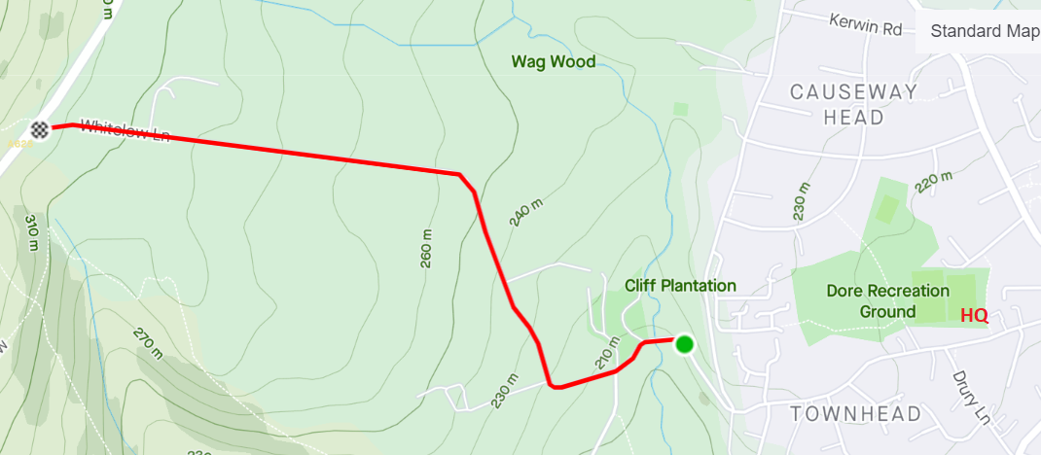
The road will be closed for the event. Other riders will be riding back down so you still need to keep to the left-hand side of the road.

Start in dip just before bridge over Redcar Brook. Proceed uphill past 2 house entrances on right, past Shorts Lane (no through road) and Roundseats Farm on left. Follow the road as it turns first right and then left. Finish opposite rough lay-by just before junction onto A625 Hathersage Road. (1620yds)

Key Instructions
- It is compulsory that working front and rear lights, either flashing or constant, are fitted to the machine in a position visible to following road users and is active whilst the machine is in use. EVEN THOUGH THIS IS A CLOSED ROAD EVENT, THIS RULE STILL APPLIES!
- ALL competitors must wear a helmet.
- If you have registered for the event as a member of 7Hills CC and require day membership, forms will be available at sign in.
- All under 16’s require parental consent forms to be completed. These will also be available at sign in.
- After competing, return your number and sign out.
- There will be no pusher off at the start and no catcher at the end.
- To avoid impeding other competitors, you must ride past the finish line before you stop and turn. No U-turns near the finish line.
- You may ride back down the course after you have finished but keep fully to the left and descend very slowly. Other competitors will still be racing on the course.
- Provisional results will be posted in real time with the link available here https://www.7hills.cc/events/whitelow-lane-hill-climb/ . Results will be provided via social media and the CTT website as fast as possible after the event.

number | start_time | firstname | lastname | club | Sex | category | age_on_day
1 | 19:01:00 | Emil | Howell | Matlock CC | Male | Juvenile | 15
2 | 19:02:00 | Lewis | Smith | Sheffield Youth Cycling Club | Male | Juvenile | 15
3 | 19:03:00 | Harry | Hudson | Matlock CC | Male | Juvenile | 14
4 | 19:04:00 | Alfie | Nott | Sheffield Youth Cycling Club | Male | Juvenile | 13
5 | 19:05:00 | Jude | Alcock | 7 Hills Cycling Club | Male | Juvenile | 12
6 | 19:06:00 | Benjamin | Taylor | Sheffield Youth Cycling Club | Male | Juvenile | 12
7 | 19:07:00 | Jamie | Brough | Matlock CC | Male | Juvenile | 12
8 | 19:08:00 | Charles | Van Adrichem | Matlock CC | Male | Juvenile | 11
9 | 19:09:00 | Joseph | Throp | Matlock CC | Male | Juvenile | 11
10 | 19:10:00 | Lydia | Turan | JRC Interflon Race Team | Female | Juvenile | 14
11 | 19:11:00 | Joe | Spiers | 7 Hills Cycling Club | Male | Juvenile | 8
12 | 19:12:00 | Oliver | Coefield | Sheffield Youth Cycling Club | Male | Juvenile | 9
13 | 19:13:00 | Austin | Wood | 7 Hills Cycling Club | Male | Juvenile | 8
14 | 19:14:00 | Olivia | Marriott | Derby Mercury R C | Female | Juvenile | 10
15 | 19:15:00 | Fenella | Wood | 7 Hills Cycling Club | Female | Juvenile | 10
16 | 19:16:00 | Pippa | Spiers | 7 Hills Cycling Club | Female | Juvenile | 7
17 | 19:17:00
18 | 19:18:00 | Jane | Harriman | Sheffield Triathlon Club | Female | Veteran
19 | 19:19:00 | Paolo | Coppo | Rugby Velo | Male | Veteran
20 | 19:20:00 | Joe | Kang | 7 Hills Cycling Club | Male | Senior
21 | 19:21:00 | Mark | Buskwood | 7 Hills Cycling Club | Male | Veteran
22 | 19:22:00 | Timothy | Shire | North Cheshire Clarion | Male | Veteran
23 | 19:23:00 | Hannah | Nicklin | Les Filles Racing Team | Female | Senior
24 | 19:24:00 | Mark | Newitt | 7 Hills Cycling Club | Male | Veteran
25 | 19:25:00 | Greg | Genna | Clapham Chasers | Male | Senior
26 | 19:26:00 | Ben | Sampson | 7 Hills Cycling Club | Male | Senior
27 | 19:27:00 | Kevin | Tang | 7 Hills Cycling Club | Male | Senior
28 | 19:28:00 | Hannah | Fawcett | Liverpool Braveheart Bicycle Club | Female | Veteran
29 | 19:29:00 | Mark | Harrison | 7 Hills Cycling Club | Male | Veteran
30 | 19:30:00 | Martin | Smith | 7 Hills Cycling Club | Male | Veteran
31 | 19:31:00 | Nathan | Thomas | 7 Hills Cycling Club | Male | Senior
32 | 19:32:00 | Glen | Mailer | Sheffield Triathlon Club | Male | Senior
33 | 19:33:00 | Jake | Hounsell | 7 Hills Cycling Club | Male | Senior
34 | 19:34:00 | Philippa | Rose | 7 Hills Cycling Club | Female | Veteran
35 | 19:35:00 | Andrew | Spiers | 7 Hills Cycling Club | Male | Veteran
36 | 19:36:00 | John | Turney | Sheffield Triathlon Club | Male | Veteran
37 | 19:37:00 | Justin | Gale | 7 Hills Cycling Club | Male | Veteran
38 | 19:38:00 | Christopher | Osborne | 7 Hills Cycling Club | Male | Veteran
39 | 19:39:00 | Amelia | Cass | Loughborough Students Cycling Club | Female | C3
40 | 19:40:00 | George | Newman | 7 Hills Cycling Club | Male | Senior
41 | 19:41:00 | Lee | Wade | 7 Hills Cycling Club | Male | Senior
42 | 19:42:00 | Jonathan | Pupius | 7 Hills Cycling Club | Male | Veteran
43 | 19:43:00 | Tom | Damant | 7 Hills Cycling Club | Male | Senior
44 | 19:44:00 | Edward | Throp | Matlock CC | Male | Veteran
45 | 19:45:00 | Harriet | Eisner | Sheffield Triathlon Club | Female | Veteran
46 | 19:46:00 | Euan | Adams | 7 Hills Cycling Club | Male | Senior
47 | 19:47:00 | Lilja | Raine | JRC Interflon Race Team | Female | Junior
48 | 19:48:00 | Daniel | Farrand | TrueSapien | Male | Veteran
49 | 19:49:00 | Jack | Ainscough | 7 Hills Cycling Club | Male | Senior
50 | 19:50:00 | Brian | Whiteley | Doncaster Wheelers C.C. | Male | Veteran
51 | 19:51:00 | Gavin | Alcock | 7 Hills Cycling Club | Male | Veteran
52 | 19:52:00 | Fiona | Kay | 7 Hills Cycling Club | Female | Veteran
53 | 19:53:00 | Benjamin | Jordan | Velo Bavarian | Male | Senior
54 | 19:54:00 | Chris | Kaye | Ilkeston Cycle Club | Male | Veteran
55 | 19:55:00 | Oliver | Humphreys | National Clarion CC | Male | Veteran
56 | 19:56:00 | Tommy | Rush | 7 Hills Cycling Club | Male | Senior
57 | 19:57:00 | Andrew | Laidler | Sitwell Cycling Club | Male | Veteran
58 | 19:58:00 | Yvonne | Twelvetree | Sheffield Triathlon Club | Female | Veteran
59 | 19:59:00 | Maddi | Smith | Bolsover and District CC | Female | Veteran
60 | 20:00:00 | Anna | Brittain | 7 Hills Cycling Club | Female | Senior
61 | 20:01:00 | Chris | Dyke | Rutland Cycling Club | Male | Senior
62 | 20:02:00 | David | Setterington | 7 Hills Cycling Club | Male | Senior
63 | 20:03:00 | John | Sammut | Pocomotion Road Club | Male | Veteran
64 | 20:04:00 | Heather | Wallis | 7 Hills Cycling Club | Female | Senior
65 | 20:05:00 | Nicholas | Latimer | Team Lifting Gear Products | Male | Veteran
66 | 20:06:00 | Ryan | Williams | Beeston Cycling Club | Male | Junior
67 | 20:07:00 | Iain | Duffield | PMRR | Male | Senior
68 | 20:08:00 | Andy | Nichols | Team Lifting Gear Products | Male | Senior

