 | Risk Assessment
Course/Road(s) Assessed: | Course: P886/10
Date of Assessment/Review: 17th January 2022 | Name of Assessor: David Collard-Berry
CYCLING TIME TRIALS
SOUTH DISTRICT COUNCIL
COURSE DETAILS FOR START SHEET RISK ASSESSMENT
Field Placement:
Whilst the underlying principle of field placement is to arrange the starting position of each rider to avoid paced and company riding, the overriding consideration must be the Safety of Competitors. The event should be on the road for as little time as practicable, so that slower riders are not exposed to the danger of becoming left adrift by being placed at the end of the field. This will also reduce the duty of care placed on marshals and timekeepers who may not be aware that riders are still out on the course. The Safety of Competitors must be given priority over the strict application of the principle of field placement as per Guidance Note (Revised December 2017). In order to reduce the danger to the slower riders, consideration should be given to placing faster riders at the end of the field even though previously to Dec. 2017 their potential time might qualify them for a higher spot nearer the front of the field.

The Event Organiser (or Promoting Secretary)
The Promoting Secretary (Event Organiser) has a “Duty of Care”. He or she is responsible for:
- Implementing the Measures to Reduce Risk identified in the Course Risk Assessment
- Erecting and removing Traffic Safety Signs as specified in the Course Risk Assessment warning other road users a of Cycle Event. These signs should normally be removed on the day of the event.
- Completing an Event Risk Assessment to identify any additional risks arising shortly before the event and briefing riders, if appropriate, and taking measures to reduce new risks to “LOW”. This could include contacting the Highways Authority to eliminate hazards, eg; potholes, broken grids, and abandoned cars as part of the Authority’s “Duty of Care
- Submitting an Event Risk Assessment to the District Secretary of the Governing Body after the event. Even if there were no additional hazards, a Nil Return is required
Notes to be Included on Start Sheets or Displayed at Signing-On ~ Safety Instructions
- Take Care at Hillbrow (Staggered) Cross Roads
- Care at the Outward approach at the A272 Junction
- Move to the right for the approach at the Rams Hill Roundabout
Riders waiting to start and must no obstruct the view of the Timekeeper or the Start Line Official of approaching traffic.
No times will be given to competitors at the FINISH
Any rider observed riding in a manner which may jeopardise his or her own safety, the safety of others and the future of the Sport will be disqualified and reported to the South District Council of Cycling Time Trials.
Safety Helmets, Front & Rear Lights
Helmets are compulsory for all events, the following should be printed on all Start Sheets: “In the interests of your Own Safety, Cycling Time Trials and the event promoters advise competitors to wear a HARD SHELL HELMET that meets an internationally accepted safety standard. Cycling Time Trial regulations require all competitors to wear a Hard Shell Helmet”.
An active Front & Rear light is mandatory during the event.
Signing-On Sheet & Race Numbers
Riders must sign the Official Signing-On Sheet at the Event HQ to obtain their Race Number & remember to sign out when returning.
USUAL HQ- At Rake Village Hall (behind the Flying Bull PH) SU 803278)
or Bohunt School Liphook GU30 7NY

SAFE ROUTE TO START
The Safe route from the Headquarters to the START, is to turn LEFT on to the B2070 and proceed north to the Black Fox PH and then retrace to the Lay - by at the START.
SAFE ROUTE FROM FINISH After finishing, competitors should continue on the B2070 to the gap in the central reservation to cross the road and then retrace on the B2070 to the Event Headquarters taking care when crossing the road into St Patrick’s Lane.
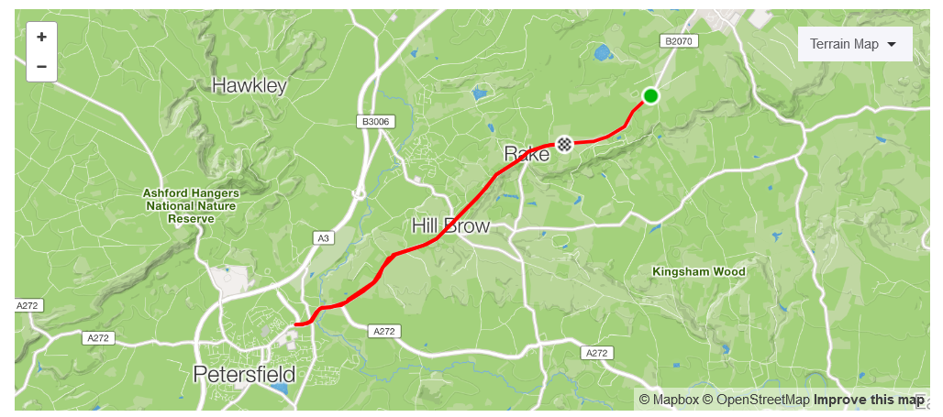
COURSE DESCRIPTION 10 MILE TT P886/10: B2070 (Old A3) Rake / Petersfield/ Rake
Start On the Layby (25 yards before the exit) on the London Road B2070 facing towards Petersfield (South) 100 yards from the “Black Fox” public house and the turning to (North) Milland Hill.
Proceed south along B2070 passing the junction opposite the “Flying Bull” PH (1.7 miles) and continue to Hill Brow (3.1 miles). Continue south on the B2070 and pass the junction (Care) with A272 (4.9 miles) until the Rams Hill roundabout at Sheet (5.17 miles).
Turn, take the third exit to retrace the outward route re-passing the A272 junction at 6.4 miles and Hill Brow at 8.1 miles. Continue along the B2070 passing the “Rake” sign at 9 miles to
Finish at a point just before the turning of an unclassified road to Chapel Common opposite Coldharbour Wood approximately 100 yards from the start of the Dual Carriageway, 10 miles.

COURSE RISK ASSESSMENT P886/10
 | Location | Details of Hazard | Risk H/M/L | Measures to Reduce Risk
1 | General Requirements | Road Usage meets CTT Traffic Standards | L | Traffic Counts  Time restrictions on use of Course.
2 | Before START | Competitors riding from Event Headquarters Competitors warming up | M | Cycle Event Warning Sign Instructions on Start Sheet;-safe routes to START-prohibited areas for warming up-competitors must not cross the B2070 at Start Area within 100 yards of Timekeeper
3 | Area of START On B2070, south of Black Fox PH and Milland Lane  SU 827288 | Competitors waiting in Lay-by | L | Cycle Event north of Start on B2070.Instruction on Start Sheet on conduct at Start. Competitors to have CTT approved body numbers affixed
4 | START Lay-by on B2070, 100 yards south of Black Fox PH and Milland Lane.  SU 827288 | Competitors and/or Holder-up falling | L | No additional measures required
5 | Unclassified road to Milland Parish Church.  SU 824284 | Minor road on Left | L | No additional measures required
6 | Unclassified road to Coldharbour Wood.  SU 813280 | Minor cross road.B2070 narrows single carriageway | L | No additional measures required
7 | Rake Business Park & Princes Garden Centre.  SU 807279 | Inattentive motorists entering or leaving Garden Centre on Right. | M | Warning on Start Sheet
8 | St Patrick’s Lane & Bull Hill at Rake SU 804278 | Minor cross road | L | No additional measures required
9 | Hill Brow Road  SU 788262 | B3006 cross road from Liss. Traffic islands to narrow B2070. | L | Warning on Start Sheet
10 | Durford Wood  SU 783258 | B2070 widens to dual carriageway | L | No additional measures required
11 | Stodham Lane  SU 773255 | Minor road on Right. Gap in central reservation. Cross hatching on road in outside lane to protect traffic turning right | L | No additional measures required
12 | Rogate Road  SU 76624 | A272 joins from LEFT. Short acceleration lane for west bound traffic. Traffic turning right across path of competitors but event route has priority. Road narrows to single carriageway | M | HCC traffic calming scheme to reduce speed of traffic turning Right. Cycle Event Warning Sign in Rogate Road. Warning on Start Sheet
13 | Village Street  SU 761245 | Minor road on Right | L | No additional measures required
14 | Pullens Lane  SU 759242 | B2199 is now minor crossroads. Traffic joins A272 from Left en-route to Petersfield By-pass. Traffic turning Right. Event route has priority | L | No additional measures required
15 | Shear Hill  SU 758241 | Minor road on Left | L | No additional measures required
16 | TURN Ramshill RAB  SU 756241 | TURN, 3rd Exit to rejoin A272 eastbound. Traffic coming from Right. Traffic taking 1st and 2nd exits | M | Cycle Event Warning Signs. Marshals & Direction Signs. Instruction on Start Sheet.
17 | Inmans Lane  SU752242 | Minor road on Left to Sheet Village. Traffic turning Right into B2199 Pullens Lane | L | No additional measures required
18 | Village Street  SU 761245 | Minor road on Left to Sheet Village. | L | No additional measures required
19 | Junction with B2070.  SU 766245 | A272 turns Right into Rogate Road. Traffic turning Right from Rogate Road to proceed north east on B2070.Event Route joins B2070 & has priority. B2070 becomes dual carriageway | L | No additional measures required
20 | Stodham Lane  SU 775255 | Minor road on Left. Gap in central reservation for access to Stodham Lane. Cross hatching on near side of carriageway to protect & slow traffic | L | Warning on Start Sheet
21 | Pruetts Lane  SU 778257 | Minor road on Left | L | No additional measures required
22 | Durford Wood  SU 783258 | B2070 narrows to single carriageway | L | No additional measures required
23 | Hill Brow Road  SU 788262 | B3006 cross road from LissTraffic islands to narrow B2070 | M | Warning on Start Sheet
24 | Huntsbottom Lane  SU 792267 | Minor Road on Left | L | No additional measures required
25 | Hatch Lane  SU 797273 | Minor Road on Left | L | No additional measures required
26 | Primrose Lane  SU 801276 | Minor Road on Left | L | No additional measures required
27 | St Patrick's Lane Rake  SU 804278 | Minor road on Left.Competitors returning to Event Headquarters crossing path of other competitors still riding. | L | Instruction on Start Sheet on Safe Routes to Start and from Finish
28 | Rake Business Park and Princes Garden Centre  SU 807279 | Inattentive motorists entering or leaving the Garden Centre. | L | Warning on Start Sheet
29 | Road to Langley  SU 809280 | Minor Road on Left | L | No additional measures required
30 | FINISH  East of unclassified road to Chapel Common approximately 100 yards short of start of dual carriageway  SU 813280 | Finish Area with Timekeeper's vehicle only | L | Chequered Board/Flag  Cycle Event Warning Sign  Instructions on Start Sheet  - no times to be given to competitors at Finish  - competitors must not cross the road at the Finish Area  - competitors must not stop at the Finish but continue until a gap in the central reservation to cross and return to Event Headquarters
31 | After FINISH | Competitors returning to the Event Headquarters | M | Instructions on Start Sheet on Safe Route from FINISH back to the Headquarters
Time Restrictions on using the Course P886/10
Day(s) | Months | Last Rider on Road  (am events) | First Rider on Road  (pm events)
Weekdays | All | No Events | 19:00
Saturdays | All | No Events | 14:00
Sundays & Bank Holidays | February to May  June to last week of September  October to December | 11:30  11:00  11:30 | No Events  No Events  No Events
Field size should be restricted in size so that the last rider on the road (pm events) should be able to return to the Event HQ comfortably before sunset, i.e., to start no later than 45 minutes before sunset
The course is suitable for 30 second starts.

