
West DC: Risk Assessment

Cycling Time Trials – West DC Course Risk Assessment Document. The measures to reduce risk identified in the right hand column must be included on the start sheet or implemented for the duration of the event as applicable. Failure to comply with the requirements of this document may result in approval being withheld with respect to subsequent race promotions by the promoting club.
(CTT Guidance Note 22 – provides additional advice)

Course/Road(s) Assessed:  A38 Woodford – Wanswell - B4066 Berkeley – A38 Slimbridge - Stone | Course:  U17  Distance (in miles):  25 Miles
Date of Assessment/Review:  22 February 2024 – updated traffic counts | Name of Assessor:  Paul Winchcombe
Review History:  First Produced (if known): 22 Feb 2014 earliest held  Last Review:  15 February 2024 – updated format  26 Jan 2024 – include new traffic count  21 November 2022, including adding street view | Sponsoring Club or Organisation:  West District – course used by several clubs
Course Description:
Incorporates all of the U7B '10' course plus a side loop repeated twice making up the 25 mile distance. Start at splay at northern end of bus stop at Woodford (GR 690958). North on A38 to minor road at Berkeley Road (GR717001) ( 4.01 miles). Left (SP Breadstone, Halmore, Purton) to Wanswell where left at give way sign to RAB with B4066, 1st exit (SP Gloucester, Bristol, A38), at 2nd RAB take 1st exit (SP Gloucester, Bristol, A38), to give way sign on A38. Left on A38 to complete circuit (10.41 miles). Repeat circuit (16.81 miles) and continue north on A38 to Slimbridge RAB where turn and retrace past start to Stone. Finish at 2nd drain cover past Catherine Villa (white house next to garage) (GR684949) (25 miles).
Link:
https://www.cyclingtimetrials.org.uk/course-details/u17
All images are hyperlinked to Google Street View
Course Type:
- Single Carriageway (with long sections with a usable cycle lane)
- Circuit – Out and Back
- Bridge narrows for rail crossing near Berkeley turn. No 20mph restriction identified.
Traffic Flows:
Traffic flows are low and no issues have been encountered.
Traffic count Sunday 21 Jan 2024 – 240 northbound and 200 southbound
Traffic count Sunday 18 February
Results for Northbound: Reading 1 = 172 units per hour. Reading 2 =234 units per hour
Results for Southbound: Reading 1 = 148 units per hour. Reading 2 = 258 units per hour
Course / Event History:
Course has been in use since at least 2010. It is used for the WTTA Hardriders and has also been used for University 3 Up races. There was a minor incident in 2021 when a driver joined the course at B4066 junction without carrying out proper observations. https://www.google.com/maps/@51.6995793,-2.4069885,3a,75y,232.16h,75.28t/data=!3m6!1e1!3m4!1s7EiXYDshf9YpGGehL2D41Q!2e0!7i16384!8i8192
Police Authority:
David Holland
Road Safety and Traffic management, Gloucestershire Constabulary HQ, No 1 Waterwells, Quedgeley, GLOUCESTER, GL2 2AN 01452 754547 Force Control Room – 101
RoadSafety.&TrafficManagement@gloucestershire.pnn.police.uk

RISKS IDENTIFIED
No. | Distance / Location | Risk/Hazard | Level of Risk  (Low/ Med/ High) | Measures to reduce Risk  (if applicable)
1 | General Requirements | Time/Traffic Volume meets CTT Standards | Low | Traffic Counts undertaken: well within limits.
a) Falfield or Stone village hall to start of U17
2 | Village hall | Riders turning left to join A38 north | Low | Cycle Event Warning signs on A38 approaching village hall in both directions
3 | A38 – Start at Woodford | Riders at start point.  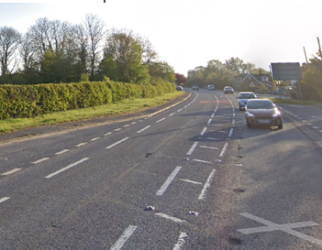 | Low | Start Observer. Warning on start sheet – no U-turns.  Cycle Event Warning signs on A38 approaching start
b) Start to turn off A38 onto minor road to Wanswell
4 | Junction with Berkeley Road B4066 | Riders continue on A38; traffic and riders completing circuits joining A38  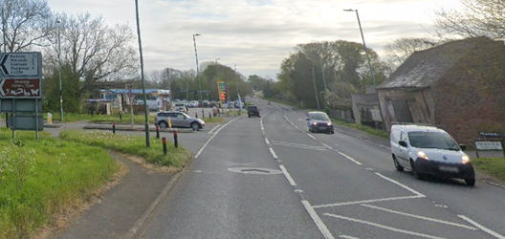 | Medium | Observer;  Cycle Event Warning sign on A38 south of junction
5 | A38 through Newport | Vehicles exiting/entering numerous laybys, residential driveways and public house access in Newport village | Low | Warning on start sheet
c) Turn off A38 onto minor road to Wanswell, B4066 Berkeley bypass, and back to the A38: two circuits
6 | Turn left offA38 before bridge over railway | Riders turn left off A38 and onto minor road to Wanswell. Turn is tight, c. 70 degrees so risk of drifting in to opposing traffic.  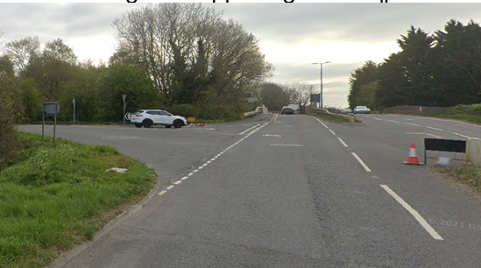 | Low | Observer (optional riders have right of way)  Turn Left sign with an advance notice arrow; Warning on start sheet of sharp left turn.  Cycle Event Warning signs on A38 on south and north approaches to the junction and on minor road approach to junction.
7 | T junction in Wanswell, riders turn left onto minor road | Riders give way to traffic from the right. Parked cars opposite junction can force northbound traffic on to opposite side of road in conflict with riders.  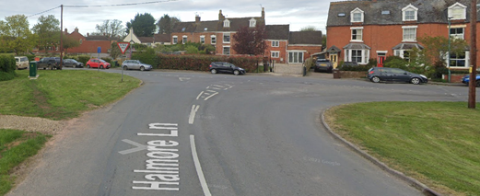 | Medium | Turn Left sign; Cycle Event Warning signs on both approaches to the junction. Riders advised to look BOTH ways at junction on start sheet.
8 | B4066 roundabout | Riders turn left to bypass Berkeley  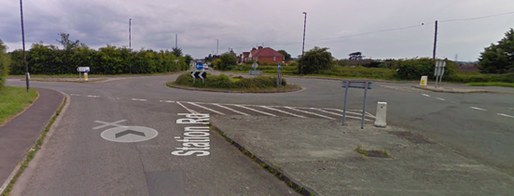 | Low | Turn Left sign;  Cycle Event Warning signs on all approaches to the roundabout  Riders have good visibility
9 | B4066 roundabout | Riders turn left to stay on B4066  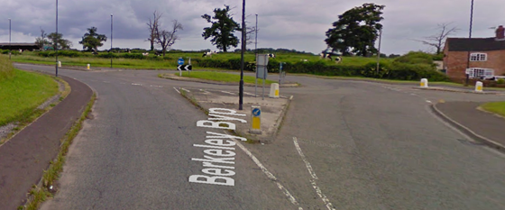 | Low | Turn Left sign; Cycle Event Warning signs on all approaches to the roundabout  Riders have good visibility
10 | B4066 / A38 | Riders turn left from B4066 and join the A38 going north  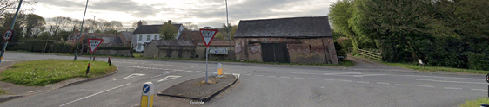 | Medium | Observer as per 4;  Turn Left sign on approach to junction; Cycle Event Warning sign on A38 south of junction
11 | Repeat circuit | Repeat 5 to 9 as above
d) A38 Berkeley Junction to Slimbridge Roundabout
12 | Car Auctions road layout | Road narrows; traffic may turn right across riders into car auctions premises | Medium | Warning on Start Sheet;  Cycle Event Warning Sign on northbound approach
13 | Slimbridge roundabout – turn | 2 Lane approach (north bound), Riders changing lanes. Traffic joining roundabout. Riders in centre of carriageway so as to turn  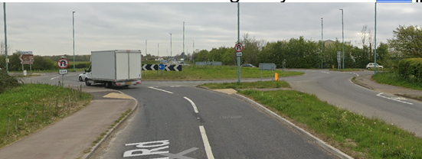 | Medium | Observer on joining road from East;  Turn sign;  Cycle Event Warning Signs on all approaches
e) A38 Slimbridge Roundabout to Finish
14 | Car Auctions road layout | Road narrows; traffic may turn right into car auctions premises | Medium | As 12
15 | Finish past Stone | Riders sprinting to finish | Low | See 16
16 | Finish | Road Users – riders performing U turns after the finish | Low | Warning on start sheet not to perform ‘U’ turns at the finish. Also a note to be aware of surroundings and other road users at the finish. Cycle Event Warning sign on northbound side south of the finish area.

Notes
- The use of a vehicle for the timekeeper(s) at start and finish is where appropriate and is only identified as an example for the action to be taken
- The small junctions or entrances to farms/ facilities (garage, eatery, etc) that are not identified in this risk assessment have been considered, however are not considered significant to pose a risk and therefore have not been noted.
- The course should not be used on public bank holiday weekends or when there are major local events or traffic may be diverted of the M5 unless an early start is used. E.g. Womad, Badminton, Polo Competition, Air Show, etc

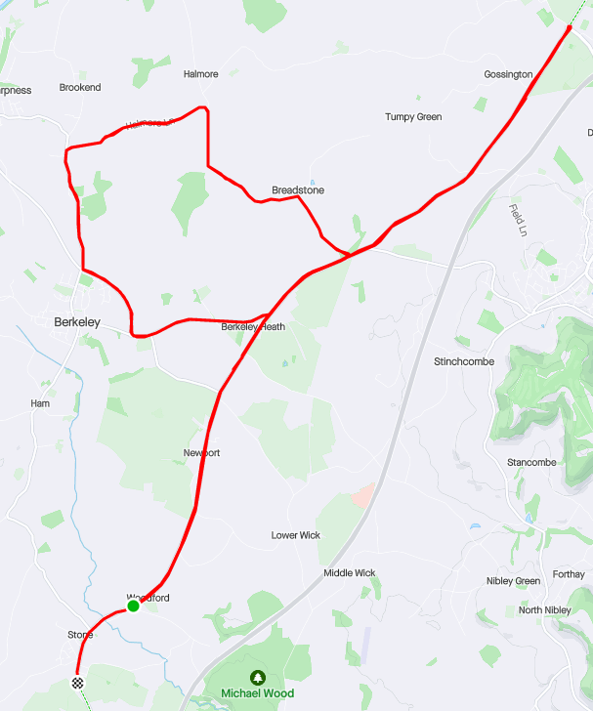

This document remains live and any changes to the items listed above or new hazards/risk that arise should be notified to the district committee at the earliest opportunity.

CYCLING TIME TRIALS IS A COMPANY LIMITED BY GUARANTEE REGISTERED IN ENGLAND No: 4413282
Registered Address: 77 ARLINGTON DRIVE, PENNINGTON, LEIGH, LANCASHIRE. WN7 3QP November 2003

