
West DC: Risk Assessment

Cycling Time Trials – West DC Course Risk Assessment Document. The measures to reduce risk identified in the right hand column must be included on the start sheet or implemented for the duration of the event as applicable. Failure to comply with the requirements of this document may result in approval being withheld with respect to subsequent race promotions by the promoting club.
(CTT Guidance Note 22 – provides additional advice)

Course/Road(s) Assessed:  A38 Newport Towers - Slimbridge | Course:  U7b  Distance (in miles):  10
Date of Assessment/Review:  15 March 2024 – updated traffic counts | Name of Assessor:  Paul Winchcombe
Review History:  First Produced (if known): N/K  Last Review:  2019 RA and reapproved, following club 2020 review  27 Sep 2022  Updated 2 January 2023 with street views (hyperlinked)  20 Jan 2024 – confirming start/finish locations, adding bus times  22 February 2024 – updated traffic counts | Sponsoring Club or Organisation:  West District RA Secretary as course is used by several clubs
Course Description:
OS Landranger map number 162. Start in middle of bus stop layby opposite start of the splay for the opposing layby (GR ST 69577 96429). Proceed north on the A38 through Berkeley Road and over the railway bridges to the Slimbridge roundabout where turn (5.3 miles). Circle and retrace south on the A38 to finish on opposite side of the road to a bus stop just south of Newport (GR ST 69836 97078) approximately ¼ mile before the start.
Organisers should check bus timetable to ensure that starts are not interrupted by buses
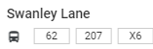
Route 62: 10:17 hrs, Route 207: 08:07 hrs, x6: 07:43 hrs
https://citymapper.com/bristol/bus/stops/BristolStop_SwanleyLane_SW_1
Link:
https://www.strava.com/activities/7364389110
Course Type:
- Single Carriageway
- Out and Back
- Road narrows at rail bridge near Berkley
Traffic Flows:
Traffic counts are within medium limits. Note much of the course has an effective cycle lane which can be raced in.
Traffic count Saturday 9 March 2024 – 216 northbound, 198 southbound
Traffic count Sunday 21 Jan 2024 – 240 northbound and 200 southbound
Traffic count Sunday 18 February 2024
Results for Northbound: Reading 1 = 172 units per hour. Reading 2 =234 units per hour
Results for Southbound: Reading 1 = 148 units per hour. Reading 2 = 258 units per hour
Course / Event History:
Course has been in general use since at least 2010. Also forms part of U17/25
Police Authority:
David Holland
Road Safety and Traffic management, Gloucestershire Constabulary HQ, No 1 Waterwells, Quedgeley, GLOUCESTER, GL2 2AN 01452 754547 Force Control Room – 101
RoadSafety.&TrafficManagement@gloucestershire.pnn.police.uk

Key Identified Risks

No. | Distance / Location | Risk/Hazard | Level of Risk  L/M/H | Measures to reduce Risk  (if applicable)
a) Introduction
1 | General Requirements | Time of Road Usage meets CTT Traffic Standards | L | Traffic counts within acceptable numbers ; Take Traffic Counts during event
b) HQ to Start
2 | Before Start | Competitors riding from Event HQ; Competitors warming up | M | Instructions on Start Sheet and at event HQ signing on advising riders of safe routes; prohibition on warming up past the start; Cycle Event Warning signs on A38 approaching village hall in both directions
3 | Area of Start | Competitors waiting | L | Cycle Event Warning signs; Instructions on Start Sheet and at event HQ signing on - warning against making ‘U’ turns
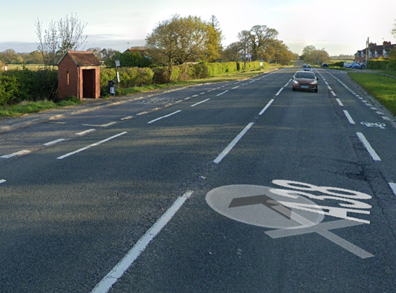
///elastic.clogging.damp
ST 69570 96432
Opposite bus shelter
c) Start to Turn at Slimbridge Roundabout
4 | B4066 to Berkeley | B4066 joins A38 on the west side – traffic joining course and traffic turning across A38. Riders go straight on and have priority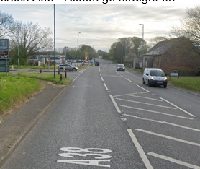 | L | Cycle Event Warning sign on B4066 before junction with A38.  Cycle Event Warning sign on A38 southbound before junction with B4066.
5 | Berkley railway bridge | Road narrows on bridge (narrower than before 2016 repairs due to footpath / cycle path)  Note: No oncoming traffic as single lane  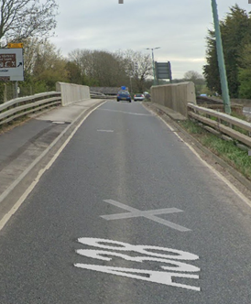 | M | Warning on Start Sheet; 2 Cycle Event Warning Signs on approach to bridge
6 | Car Auctions road layout | Road narrows - traffic from south need to be aware of cyclists taking part of the narrowed road. “  If auctions are open further measures should be taken. Traffic from north may turn right across riders into car auctions premises | L | Warning on Start Sheet; Cycle Event Warning Sign on northbound approach.  If auctions are open then warning signs on southbound approach.
7 | Slimbridge R/about - Turn | Narrow approach (north bound), traffic joining roundabout ; riders circle r/about and retrace. Riders moving into right hand lane to turn 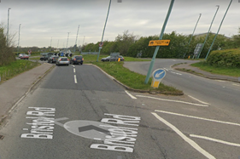 | M | Turn sign at approach to r/about ; Cycle Event Warning signs on all approaches; minimum 2 observers (1 is optional, required observer to be placed on Draycott Road entry to RAB (3rd exit if entering from South)) and 3 warning signs
d) Turn at Slimbridge Roundabout to Finish
8 | B4066 to Berkeley | B4066 joins A38 on the west side – traffic joining course and traffic turning across A38. Riders go straight on.  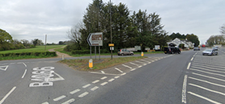 | M | As 4 above.  Note: This junction is more confusing to drivers than 4 above and drivers joining A38 have to look over shoulder when joining road
9 | Finish  Opposite bus stop on other side of the road  ///proven.woes.tenure  ST 69836 97078 | Road Users; riders completing the course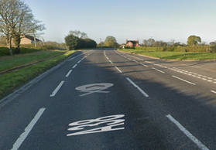 | M | Cycle Event Warning sign for traffic approaching from the south; Warning on Start Sheet not to perform ‘U’ turns at the finish & to be aware of other road users at the finish.

Notes
- The use of a vehicle for the timekeeper(s) at start and finish is where appropriate and is only identified as an example for the action to be taken
- The small junctions or entrances to farms/ facilities (garage,.eatery, etc) that are not identified in this risk assessment have been considered, however are not considered significant to pose a risk and therefore have not been noted.
- The course narrows over the railway bridges and this must be noted on the start sheet.

This document remains live and any changes to the items listed above or new hazards/risk that arise should be notified to the district committee at the earliest opportunity.

CYCLING TIME TRIALS IS A COMPANY LIMITED BY GUARANTEE REGISTERED IN ENGLAND No: 4413282
Registered Address: 77 ARLINGTON DRIVE, PENNINGTON, LEIGH, LANCASHIRE. WN7 3QP

