Risk Assessment proforma*

Course | K46/10 | 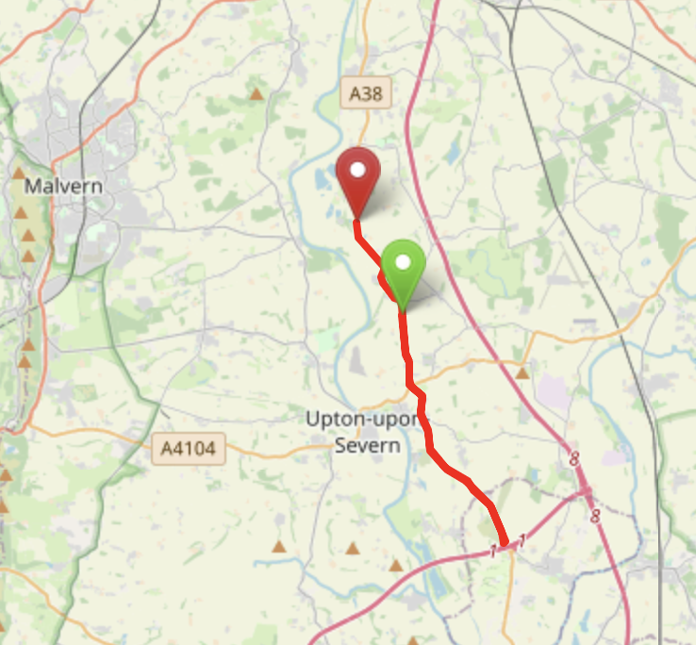
Area | Midland DC
Description | Severn Stoke – Earls Croome – M50 Island – Severn Stoke
HQ | Severn Stoke / Kempsey
Measured | 29/01/2023
Measured by | D Grant
Risk assessed | 29/01/2023
Assessed by | D Grant
Date approved | 29/01/2023
Type A | Approved for Type A & Type B
Type B | Approved
Police Authority | West Mercia  Gloucester
Additional information
Notes for riders | To be made aware of the care points, especially the descent into Severn Stoke
OS Grid # | Course description | Distance | Risk (L/M/H) | Risk description | Minimum management  (Without prejudice)
SO 8618 4322 | Start at: Far southern end of Bus Stop on the A38 at the top of the hill south of Severn Stoke | 0 | L | Riders and officials on or near the highway  Riders not yet started the race arriving at | Cycle event in progress signs.  Officials on or near road to wear high viz jackets.  Riders not yet started to wait off the carriageway
SO 8642 4147 | Cross the traffic island, taking the second exit signposted A38  Care Point #1 | 1.1 | M | Major road / traffic island with occasional heavy traffic. | Cycle event in progress signs on all approaches to the island.  Marshalls on island  Advise rider caution
SO 8876 3757 | At next island junction approaching M50 flyover bridg. Encircle the island, taking third exit to retrace (A38) | 4.1 | M | Major road / traffic island with occasional heavy traffic. | Cycle event in progress signs on all approaches to the island.  Marshall on the island
SO 8643 4141 | Cross the traffic island, taking the second exit signposted A38  Care Point #2 | 7.15 | M | Major road / traffic island with occasional heavy traffic. | Cycle event in progress signs on all approaches to the island.  Marshalls on island  Advise rider caution
SO 8588 4375 | Descend hill into Severn Stoke village  Care Point #3 | 8.73 | L | Steep descent with bends, drain covers and poor road surfaces that can be particularly dangerous when wet. | Riders to be informed at sign on and advise caution and to be careful
SO 8506 4552 | Finish at: Southern end / start of the entrance to the Tarmac Clifton Quarry | 10 | L | Riders and officials on or near the highway | Finish sign at approach to finish and finish board by timekeeper.  Officials on or near road to wear high viz jackets.  Finished riders to return to HQ

References:

CTT GN22 – Risk Assessment

Date of Issue | Reason of Revision | Author
March 2013 | New edition | David Barry  (CTT Board Director)  (CTT Course Risk Assessor)
August 2018 | Revised format | Nick Sharpe  (CTT National Secretary)
October 2022 | Revised to reflect current CTT Articles, Rules, and Regulations | David Barry  (CTT Board Director)

