Risk Assessment proforma*

Course | K22/39 | 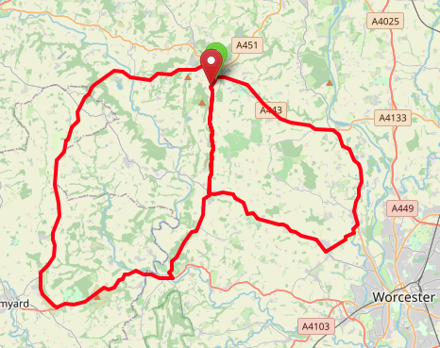
Area | Midland DC
Description | Great Witley – Hallow - Bromyard  Little Mountain TT
HQ | Great Witley (WR6)
Measured | 30/09/2023
Measured by | D Grant
Risk assessed | 29/11/2022
Assessed by | DC Risk Assessor
Date approved | 13/06/2001
Type A | Approved for Type A & Type B
Type B
Police Authority | West Mercia  ian.connolly@westmercia.police.uk
Additional information
Notes for riders
OS Grid # | Course description | Distance | Risk (L/M/H) | Risk description | Minimum management  (Without prejudice)
SO7569965600 | Start on B4197 (Great Witley - Martley road) 20 yards south of junction with A443 at Great Witley, in lay-by opposite telegraph pole. Ride south along B4197 | 0 | M | Riders and officials on or near the highway  Riders congregating at the start | Cycle event in progress signs.  Officials on or near road to wear high viz jackets.  Riders not yet started to wait off the carriageway.
SO7532059980 | At Martley turn left with care and immediately left again (B4204) | 3.64 | M | Riders travelling at speed on approach to village | Cycle event signs on B4204 approach to junction in both directions. 2 Marshals with high viz jackets
SO8114357060 | At Lower Broadheath turn left along road signposted to Hallow | 8 | L | Left turn into side road | Cycle event sign on B4204 approach to junction westbound.
SO8270758402 | At Hallow Turn left (A443) | 9.4 | M | Riders joining main road are to give way to traffic on the A443 | Cycle event signs on A443 before junction, north and south bound. 1 Marshal
SO8138063100 | At Holt Heath bear left staying on A443 | 12.5 | L | Road bears to the left, riders continue on main road | Cycle event signs on A4133, westbound approach to junction and B4196 southbound approach.
SO7501566294 | At Great Witley turn left onto B4203 | 17.5 | L | Left turn into side road | Cycle event sign on A443 approach to junction westbound.
SO7034065880 | Ride yhrough Stanford on Teme | 21.5 | L | Information Point | No Action required
SO6696856095 | At Bromyard Downs Turn left over the Bromyard Downs | 27.59 | L | Left turn into side road | Cycle event sign on B4203 nortbound approach to junction.
SO6787054429 | At junction with A44 turn left (A44) | 29.0 | M | Riders joining main road | cycle event signs before junction east and west bound on A44.  1 Marshal
SO7351055760 | At Knightwick turn left (B4197) | 32.5 | L | Left turn into side road | Cycle event sign on A44 westbound approach to junction
SO7344056150 | Ride up Ankerdine hill | 33.2 | L | Information Point | No Action required
SO7533759960 | At Martley turn right (B4197) | 35.5 | M | Riders turning right in the village | Cycle event signs on B4204 approach to junction in both directions and on B4197 southbound.  1 Marshal
SO7545965257 | Finish by grass triangle at junction with lane on left signposted Walsgrove Home farm | 39.5 | L | Riders and officials on or near the highway | Finish sign at approach to finish and finish board by timekeeper.  Officials on or near road to wear high viz jackets.  Finished riders to return to HQ

References:

CTT GN22 – Risk Assessment

Date of Issue | Reason of Revision | Author
March 2013 | New edition | David Barry  (CTT Board Director)  (CTT Course Risk Assessor)
August 2018 | Revised format | Nick Sharpe  (CTT National Secretary)
October 2022 | Revised to reflect current CTT Articles, Rules, and Regulations | David Barry  (CTT Board Director)

