Risk Assessment proforma*

Course | K11/10T | 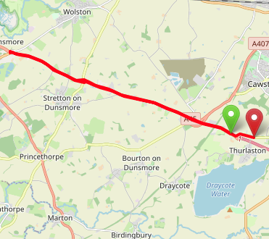
Area | Midland DC
Description | Thurlaston TI (A45/M45) - A45 - Stretton TI (A445) -Thurlaston TI - B4429
HQ | Thurlaston, CV22
Measured | 30/09/2023
Measured by | D Grant
Risk assessed | 29/11/2022
Assessed by | DC Risk Assessor
Date approved | 21/05/2001
Type A | Approved for Type A & Type B
Type B
Police Authority | Warwickshire  tma@warwickshire.police.uk
Additional information
Notes for riders
OS Grid # | Course description | Distance | Risk (L/M/H) | Risk description | Minimum management  (Without prejudice)
SP4625271611 | Start at: Start in lay-by 200 yds west of the A45/M45 Thurlaston island, at the 3rd join in the concrete apron. Ride East (A45) | 0 | M | Riders and officials on or near the highway  Riders congregating at the start | Cycle event in progress signs.  Officials on or near road to wear high viz jackets.  Riders not yet started to wait off the carriageway.
SP4155573227 | At island junction with B4455 (Fosse way) take 2nd exit | 3.14 | M | Riders have to give way to their right. Rumble strips on the approach to the island. | Cycle event signs on all approaches to the island
SP4146473241 | Two lanes on the left from Stretton on Dunsmore. | 4.77 | L | Traffic has to give way to the riders. | No action required
SP3917674162 | At A445 island encircle to retrace (4th exit) (A45) | 6.38 | M | Riders have to give way to their right. | Cycle event signs on all approaches to the island
SP3918574190 | continue on A45 | 6.39 | L | No significant risk | No action required
SP4146073287 | At island junction with B4455 (Fosse way) take second exit (A45) |  | M | Riders have to give way to their right. | Cycle event signs on all approaches to the island
SP4156673292 | Continue E A45 |  | L | No significant risk | No action required
SP4503072080 | Continue straight on at junction with A4071 (A45) |  | L | No significant risk | No action required
SP4650071500 | At M45 island turn left (B4429) | 9.64 | L | Riders have to give way to their right. | Cycle event signs on all approaches to the island
SP4701371506 | Finish: 60 yards past the turn to Thurlaston (Main Street), in line with the eastern and the exposed gate post immediately past the property named Newhaven | 10 | L | Riders and officials on or near the highway | Finish sign at approach to finish and finish board by timekeeper.  Officials on or near road to wear high viz jackets.  Finished riders to return to HQ

References:

CTT GN22 – Risk Assessment

Date of Issue | Reason of Revision | Author
March 2013 | New edition | David Barry  (CTT Board Director)  (CTT Course Risk Assessor)
August 2018 | Revised format | Nick Sharpe  (CTT National Secretary)
October 2022 | Revised to reflect current CTT Articles, Rules, and Regulations | David Barry  (CTT Board Director)

