
West DC: Risk Assessment

Cycling Time Trials – West DC Course Risk Assessment Document. The measures to reduce risk identified in the right hand column must be included on the start sheet or implemented for the duration of the event as applicable. Failure to comply with the requirements of this document may result in approval being withheld with respect to subsequent race promotions by the promoting club.
(CTT Guidance Note 22 provides additional guidance)

Course/Road(s) Assessed:  B4069 Sutton Benger | Course:  UC861C  Distance (in miles):  5
Date of Assessment/Review:  23 March 2024 | Name of Assessor:  Paul Winchcombe
Review History:  First Produced (if known): 23 March 2024  Last Review:N/A | Sponsoring Club or Organisation:  Chippenham & District Wheelers
Course Description:
To reach start from event HQ in Sutton Lane, turn right on minor road and travel North. Start is opposite junction with B4069. Take care when crossing the road.
START (GR ST 94935 78712) in High Street, Sutton Benger. Go East on B4069 (direction of Lyneham). Several minor roads from farms join from left. Continue towards turn at Dauntsey Lock (CARE IN CASE OF CAR BOOT SALE HERE) to Lyneham. Turn left into Church Lane. Continue towards Great Somerford and past Dauntsey Park House to finish at farm field entrances 300 yds past Dauntey Park Entrance
ST 97597 82456
///interval.interview.riper

Link:
https://ridewithgps.com/routes/45921365
Course Type:
- Single Carriageway
- Straight out
- No identified traffic calming or 20mph speed restrictions
Traffic Flows:
With the collapse of Lyneham Banks Traffic Flows are now very low.
Course / Event History:
Course is a new design in 2024 but uses same roads as UC861 and UC866. However, the section from Dauntsey towards Great Somerford is in reverse of usual direction of travel.
Police Authorities:
Wiltshire Constabulary - Mr Bob Eccleston. Bob.Eccleston@wiltshire.police.uk

Key Identified Risks

No. | Distance / Location | Risk/Hazard | Level of Risk  (L / M / H) | Measures to reduce Risk  (if applicable)
a) Introduction
1 | General Requirements | Time of Road Usage meets CTT Traffic Standards | L | Traffic counts within acceptable numbers; Take Traffic Counts during event
b) HQ to Start
2 | Before Start | Competitors riding from Event HQ; Competitors warming up | M | Instructions on Start Sheet and at event HQ signing on advising riders of safe routes; prohibition on warming up past the start
3 | Area of Start – B4069 | Competitors waiting on grass / pavement area next to start. | L | Instructions on Start Sheet and at event HQ signing on - warning against making ‘U’ turns, queue in single file; Cycle Event Warning signs; Use of traffic cones
 | ///titles.crest.ourselves | 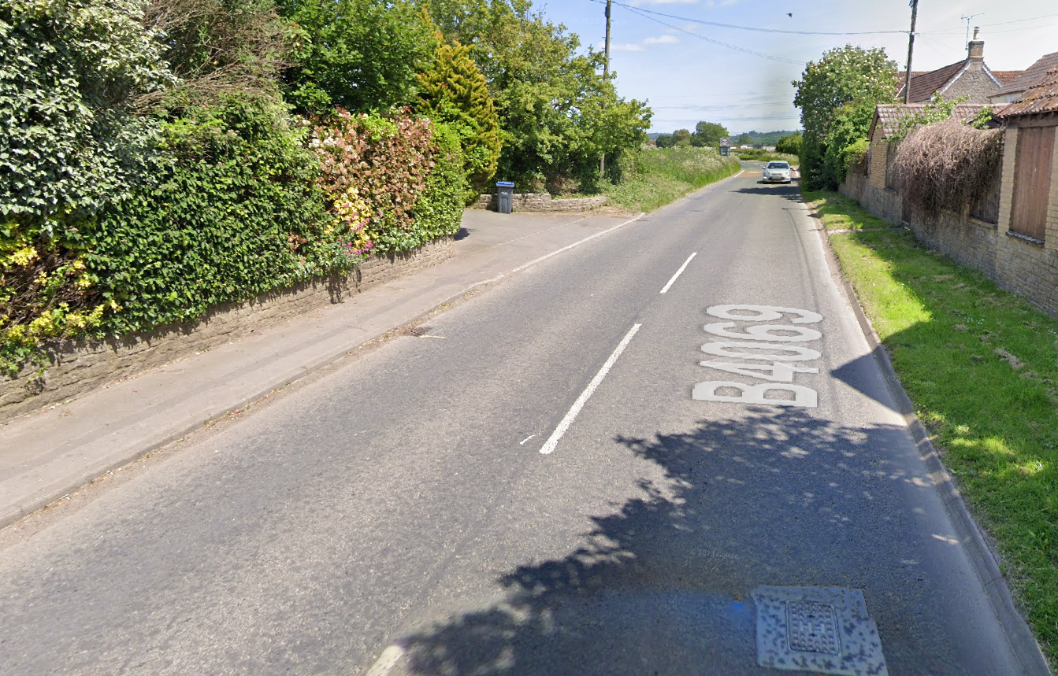
c) Start to Finish
4 | Dodford Lane turning | Traffic joins from left. Visibility is good | L | Nil. Lane leads to isolated farms. Not a through road.
5 | B4069 Swallett Gate Junction /Dauntsey Lock | Riders turn left; Slippery surface when wet  Car Boot Sale some weekends | L | Instructions on start sheet and at start.  (Course is usually only used for evening club events)
 | ///junior.tragedy.embellish | 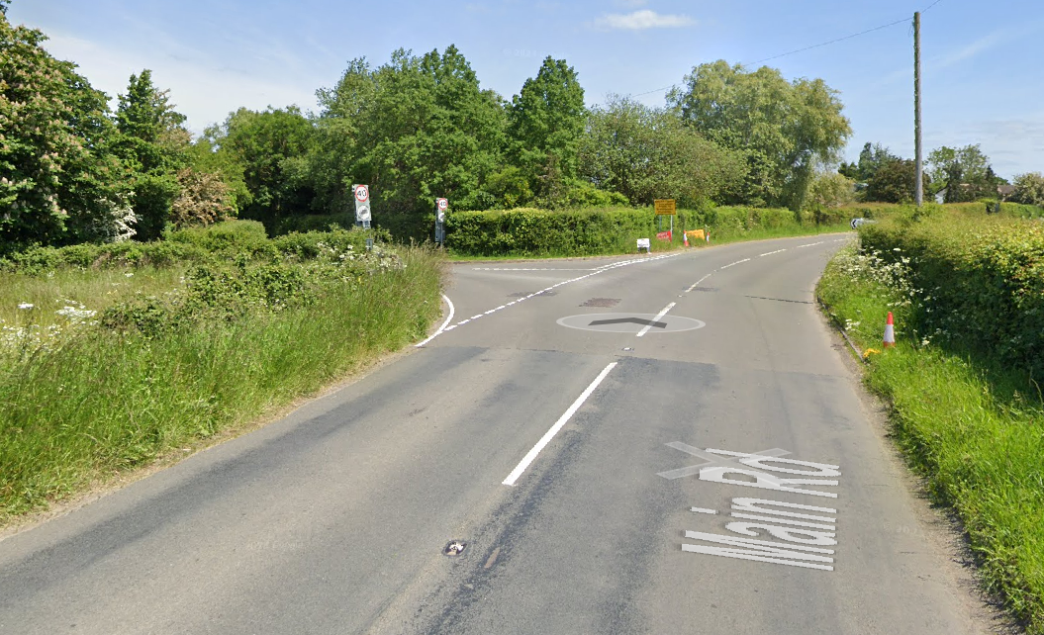
6 | Riders to continue straight along Church Lane towards Great Somerford |  | Nil
7 | S Bend at entrance to Dauntsey Park House ///lower.senders.packets may be slippery when wet. Riders to keep left | 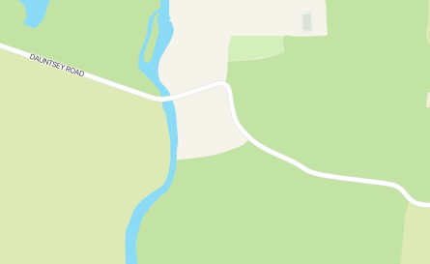
8 | FINISH by farm field entrances 300 yds past Dauntey Park Entrance  ST 97597 82456  ///interval.interview.riper | Finish area with time keepers vehicle only on grass verge. | L | Instructions that no times will be given to competitors or supporters at the finish.
 |  | 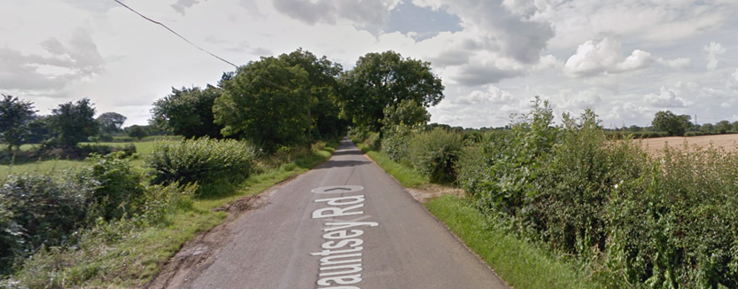
9 | Finish | Awareness of surroundings | L | No u-turns.  Note on start sheet to be aware of surroundings and other road users at the finish.
10 | After finish | Competitors returning to event HQ. | L | Instructions on safe route back from finish to HQ.

Notes
- The small junctions or entrances to farms/ facilities (garage,.eatery, etc) that are not identified in this risk assessment have been considered, however are not considered significant to pose a risk and therefore have not been noted.
Riders should be notified of:
- S Bend near Dauntsey Park House can be slippery and riders are to keep left

This document remains live and any changes to the items listed above or new hazards/risk that arise should be notified to the district committee at the earliest opportunity.

