
West DC: Risk Assessment

Cycling Time Trials – West DC Course Risk Assessment Document. The measures to reduce risk identified in the right hand column must be included on the start sheet or implemented for the duration of the event as applicable. Failure to comply with the requirements of this document may result in approval being withheld with respect to subsequent race promotions by the promoting club.
(CTT Guidance Note 22 – Appendix 2 – Issue 2 September 2011 provides additional advice)
Course/Road(s) Assessed:  A466 – Tintern to Chepstow return | Course:  UC507  Distance (in miles):  6 miles
Date of Assessment/Review:  06 February 2024 | Name of Assessor:  John Linden
Review History:  First Produced (if known): 2006  Last Review: 16/8/22 | Sponsoring Club or Organisation:  Royal Dean Forest CC
Course Description:
Start (GR SO 62276 10950) at Boy's Grave car park, 1 mile south of Speech House Hotel, proceed north to turn left onto B4226, left onto B4234 to Parkend, where left onto minor road to the Barracks, where left onto minor road to finish at start (SO 62276 10950).
Note this course is used for 1,2 and 3 lap events.
Link:
https://ridewithgps.com/routes/4051051
Course Type:
- Single Carriageway
- Circuit
- No identified traffic calming
Traffic Flows:
Low
Course / Event History:
Was mistakenly called UC611 in 2006
The course has been used very regularly without incident
Key Identified Risks
No. | Distance / Location | Risk/Hazard | Level of Risk  (L / M / H) | Measures to reduce Risk  (if applicable)
a) Introduction
1 | General Requirements | Time of Road Usage meets CTT Traffic Standards | L | Traffic counts within acceptable numbers
b) HQ to Start
2 | Before Start | Competitors riding from Event HQ; Competitors warming up | L | Instructions on Start Sheet and at event HQ signing on advising riders of safe routes; prohibition on warming up past the start
3 | Area of Start:  ///direction.poster.dimes  SO 62271 10959 | Competitors wait in entrance off road | L | Instructions on Start Sheet and at event HQ signing on - warning against making ‘U’ turns, queue in single file; Cycle Event Warning signs
 | Layby  B4234 New Road | 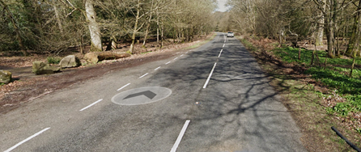
c) Start to Finish
4 | North to Speech House Hotel  Turn Left onto B4226, Speech House Road | Traffic from right has priority | L | Riders have good visibility to right and is a large junction
 |  | 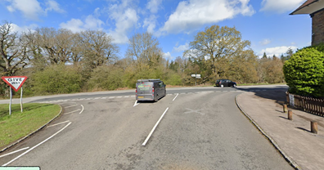
5 | Turn Left onto B4234 New Road in Cannop | Drivers turning across riders | L | Riders have priority and visibility is good
 |  | 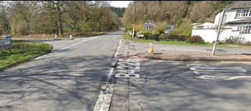
6 | Turn Left onto Fancy Road at junction of B4234 and Fancy Road | Traffic from right has priority | L | Riders have good visibility to right and is a large junction
 |  | 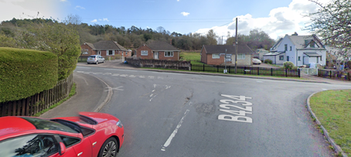
7 | Turn Left onto minor road towards start | Drivers turning across riders | L | Riders have priority and visibility is good
 |  | 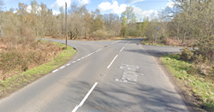
8 | Finish: (at start)  ///direction.poster.dimes  SO 62271 10959 | Awareness of surroundings | L | No u-turns.  Note on start sheet to be aware of surroundings and other road users at the finish.
 | For additional laps repeat course 3 - 8
9 | After finish | Competitors returning to event HQ. | L | Instructions on safe route back from finish to HQ.

Notes
- The use of a vehicle for the timekeeper(s) at start and finish is where appropriate and is only identified as an example for the action to be taken
- The small junctions or entrances to farms/ facilities (garages, restaurants, etc) that are not identified in this risk assessment have been considered, however are not considered significant to pose a risk and therefore have not been noted.

This document remains live and any changes to the items listed above or new hazards/risk that arise should be notified to the district committee at the earliest opportunity.

