
West DC: Risk Assessment

Cycling Time Trials – West DC Course Risk Assessment Document. The measures to reduce risk identified in the right hand column must be included on the start sheet or implemented for the duration of the event as applicable. Failure to comply with the requirements of this document may result in approval being withheld with respect to subsequent race promotions by the promoting club.
(CTT Guidance Note 22 – Appendix 2 – Issue 2 September 2011 provides additional advice)
Course/Road(s) Assessed:  B4234 | Course:  UC506  Distance (in miles):  Hilly 15 miles
Date of Assessment/Review:  02 February 2024 | Name of Assessor:  John Linden
Review History:  First Produced (if known): 2009  Last Review: N/K | Sponsoring Club or Organisation:  Royal Dean Forest CC
Course Description:
Start (GR SO 58870 16702) on Stowfield Road1 mile north of English Bicknor, proceed in a northerly direction on B4234 to turn round mini-roundabout for Frome Valley Way, retrace to finish (GR SO 57200 13400) by New Inn car park
Link:
https://ridewithgps.com/routes/45508349
Course Type:
- Single Carriageway
- Out and Back
- Identify any traffic calming measures, including speed restrictions
Traffic Flows:
Low
Course / Event History:
Was mistakenly named UC612 in 2009
The course has been used regularly since 2009 with no incident.
Key Identified Risks
No. | Distance / Location | Risk/Hazard | Level of Risk  (L / M / H) | Measures to reduce Risk  (if applicable)
a) Introduction
1 | General Requirements | Time of Road Usage meets CTT Traffic Standards | L | Traffic counts within acceptable numbers
b) HQ to Start
2 | Before Start | Competitors riding from Event HQ; Competitors warming up | L | Instructions on Start Sheet and at event HQ signing on advising riders of safe routes; prohibition on warming up past the start
3 | Area of Start:  SO 58948 16825  ///riddle.waltzed.dent | Competitors wait in entrance of Tump Lane off road | L | Instructions on Start Sheet and at event HQ signing on - warning against making ‘U’ turns, queue in single file; Cycle Event Warning signs
 | Start by traffic sign to Eastbach. | 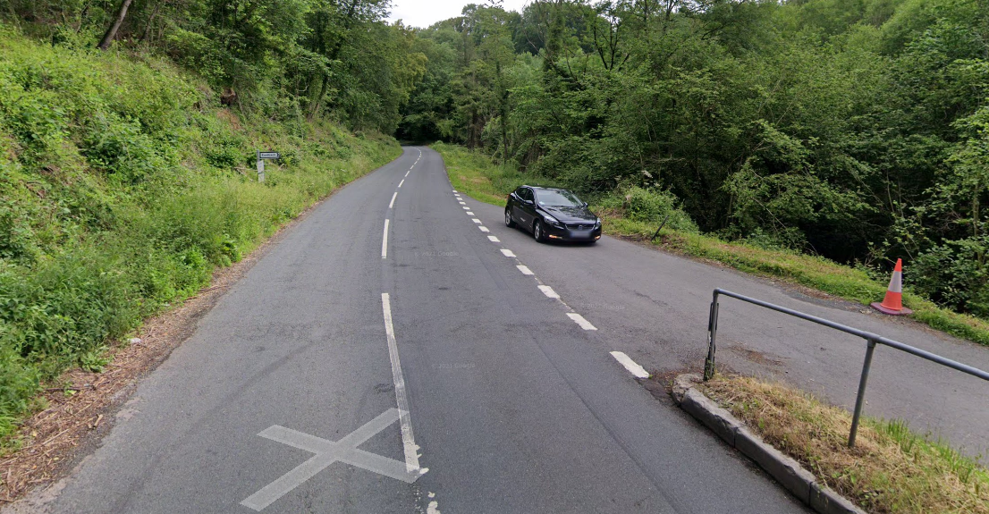
c) Start to Finish
4 | B4234 junction at Lower Lydbrook | Riders have junction priority; traffic joining course | L | Cycle Event Warning sign facing drivers joining course at T.
5 | Turn at mini-roundabout for Frome Valley Way  SO 59480 22622  ///announce.clips.outlawing | Riders make a full turn on the mini-roundabout  Drivers will not be expecting a full turn and it is quite tight | M | Turn Observer. Cycle Event Warning sign for drivers travelling south on B4234
4 |  | 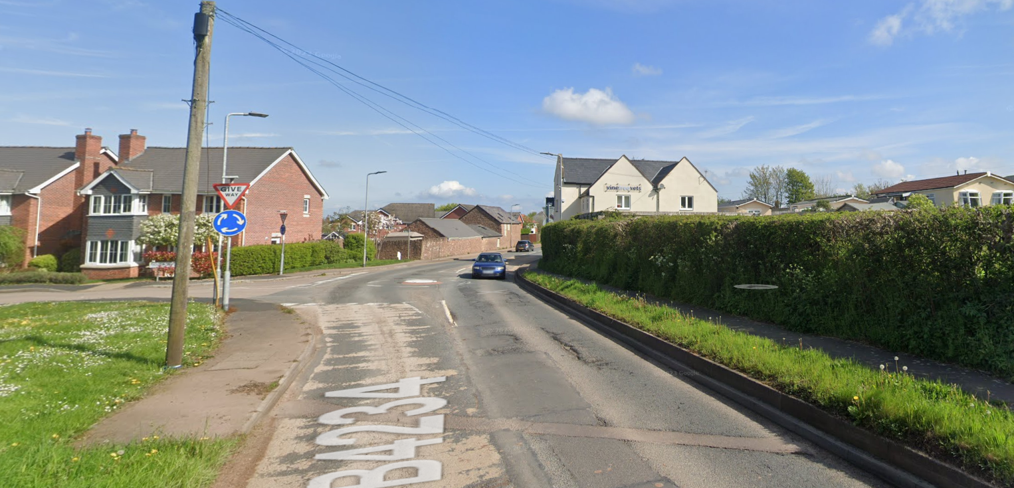
6 | Finish: South entrance of New Inn car park  ///wizards.selection.cool | Awareness of surroundings |  | No u-turns.  Note on start sheet to be aware of surroundings and other road users at the finish.
 | SO 57197 13384 | 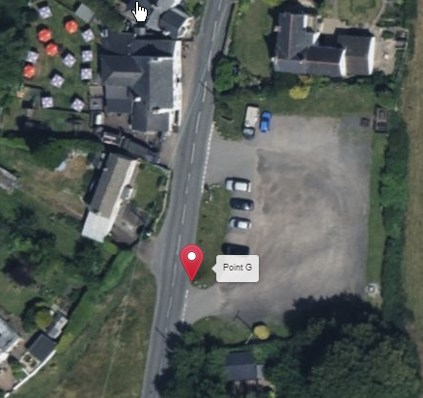  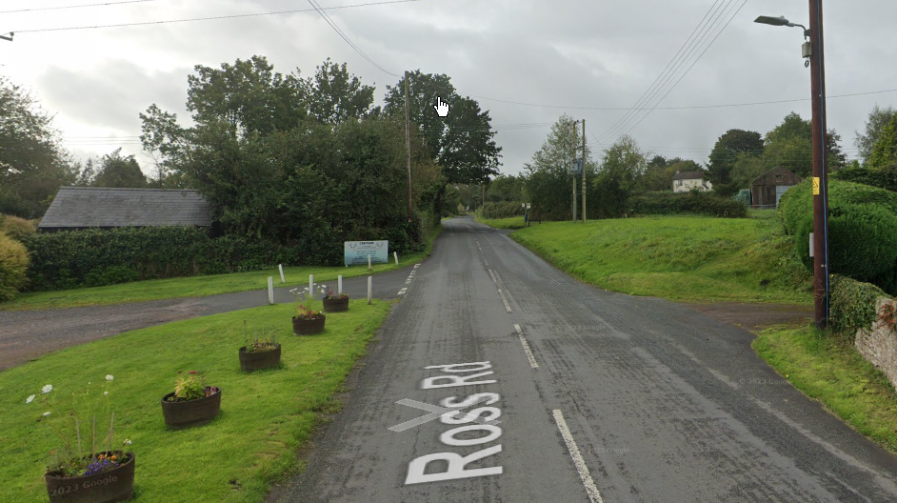
7 | After finish | Competitors returning to event HQ. | L | Instructions on safe route back from finish to HQ.

Notes
- The use of a vehicle for the timekeeper(s) at start and finish is where appropriate and is only identified as an example for the action to be taken
- The small junctions or entrances to farms/ facilities (garages, restaurants, etc) that are not identified in this risk assessment have been considered, however are not considered significant to pose a risk and therefore have not been noted.
- The course should not be used on public bank holiday weekends or when there are major local events. E.g. Forest Food Fair, etc

This document remains live and any changes to the items listed above or new hazards/risk that arise should be notified to the district committee at the earliest opportunity.

