
West DC: Risk Assessment

Cycling Time Trials – West DC Course Risk Assessment Document. The measures to reduce risk identified in the right hand column must be included on the start sheet or implemented for the duration of the event as applicable. Failure to comply with the requirements of this document may result in approval being withheld with respect to subsequent race promotions by the promoting club.
(CTT Guidance Note 22 – Appendix 2 – Issue 2 September 2011 provides additional advice)
Course/Road(s) Assessed:  Stowfield Rd - B4234 to Walford (Return) | Course:  UC501  Distance (in miles):
Date of Assessment/Review:  02 February 2024 | Name of Assessor:  John Linden
Review History:  First Produced (if known): N/K  Last Review: N/K | Sponsoring Club or Organisation:  Royal Dean Forest CC
Course Description:
Start (GR SO 58926 16800) on Stowfield Road 1 mile north of English Bicknor, proceed in a northerly direction on B4234 to u-turn at Walford (SO 59418 21200), retrace to finish (GR SO592175) 3/4 mile short of start (SO 59194 17448)
Link:
https://ridewithgps.com/routes/45499641
Course Type:
- Single Carriageway
- Out and Back
- No traffic calming measures but course has a controlled U Turn into cul de sac at mid point
Traffic Flows:
Low
Course / Event History:
The course has had a long history of regular use by RDFCC going back into the 1990s and further.
In the last 25 years there have been two reported incidents, a rider was assaulted by a horse box driver who had been held up and a junior rode into the curb but suffered no significant injury.
Was old U603 in 2023 due to a mistake
Key Identified Risks
No. | Distance / Location | Risk/Hazard | Level of Risk  (L / M / H) | Measures to reduce Risk  (if applicable)
a) Introduction
1 | General Requirements | Time of Road Usage meets CTT Traffic Standards | L | Traffic counts within acceptable numbers
b) HQ to Start
2 | Before Start | Competitors riding from Event HQ; Competitors warming up | L | Instructions on Start Sheet and at event HQ signing on advising riders of safe routes; prohibition on warming up past the start
3 | Area of Start: | By traffic sign to Eastbach.  Competitors wait in entrance of Tump Lane off road | L | Instructions on Start Sheet and at event HQ signing on - warning against making ‘U’ turns, queue in single file; Cycle Event Warning signs
 | SO 58948 16825  ///riddle.waltzed.dent | 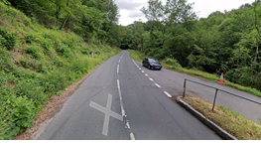
c) Start to Finish
4 | B4234 junction at Lower Lydbrook | Riders have junction priority; traffic joining course | L | Cycle Event Warning sign facing drivers joining course at T.
5 | u turn at Walford in Cedar Grove entrance  SO 59447 21257  ///legroom.send.reds | Riders pull off left into cul-de-sac entrance to make turn  Riders to dismount | M | Turn Observer.  Cycle Event Warning sign for drivers travelling south on B4234
 |  | 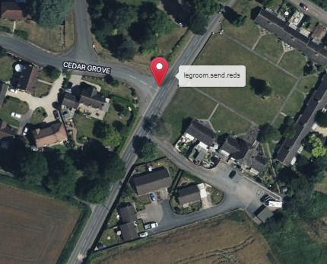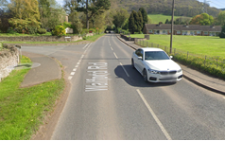
14 | Finish:  SO 58974 17504  ///weeds.guideline.admit | Awareness of surroundings | L | No u-turns.  Note on start sheet to be aware of surroundings and other road users at the finish.
 |  | 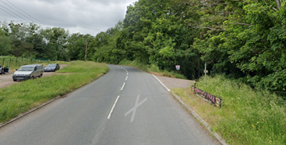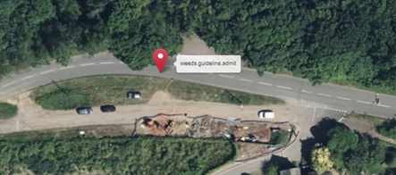
15 | After finish | Competitors returning to event HQ. | L | Instructions on safe route back from finish to HQ.
Notes
- The use of a vehicle for the timekeeper(s) at start and finish is where appropriate and is only identified as an example for the action to be taken
- The small junctions or entrances to farms/ facilities (garages, restaurants, etc) that are not identified in this risk assessment have been considered, however are not considered significant to pose a risk and therefore have not been noted.

This document remains live and any changes to the items listed above or new hazards/risk that arise should be notified to the district committee at the earliest opportunity.

