
West DC: Risk Assessment

Cycling Time Trials – West DC Course Risk Assessment Document. The measures to reduce risk identified in the right hand column must be included on the start sheet or implemented for the duration of the event as applicable. Failure to comply with the requirements of this document may result in approval being withheld with respect to subsequent race promotions by the promoting club.
(CTT Guidance Note 22 – Appendix 2 – Issue 2 September 2011 provides additional advice)

Course/Road(s) Assessed:  Folly Road / Coleford Road / Parkend Road | Course:  UHC515  Distance (in miles):  2.3 miles
Date of Assessment/Review:  1 February 2024 | Name of Assessor:  John Linden
Review History:  First Produced (if known):N/K  Last Review: 02/10/2013 | Sponsoring Club or Organisation:  Royal Dean Forest CC
Course Description:
Start just beyond Whitemead entrance on Folly Road / Coleford Road (GR SO 61153 07845), Parkend. Proceed in westerly direction along Folly Road up Fetter Hill keeping to the main highway to finish at mouth of track (GR SO 58836 10069) just at the 30mph zone for Coalway
Link:
https://ridewithgps.com/routes/45485201
Course Type: Please choose one of the options below and delete the others
- Single Carriageway
- Out Only
- Identify any traffic calming measures, including speed restrictions
Traffic Flows:
Low
Course / Event History:
Course used since at least 2013 with no incidents
Key Identified Risks
No. | Distance / Location | Risk/Hazard | Level of Risk  (L / M / H) | Measures to reduce Risk  (if applicable)
a) Introduction
1 | General Requirements | Time of Road Usage meets CTT Traffic Standards | L | Traffic counts within acceptable numbers
b) HQ to Start
2 | Before Start | Competitors riding from Event HQ; Competitors warming up | L | Instructions on Start Sheet and at event HQ signing on advising riders of safe routes; prohibition on warming up past the start
3 | Area of Start:  /// blazed.sharpness.tonal | Competitors wait in entrance off road | L | Instructions on Start Sheet and at event HQ signing on - warning against making ‘U’ turns, queue in single file; Cycle Event Warning signs
 | Whitemead Forest Park Entrance | 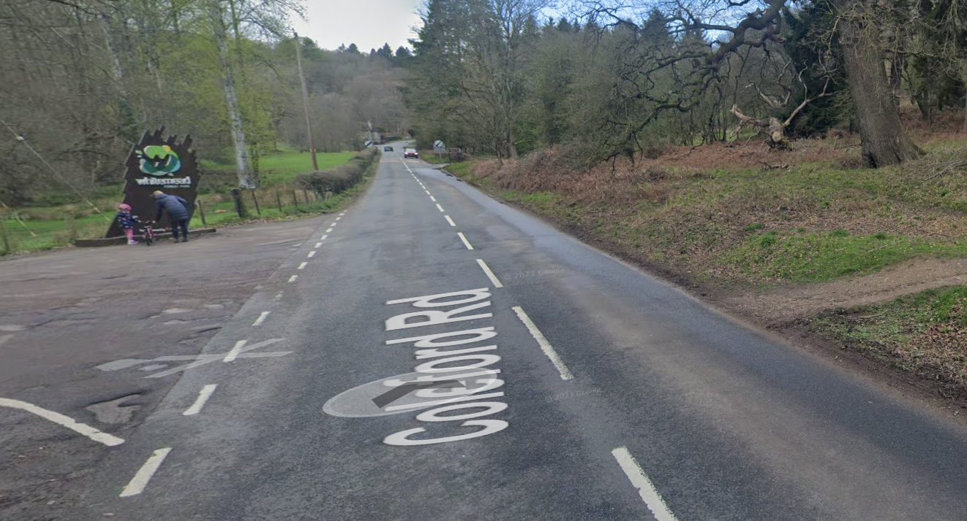
c) Start to Finish
4 | Proceed in westerly direction along Folly Road up Fetter Hill keeping to the main highway | Unclassified road with centre white line | L | Nil
5 | Junctions with:  - Bowson Road  - Smiths Hill road  - Clements End Road | Riders have junction priority; traffic joining course from left | L | Cycle Event Warning sign facing drivers going up course.
6 | Finish:  /// claims.snowballs.flannel | Awareness of surroundings | L | No u-turns.  Note on start sheet to be aware of surroundings and other road users at the finish.
 | Just after 30mph signs | 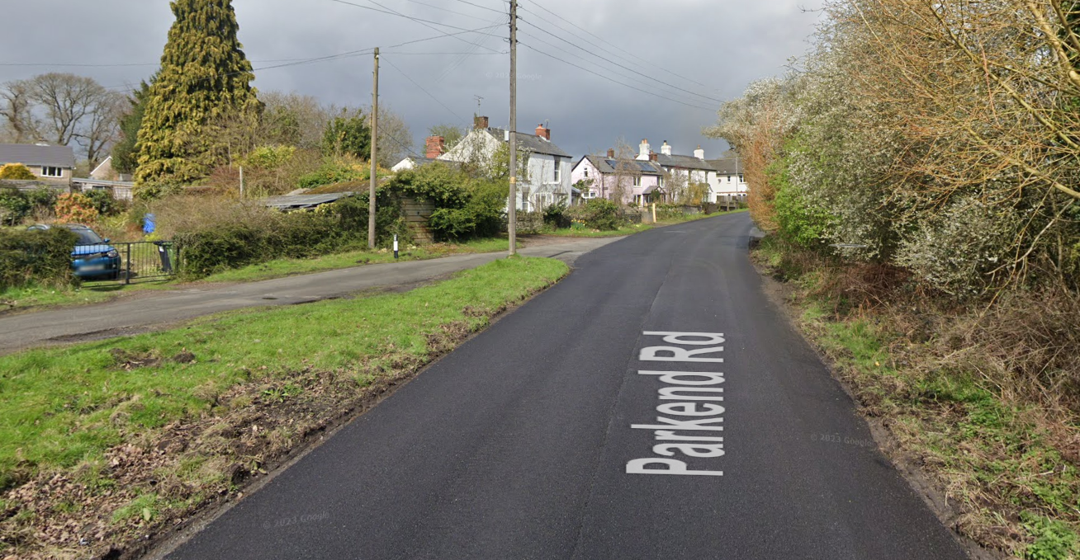
7 | After finish | Competitors returning to event HQ. | L | Instructions on safe route back from finish to HQ.

Notes
- The use of a vehicle for the timekeeper(s) at start and finish is where appropriate and is only identified as an example for the action to be taken
- The small junctions or entrances to farms/ facilities (garages, restaurants, etc) that are not identified in this risk assessment have been considered, however are not considered significant to pose a risk and therefore have not been noted.

This document remains live and any changes to the items listed above or new hazards/risk that arise should be notified to the district committee at the earliest opportunity.

