
West DC: Risk Assessment

Cycling Time Trials – West DC Course Risk Assessment Document. The measures to reduce risk identified in the right hand column must be included on the start sheet or implemented for the duration of the event as applicable. Failure to comply with the requirements of this document may result in approval being withheld with respect to subsequent race promotions by the promoting club.
(CTT Guidance Note 22 – Appendix 2 – Issue 2 September 2011 provides additional advice)

Course/Road(s) Assessed:  B4234 - Cats Hill - Ruardean | Course:  UHC514  Distance (in miles):  2.3 miles
Date of Assessment/Review:  1 February 2024 | Name of Assessor:  John Linden
Review History:  First Produced (if known): N/K  Last Review: N/K | Sponsoring Club or Organisation:  Royal Dean Forest CC
Course Description:
Start (SO 59919 18105) on B4234 and proceed up Cats Hill hill, along High Street through Ruardean to finish (GR SO 62900 17600) on Morse Rd by Crooked End Farm
Link:
https://ridewithgps.com/routes/45484702
Course Type:
- Single Carriageway
- Out Only
- Google maps shows Ruardean as 30 mph but it is assumed that the village is now a 20mph zone. Riders are riding uphill so unlikely that 20mph limit is broken.
Traffic Flows:
Very Low
Course / Event History:
Not known
Key Identified Risks
No. | Distance / Location | Risk/Hazard | Level of Risk  (L / M / H) | Measures to reduce Risk  (if applicable)
a) Introduction
1 | General Requirements | Time of Road Usage meets CTT Traffic Standards | L | Traffic counts within acceptable numbers
b) HQ to Start
2 | Before Start | Competitors riding from Event HQ; Competitors warming up | L | Instructions on Start Sheet and at event HQ signing on advising riders of safe routes; prohibition on warming up past the start
3 | Area of Start:  ///roadblock.script.teaching | Competitors wait in entrance off road | L | Instructions on Start Sheet and at event HQ signing on - warning against making ‘U’ turns, queue in single file; Cycle Event Warning signs
 | B4234 | 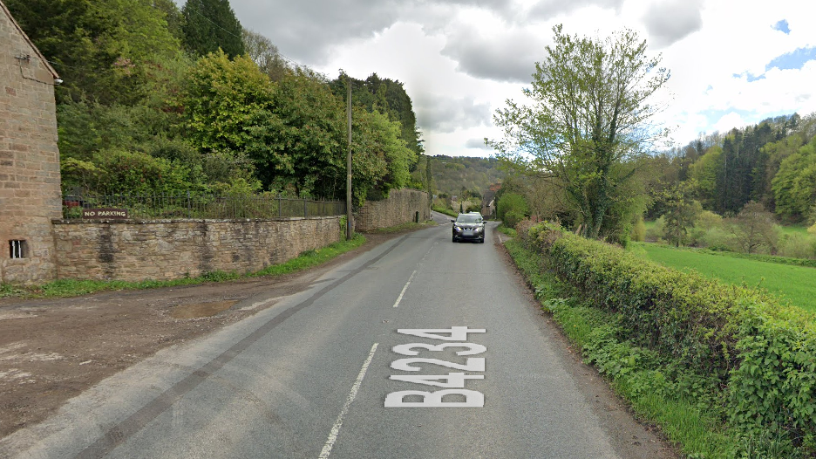
c) Start to Finish
 | Left Turn onto Cats Hill | Cars turning onto main road cutting corner | L | Nil
4 | Left onto High Street in Ruardean | Traffic from right must give way at junction | L | Cycle Event Warning sign may be used but joining traffic has good view
 |  | 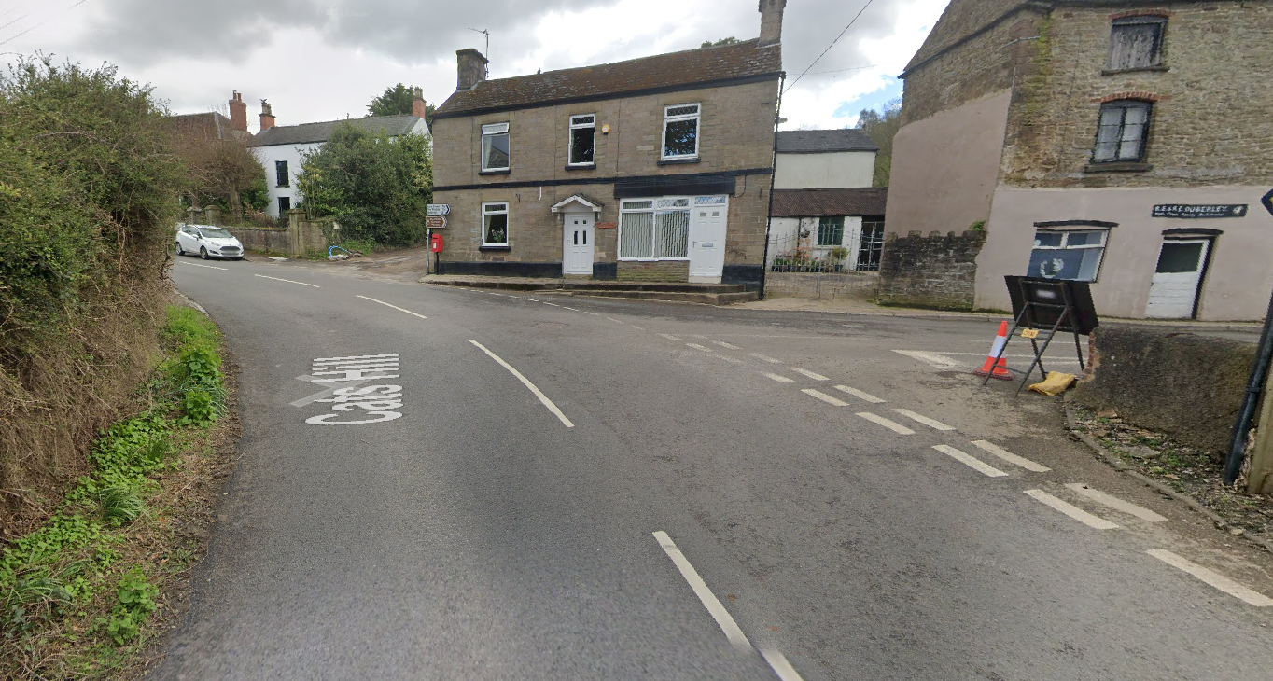
5 | Ruardean High Street | Parked cars on both sides of street | L | Riders must give way if necessary
7 | Finish:  /// overlaps.office.cure | Awareness of surroundings | L | No u-turns.  Note on start sheet to be aware of surroundings and other road users at the finish.
 | Finish on Morse Road after junction with Walkers Lane having left village of Ruardean | 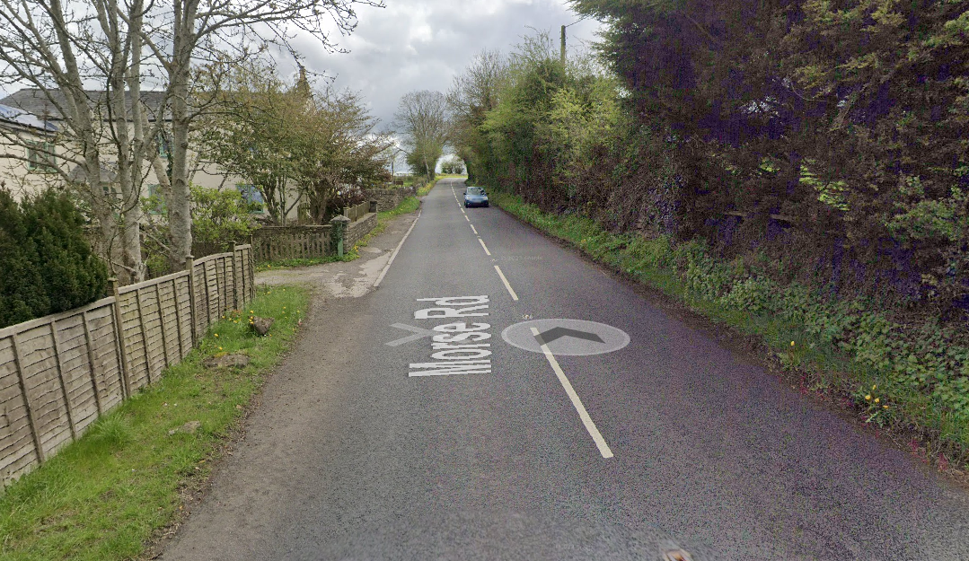
15 | After finish | Competitors returning to event HQ. | L | Instructions on safe route back from finish to HQ.

Notes
- The use of a vehicle for the timekeeper(s) at start and finish is where appropriate and is only identified as an example for the action to be taken
- The small junctions or entrances to farms/ facilities (garages, restaurants, etc) that are not identified in this risk assessment have been considered, however are not considered significant to pose a risk and therefore have not been noted.

This document remains live and any changes to the items listed above or new hazards/risk that arise should be notified to the district committee at the earliest opportunity.

