
West DC: Risk Assessment

Cycling Time Trials – West DC Course Risk Assessment Document. The measures to reduce risk identified in the right hand column must be included on the start sheet or implemented for the duration of the event as applicable. Failure to comply with the requirements of this document may result in approval being withheld with respect to subsequent race promotions by the promoting club.
(CTT Guidance Note 22 – Appendix 2 – Issue 2 September 2011 provides additional advice)
Course/Road(s) Assessed:  B4324 – Parkend to Whitecroft | Course:  UC503  Distance (in miles):  1 Km
Date of Assessment/Review:  1 February 2024 | Name of Assessor:  John Linden
Review History:  First Produced (if known): 8/12/2006  Last Review: | Sponsoring Club or Organisation:  Royal Dean Forest CC
Course Description:
Start (GR SO 61715 07753) at Parkend and proceed in a southerly direction to finish (GR SO 61834 06737) 1/2 mile north of Whitecroft
Link:
https://ridewithgps.com/routes/45484456
Course Type:
- Single Carriageway
- Out Only
- No traffic calming measures
Traffic Flows:
Traffic is very low
Course / Event History:
Course has been in use since at least 2006 with no issues
Key Identified Risks
No. | Distance / Location | Risk/Hazard | Level of Risk  (L / M / H) | Measures to reduce Risk  (if applicable)
a) Introduction
1 | General Requirements | Time of Road Usage meets CTT Traffic Standards | L | Traffic counts within acceptable numbers
b) HQ to Start
2 | Before Start | Competitors riding from Event HQ; Competitors warming up | L | Instructions on Start Sheet and at event HQ signing on advising riders of safe routes; prohibition on warming up past the start
3 | Area of Start:  ///helpless.nature.myths | Competitors wait in entrance off road | L | Instructions on Start Sheet and at event HQ signing on - warning against making ‘U’ turns, queue in single file; Cycle Event Warning signs
 |  | 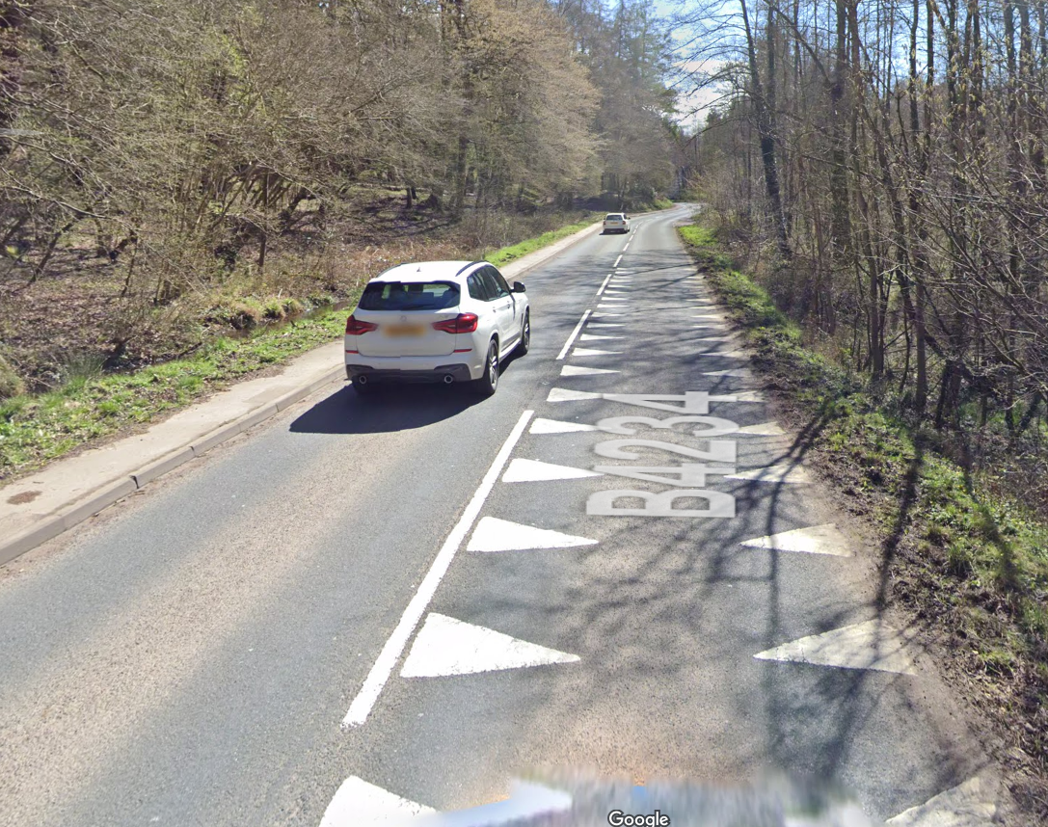
c) Start to Finish
4 | Proceed in a southerly direction to finish 1/2 mile north of Whitecroft | B road with centre line markings | L | Nil
5 | Finish:  /// whillside.richest.allowable | Awareness of surroundings | L | No u-turns.  Note on start sheet to be aware of surroundings and other road users at the finish.
 |  | 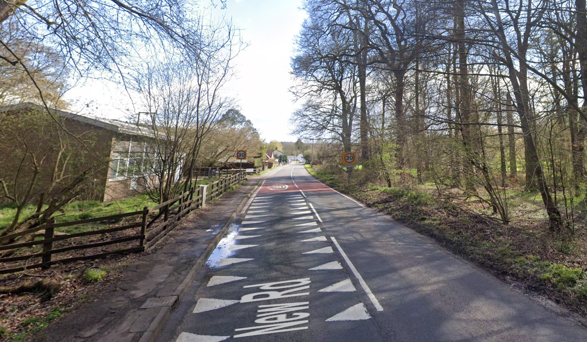
6 | After finish | Competitors returning to event HQ. | L | Instructions on safe route back from finish to HQ.

Notes
- The use of a vehicle for the timekeeper(s) at start and finish is where appropriate and is only identified as an example for the action to be taken

This document remains live and any changes to the items listed above or new hazards/risk that arise should be notified to the district committee at the earliest opportunity.

