
West DC: Risk Assessment

Cycling Time Trials – West DC Course Risk Assessment Document. The measures to reduce risk identified in the right hand column must be included on the start sheet or implemented for the duration of the event as applicable. Failure to comply with the requirements of this document may result in approval being withheld with respect to subsequent race promotions by the promoting club.
(CTT Guidance Note 22 – Appendix 2 – Issue 2 September 2011 provides additional advice)

Course/Road(s) Assessed:  Stowe Road | Course:  UHC513  Distance (in miles):  1.6 miles
Date of Assessment/Review:  31 January 2024 | Name of Assessor:  John Linden
Review History:  First Produced (if known): 8/12/2006  Last Review:  8/12/2016  21/10/2011 | Sponsoring Club or Organisation:  Royal Dean Forest Cycle Club
Course Description:
Start (GR SO 54359 05505) on minor road between Bigsweir and Stowe. Proceed in an easterly direction to finish (GR SO 56606 06696) west end of Clearwell Quarry entrance, Stowe Green
Link:
https://ridewithgps.com/routes/45483671
Course Type:
- Single Carriageway
- Out Only
- No traffic calming measures
Traffic Flows:
Very low
Course / Event History:
Course has been used since at least 2006 with no incidents.

No. | Distance / Location | Risk/Hazard | Level of Risk  (L / M / H) | Measures to reduce Risk  (if applicable)
a) Introduction
1 | General Requirements | Time of Road Usage meets CTT Traffic Standards | L | Traffic counts within acceptable numbers; Take Traffic Counts during event
2 | Event timing | Quarry Operations | H | The course must not be used when Clearwell Quarry is operating and the entrance open.
b) HQ to Start
3 | Before Start | Competitors riding from Event HQ; Competitors warming up | L | Instructions on Start Sheet and at event HQ signing on advising riders of safe routes ; prohibition on warming up past the start
4 | Area of Start | Competitors waiting | L | Instructions on Start Sheet and at event HQ signing on - warning against making ‘U’ turns. Cycle Event Warning sign.
 | Start (GR SO543054) at east end of Cadora Wood car park entrance on Stowe Road between Bigsweir and Stowe  ///bikes.butternut.snowboard | 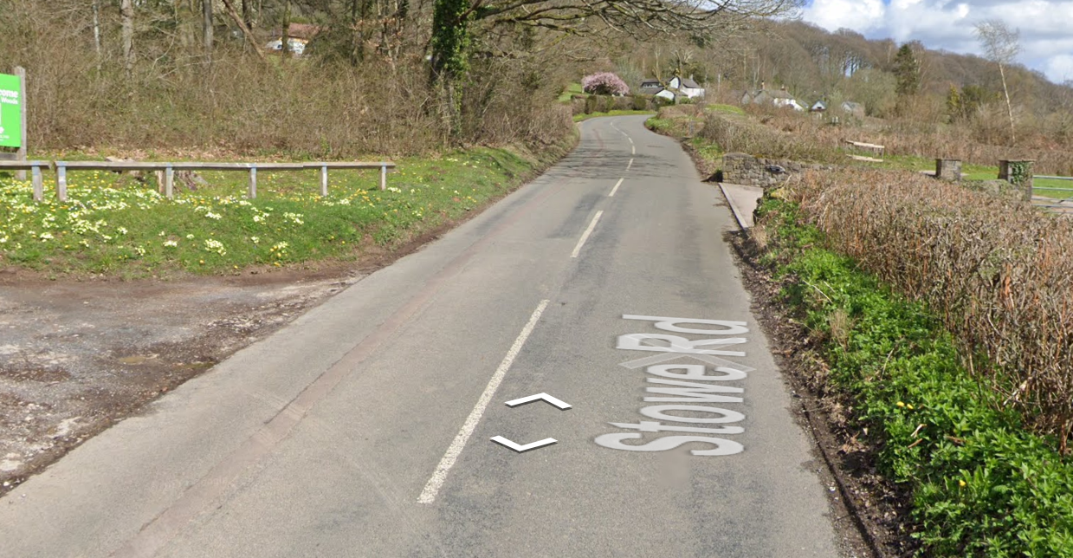
c) Start to Finish: .
 | Proceed in an easterly direction on Stowe Road | Unclassified minor road | L | Nil
 | Finish (GR SO 56606 06696) west end of Clearwell Quarry entrance, Stowe Green  ///appraised.chambers.firm | 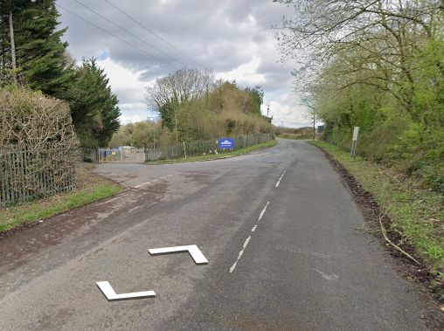
 | Finish | Road Users – riders performing U turns after the finish | L | Warning on start sheet not to perform ‘U’ turns at the finish. Also a note to be aware of surroundings and other road users at the finish. Cycle Event Warning sign.

This document remains live and any changes to the items listed above or new hazards/risk that arise should be notified to the district committee at the earliest opportunity.

CYCLING TIME TRIALS IS A COMPANY LIMITED BY GUARANTEE REGISTERED IN ENGLAND No: 4413282
Registered Address: 77 ARLINGTON DRIVE, PENNINGTON, LEIGH, LANCASHIRE. WN7 3QP

