 | Risk Assessment
Course/Road(s) Assessed: | Course: P889/17.6m
Date of Assessment/Review: 17th October 2023 | Name of Assessor: David Collard-Berry
CYCLING TIME TRIALS
SOUTH DISTRICT COUNCIL
COURSE DETAILS FOR START SHEET RISK ASSESSMENT
Field Placement:
Whilst the underlying principle of field placement is to arrange the starting position of each rider to avoid paced and company riding, the overriding consideration must be the Safety of Competitors. The event should be on the road for as little time as practicable, so that slower riders are not exposed to the danger of becoming left adrift by being placed at the end of the field. This will also reduce the duty of care placed on marshals and timekeepers who may not be aware that riders are still out on the course. The Safety of Competitors must be given priority over the strict application of the principle of field placement as per Guidance Note (Revised December 2017). In order to reduce the danger to the slower riders, consideration should be given to placing faster riders at the end of the field even though previously to Dec. 2017 their potential time might qualify them for a higher spot nearer the front of the field.

The Event Organiser (or Promoting Secretary)
The Promoting Secretary (Event Organiser) has a “Duty of Care”. He or she is responsible for:
- Implementing the Measures to Reduce Risk identified in the Course Risk Assessment
- Erecting and removing Traffic Safety Signs as specified in the Course Risk Assessment warning other road users a of Cycle Event. These signs should normally be removed on the day of the event.
- Completing an Event Risk Assessment to identify any additional risks arising shortly before the event and briefing riders, if appropriate, and taking measures to reduce new risks to “LOW”. This could include contacting the Highways Authority to eliminate hazards, eg; potholes, broken grids, and abandoned cars as part of the Authority’s “Duty of Care
- Submitting an Event Risk Assessment to the District Secretary of the Governing Body after the event. Even if there were no additional hazards, a Nil Return is required
Notes to be Included on Start Sheets or Displayed at Signing-On ~ Safety Instructions
- Take Care at Station Road Liphook
- Take Care at Hillbrow (Staggered) Cross Roads
- Care at the Outward approach to the turn at the A272 Junction
- Care at the left turn at Rogate Cross Roads
Riders waiting to start and must no obstruct the view of the Timekeeper or the Start Line Official of approaching traffic.
No times will be given to competitors at the FINISH
Any rider observed riding in a manner which may jeopardise his or her own safety, the safety of others and the future of the Sport will be disqualified and reported to the South District Council of Cycling Time Trials.
Safety Helmets, Front & Rear Lights
Helmets are compulsory for all events, the following should be printed on all Start Sheets: “In the interests of your Own Safety, Cycling Time Trials and the event promoters instruct competitors to wear a HARD SHELL HELMET that meets an internationally accepted safety standard. Cycling Time Trial regulations require all competitors to wear a Hard Shell Helmet”.
An active Front & Rear light is mandatory during the event.
Signing-On Sheet & Race Numbers
Riders must sign the Official Signing-On Sheet at the Event HQ to obtain their Race Number & remember to sign out when returning.
USUAL HQ- At Rake Village Hall (behind the Flying Bull PH) SU 803278)
SAFE ROUTE TO START:
The Safe route from the Headquarters to the START, is to turn right on to the B2070 & take the next left turn, straight on the Harting Coome X-Road & the left again to proceed to the start approximately 880 metres.
SAFE ROUTE FROM FINISH:
After finishing, competitors should continue on the B2070 at Hillbrow & turn right at the staggered crossroads, beware of other competitors on the outward part of the course coming from the right.
Course Details P889/17.6m
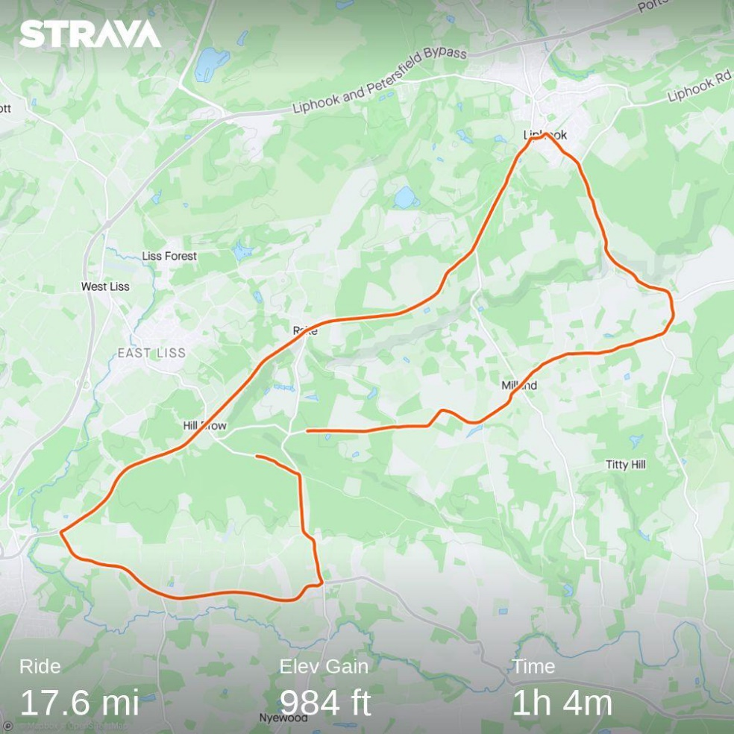

Course Description P889/17.6m

Start in Gateway 880 metres (approx.) from Harting Combe X-Roads (Rake) & proceed towards Milland , pass through Milland X- Roads (2.5 miles) avoiding the Geese at the pond. Carry on straight passing the Linch turning on the right (4 mile), then past Vann Road on the right & Elmers Marsh Farm on the left (4.4 miles).
Continue up the hill past Hollycombe & into Liphook. After crossing the railway bridge (no kom points) turn left onto Station Road (6.6 m), at the end turn left onto Portsmouth Road (B2070) & proceed south (6.8 miles).
Continue on the Portsmouth Road B2070 (old A3) passing the Milland turning on the left (8 miles), continue through Rake past Flying Bull (10 miles) & on to Hillbrow (The Jolly Drovers PH) (11.2 miles). Continue on the B2070 until the junction of the A272 (Midhurst) (13.2m).
At the A272 junction take inside lane to make a left turn signposted Midhurst, be aware of “Give Way” sign.
On the A272 continue until Rogate, at Crossroads opposite Rogate Church (16.1 miles) take left turn & continue past Rogate Village Hall (on the right), take care very narrow road.
At the top of the "slight slope" at a staggered crossroads take a left turn to Hillbrow (Fynings Wood 17.2 miles)) to finish (17.6 miles) at a point 200 metres before Junction sign & almost opposite turning to Rogate Downhill Bikepark.

HQ can be Rake Village Hall.

COURSE RISK ASSESSMENT P889/17.6m
 | Location | Details of Hazard | Risk H/M/L | Measures to Reduce Risk
1 | General Requirements | Road Usage meets CTT Traffic Standards | L | Traffic Counts  Time restrictions on use of Course.
2 | Before START | Competitors riding from Event Headquarters Competitors warming up | L | Cycle Event Warning Sign Instructions on Start Sheet;-safe routes to START-prohibited areas for warming up-competitors must not cross Harting Coombe Road at Start Area within 100 yards of Timekeeper
3 | Area of START On Harting Coombe Road towards Milland (East) by a Gateway. | Competitors waiting in beside of road | L | Cycle Event Sign on Harting Coombe X-Roads. Instruction on Start Sheet on conduct at Start. Competitors to have CTT approved body numbers affixed & front & rear lights switched on.
4 | START on Harting Coombe Road approximately 880 yards from the X-Roads. SU 802262 | Competitors and/or Holder-up falling | L | No additional measures required
5 | Canhouse Lane Junction on left (1 m)  SU818265 | Minor Junction | L | No additional measures required
6 | Cooks Pond Lane on Right (2 m)  SU834265 | Minor Junction | L | No additional measures required
7 | Milland X-Roads (2.5)  SU 837268 | Traffic turning & Riders have “Right of Way | M | Cycle Event Warning Signs & Straight-on Arrow
8 | Wardley Lane on left (2.8m)  SU 842273 |  | L | Riders have “Right of Way
9 | Unclassified Road on Left (3m)  SU 843275 | Road leads to Primary School, busy weekdays during term time | L | No additional measures required during weekends.
10 | Lamborne Lane X-Roads (3.2m)  SU 849275 | Minor Lanes leading off Fernhurst Road Riders have “Right of Way | L | Riders have “Right of Way
11 | Linch Road on Right (4 m)  SU860278 | Traffic turning, Riders have “Right of Way” | L | Cycle Event Warning Signs & Straight-on Arrow
12 | Vann Road on right (4.4m)  SU 862283 | Traffic turning in & out of Vann Road | L | Cycle Event Warning Signs & Straight-on Arrow
13 | Minor Road on left going up Hollycombe Hill (5 m)  SU 852289 | Sharp turn & a partially sighted turn | L | Cycle Event Warning Sign
14 | Iron Hill Car Park on Right (5.9)  SU 850300 | Dog Walkers & Ramblers (The Devils Children) | L | Cycle Event Warning Sign
15 | Highfield Lane on the Right (6.1 m)  SU 846305 | Traffic emerging out, turning towards Liphook | L | Cycle Event Warning Sign & Left arrow plus Marshal
16 | Turning on the left (Station Road) after going over Railway Bridge (6.6 m)  SU 843308 | Traffic turning in & out of Station Road | M | Cycle Event Warning Sign & Left arrow plus Marshal
17 | Left turn out of Station Road onto Portsmouth Road. (6.8 m) SU838309 | Traffic coming from the Right, riders do not have “right of way” | M | Cycle Event Warning Signs & Left arrow plus Marshal
18 | Milland Lane on Left (8 m)  SU 827288 | Traffic emerging | L | Cycle Event Warning Sign & Left arrow plus Marshal
19 | Unclassified road to Milland Parish Church. (8.7 m) SU 824284 | Minor road on Left | L | No additional measures required
20 | Unclassified road to Coldharbour Wood. (9.7m) SU 813280 | Minor cross road.B2070 narrows single carriageway | L | Cycle Event Warning Sign
21 | Rake Business Park & Princes Garden Centre. (9.9m) SU 807279 | Inattentive motorists entering or leaving Garden Centre on Right. | M | Warning on Start Sheet
22 | St Patrick’s Lane & Bull Hill at Rake (10 m) SU 804278 | Minor cross road beware of Inattentive cyclist looking for the start | L | No additional measures required
23 | Hill Brow Road. (11.2m)  SU 788262 | B3006 cross road from Liss. Traffic islands to narrow B2070. | L | Warning on Start Sheet
24 | Durford Wood (12.1m)  SU 783258 | B2070 widens to dual carriageway | L | Cycle Event Warning Sign
25 | Stodham Lane (12.3m)  SU 773255 | Minor road on Right. Gap in central reservation. Cross hatching on road in outside lane to protect traffic turning right | L | No additional measures required
26 | Rogate Road (A272) (13.2m)  SU 76624 | Riders Turn Left onto A272 using Slip Road Beware of Traffic coming across from B2070 from Petersfield to join A272 | M | Cycle Event Warning Signs & Turn Left signs approaching the Junction onto A272. At least one Marshal. Warning on Start Sheet
27 | A272 Rogate Road towards Rogate | Wide Single Carriageway | L | Cycle event warning signs towards Rogate, to make other road users aware of event
28 | A272 Rugate X-Roads (16.1m)  SU 805236 | Riders Turn Left onto minor road, riders to be aware of traffic turning right & straight over by the church | M | Cycle Event Warning Signs & Turn Left signs approaching the Junction onto minor road. Two marshals. Warning on Start Sheet
29 | Unclassified Road  SU 805239 | Riders take care past Village Hall on right. Narrow Road | L | Cycle event warning signs, to make other road users aware of event
30 | Unclassified Road on the left coming out of the “S” bend (16.6m)  SU 804247 | Riders have “Right of Way” | L | Cycle Event Warning Sign
31 | Fynings Wood Staggered X- Roads  (17.2m) SU 803255 | Riders take left Turn (Sign Posted Hillbrow, Rake Liphook) | L | Cycle Event Warning Signs & Turn Left signs approaching the turn onto minor road.
32 | Unclassified Road towards Hillbrow | Quiet road with dog walkers cars parked along verge | L | Cycle Event Warning Sign
33 | FINISH  On Unclassified Road at a point opposite Water Board Gates, (17.6m)  SU796259 | Finish Area with Timekeeper's vehicle only | L | Chequered Board/Flag  Cycle Event Warning Sign  Instructions on Start Sheet  - no times to be given to competitors at Finish  Competitors to ride on toward Hillbrow & then to - Event Headquarters
31 | After FINISH | Competitors returning to the Event Headquarters | M | Instructions on Start Sheet on Safe Route from FINISH back to the Headquarters
Time Restrictions on using the Course P889/17.5
Day(s) | Months | Last Rider on Road  (am events) | First Rider on Road  (pm events)
Weekdays | All | No Events | 19:00
Saturdays | All | No Events | No Events
Sundays & Bank Holidays | February to May  June to last week of September  October to December | 11:30  10:30  11:30 | No Events  No Events  No Events
Field size should be restricted in size so that the last rider on the road (pm events) should be able to return to the Event HQ comfortably before sunset, i.e., to start no later than 30 minutes before sunset.
The course is suitable for 30 second starts, restricted to 80 riders.

