
West DC: Risk Assessment

Cycling Time Trials – West DC Course Risk Assessment Document. The measures to reduce risk identified in the right hand column must be included on the start sheet or implemented for the duration of the event as applicable. Failure to comply with the requirements of this document may result in approval being withheld with respect to subsequent race promotions by the promoting club.
(CTT Guidance Note 22 – provides additional advice)

Course/Road(s) Assessed:  Speech House Road (B4226) | Course:  UHC512  Distance (in miles):  1 mile
Date of Assessment/Review:  20 February 2024 | Name of Assessor:  John Linden
Review History:  First Produced (if known):N/K  Last Review: 10/12/2006 | Sponsoring Club or Organisation:  Royal Dean Forest CC
Course Description:
Start at east (up hill) side of Cycle Trail entrance (SO 61034 11652) on B4226. Proceed in easterly direction along Speech House Road (B4226) keeping to the main highway to finish at mouth of Speech House Car Park (SO 62395 12400) beyond Speech House Hotel.
Sign on in Speech House Car Park.
Link:
https://ridewithgps.com/routes/4051169
Course Type: Please choose one of the options below and delete the others
- Single Carriageway
- Out Only
- No traffic calming measure or 20 mph restrictions
Traffic Flows: Medium
April 22 -156 units/hour in the direction of the riders as the finish (162 in the westerly direction).
Course / Event History:
Course used since at least 2006 with no incidents
Key Identified Risks
No. | Distance / Location | Risk/Hazard | Level of Risk  (L / M / H) | Measures to reduce Risk  (if applicable)
a) Introduction
1 | General Requirements | Time of Road Usage meets CTT Traffic Standards | L | Traffic counts within acceptable numbers
b) HQ to Start
2 | Before Start | Competitors riding from Event HQ; Competitors warming up | L | Instructions on Start Sheet and at event HQ signing on advising riders of safe routes; prohibition on warming up past the start
3 | Area of Start:  /// scream.plants.vented | Competitors wait in entrance off road | L | Instructions on Start Sheet and at event HQ signing on - warning against making ‘U’ turns, queue in single file; Cycle Event Warning signs
 | Cycle Trail Entrance | 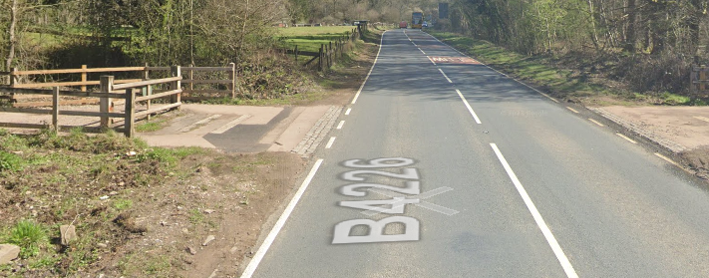
c) Start to Finish
4 | Proceed in easterly direction along Speech House Road (B4226) up Speech House Hill keeping to the main highway | Beechenhurst Site entrance | L | Nil
5 | T Junction with minor road by Speech House | Riders have junction priority | L | Nil
6 | Finish:  /// sparrows.tilting.cuter | Awareness of surroundings | L | No u-turns.  Note on start sheet to be aware of surroundings and other road users at the finish.
 | Mile stone just after Car Park entrance | 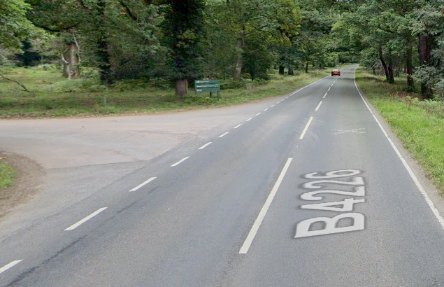
7 | After finish | Competitors returning to event HQ. | L | Instructions on safe route back from finish to HQ.

Notes
- The use of a vehicle for the timekeeper(s) at start and finish is where appropriate and is only identified as an example for the action to be taken
- The small junctions or entrances to farms/ facilities (garages, restaurants, etc) that are not identified in this risk assessment have been considered, however are not considered significant to pose a risk and therefore have not been noted.

This document remains live and any changes to the items listed above or new hazards/risk that arise should be notified to the district committee at the earliest opportunity.

