Risk Assessment proforma*

Course | K4/10K | 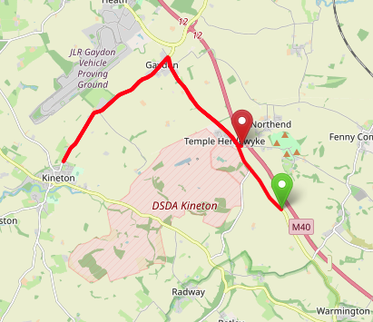
Area | Midland DC
Description | Temple Herdwyke - Gaydon - Kineton - Gaydon - Temple Herdwyke
HQ
Measured | 07/02/2023
Measured by | Dan Grant
Risk assessed | 07/02/2023
Assessed by | Rhys Martin
Date approved | 07/02/2023
Type A | Approved
Type B | Approved
Police Authority | Warwickshire  tma@warwickshire.police.uk
Additional information
Notes for riders
OS Grid # | Course description | Distance | Risk (L/M/H) | Risk description | Minimum management  (Without prejudice)
SP 3953 5035 | Start at: B4100 Farm Entrance south of entrance to Burton Hill Farm and ride in Northerly direction towards Gaydon | 0 | M | Riders and officials on or near the highway  Riders congregating at the start | Cycle event in progress signs.  Officials on or near road to wear high viz jackets.  Riders not yet started to wait off the carriageway.
SP 3839 5196 | At DM Kineton island junction continue straight on and take second exit (B4100) | 1.2 | L | Traffic island | Cycle event in progress signs on all approaches to the island.
SP 3656 5425 | At Kineton Road island take first exit towards Kineton. | 3.1 | M | Traffic island | Cycle event in progress signs on all approaches to the island.  Marshal on island
SP 3388 5160 | At island junction with new development, take third exit to retrace through Chadshunt. | 5.5 | M | Traffic island | Cycle event in progress signs on all approaches to the island.  Marshal on island
SP 3656 5425 | At Kineton Road island take third exit towards Banbury. | 8.0 | M | Traffic island | Cycle event in progress signs on all approaches to the island.  Marshal on island
SP 3840 5199 | At DM Kineton island junction take first exit towards Burton Dassett Country Park | 9.9 | L | Traffic island | Cycle event in progress signs on all approaches to the island.
SP 3846 5198 | Finish at: Gateway to field entrance on left side of road 150m down the road | 10 | L | Riders and officials on or near the highway | Finish sign at approach to finish and finish board by timekeeper.  Officials on or near road to wear high viz jackets.  Finished riders to return to HQ

References:

CTT GN22 – Risk Assessment

Date of Issue | Reason of Revision | Author
March 2013 | New edition | David Barry  (CTT Board Director)  (CTT Course Risk Assessor)
August 2018 | Revised format | Nick Sharpe  (CTT National Secretary)
October 2022 | Revised to reflect current CTT Articles, Rules, and Regulations | David Barry  (CTT Board Director)

