
West DC: Risk Assessment

Cycling Time Trials – West DC Course Risk Assessment Document. The measures to reduce risk identified in the right hand column must be included on the start sheet or implemented for the duration of the event as applicable. Failure to comply with the requirements of this document may result in approval being withheld with respect to subsequent race promotions by the promoting club.
(CTT Guidance Note 22 – Appendix 2 – Issue 2 September 2011 provides additional advice)

Course/Road(s) Assessed:  B3092 / A361 / B3092 | Course:  U32Z Hardriders  Distance (in miles):  24
Date of Assessment/Review:  28 February 2023 | Name of Assessor:  Paul Winchcombe  with street views (these are hyperlinked)
Course Description:
Start: End of Bradley Lane (onto Gare Hill Road) ///losing.handrail.skinning
Continue South: along Gare Hill Road / New Road / Stourton Lane (it changes name but no junctions)
Left Turn on B3092 ///column.playoffs.packets
Continue North on B3092 though Maiden Bradley
Blatchbridge Roundabout 3rd Exit onto A361 ///lunch.crank.juggled
Berkley (Pylon) Roundabout U-turn to retrace route on A361 ///holds.proclaims.believer
Blatchbridge Roundabout 1st Exit to retrace route on B3092 ///lunch.crank.juggled
Finish on B3092 – Unnamed road opposite High Street, Stourton ///frostbite.dugouts.umpires
Link:
https://www.strava.com/routes/3065404745274073576
Traffic Flows:
Traffic counts are low for B3092 and well within limits on A361.
Course / Event History:
Course is based on U32R and U370 due to roadworks on U32R

No. | Distance / Location | Risk/Hazard | Level of Risk  (L / M / H) | Measures to reduce Risk  (if applicable)
a) Introduction
1 | General Requirements | Time of Road Usage meets CTT Traffic Standards | Low | Traffic counts within acceptable numbers; Take Traffic Counts during event
b) HQ to Start
2 | Before Start – HQ at Maiden Bradley | Competitors riding from Event HQ; Competitors warming up - avoid using the course as much as possible | Med | Instructions on Start Sheet and at event HQ signing on advising riders of safe routes; prohibition on warming up on course – use finishing lane
3 | Competitors riding to start | Riders will be riding towards riders already racing on course | Low | Route to be on start sheet and warning that U turn will result in disqualification

4 | Area of Start – : End of Bradley Lane (onto Gare Hill Road) ///losing.handrail.skinning | Competitors waiting; light traffic | Low | Cycle Event Warning signs;  Instructions on Start Sheet and at event HQ signing on - warning against making ‘U’ turns
 | 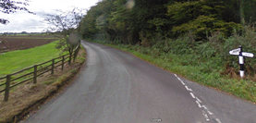 |  | This is the same start as U33
c) Start to Finish
5 | Ride South on New Road / Stourton Lane to junction with B3092
6 | Left turn on to New Road | Minor junction with low traffic | Low | Cycle event warning sign at junction. Course direction sign for competitors.
 |  | 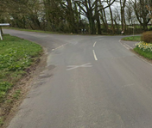
7 | Left turn onto B3092 towards Maiden Bradley | Joining B road with moderate traffic from right | Med | Observer and Cycle Event warning signs.
 |  | 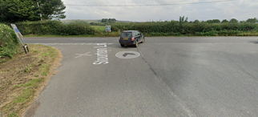 | Low | Warning on Start Sheet; Cycle Event Warning sign in left junction
8 | Through Maiden Bradley | Traffic calming measures so riders may need to give way to oncoming traffic | Med | Cycle Event warning signs at each end of calming. Observer at south end. Warning on Start Sheet to give way if required.
 |  | 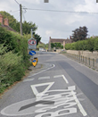
9 | Blatchbridge Roundabout | Riders take 3rd exit | Med | 2 observers (optional as direction arrows can mitigate need for direction indication); 3 Cycle Event Warning signs for traffic joining the course
 | 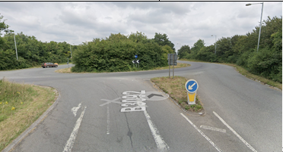
10 | Junction with A362 joining from the right. Riders have right of way. | Traffic joining the course. | Medium | Cycle Event Warning Sign on A362 (medium size), 100 yards before junction with A361.
11 | Pylon / Berkley Marsh RaB | Riders take 3rd Exit: riders give way to traffic from the right; traffic joining the course. | Medium | Cycle Event warning sign on minor road approaching the roundabout.
 | Visibility on approaches to RaB are good | 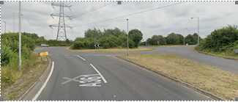
12 | Junction with A362 joining from the left. Riders have right of way. | Traffic joining the course. | Medium | Cycle Event Warning Sign on A362 (medium size), 100 yards before junction with A361.  (as Serial 10)
13 | Blatchbridge Roundabout | Riders take 1st exit | Med | 2 observers (optional as direction arrows can mitigate need for direction indication); 3 Cycle Event Warning signs for traffic joining the course
 | 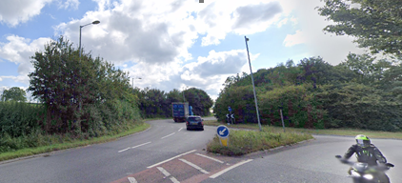
14 | Maiden Bradley village and X Road | Traffic calming and parked cars; Blind junction to left, Quiet at time of event | Low | Warning on Start Sheet; Cycle Event Warning sign in left junction
 | 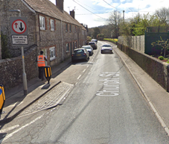 |  | Note riders must give way to oncoming traffic
 | 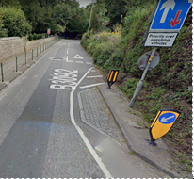
15 | Finish on B3092 – Unnamed road opposite High Street, Stourton ///frostbite.dugouts.umpires | Riders sprinting to the finish; other road users; traffic joining the course from Maiden Bradley | Med | Cycle Event Warning sign for traffic joining the course
 | 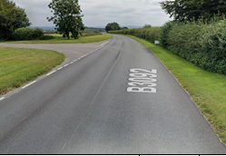
 | Riders should continue along B3092 to a small layby before U turning to ride back to the HQ.  Riders must not stop within 300 m of the finish to avoid other riders finishing at speed. |  | 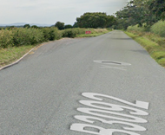
14 | After finish | Short ride back to the HQ | Low | Instruction to riders: no stopping at timekeeper. Return along B3092 to HQ after U-Turn at laybye

Notes
- The use of a vehicle for the timekeeper(s) at start and finish is where appropriate and is only identified as an example for the action to be taken
- The small junctions or entrances to farms/ facilities (garages,.eatery, etc) that are not identified in this risk assessment have been considered, however are not considered significant to pose a risk and therefore have not been noted.

This document remains live and any changes to the items listed above or new hazards/risk that arise should be notified to the district committee at the earliest opportunity. This document was last updated on February 2011.

CYCLING TIME TRIALS IS A COMPANY LIMITED BY GUARANTEE REGISTERED IN ENGLAND No: 4413282
Registered Address: 77 ARLINGTON DRIVE, PENNINGTON, LEIGH, LANCASHIRE. WN7 3QP November 2003

