
West DC: Risk Assessment

Cycling Time Trials – West DC Course Risk Assessment Document. The measures to reduce risk identified in the right hand column must be included on the start sheet or implemented for the duration of the event as applicable. Failure to comply with the requirements of this document may result in approval being withheld with respect to subsequent race promotions by the promoting club.
(CTT Guidance Note 22 – provides additional advice)

Course/Road(s) Assessed:  A38 Woodford – A38 Slimbridge - Stone | Course:  U7 x  Distance (in miles):  12.2 Miles
Date of Assessment/Review:  22 February 2024 – traffic counts updated | Name of Assessor:  Paul Winchcombe
Review History:  First Produced (if known): 22 March 2023  Last Review:07 February 2024 | Sponsoring Club or Organisation:  West District
Course Description:
Incorporates the U7B '10' course and U17 course without the Berkeley loop.
Starts and finishes as per the U17 course. Start at splay at northern end of bus stop at Woodford (GR ST 69057 95844). North on A38 to Slimbridge RAB where turn and retrace past start to Stone. Finish at 2nd drain cover past Catherine Villa (white house next to garage) (GR ST 68385 94930) (12.2 miles miles).
Link:
https://www.cyclingtimetrials.org.uk/race-details/25536
All images are hyperlinked to Google Street View
Course Type:
- Single Carriageway (with long sections with a usable cycle lane)
- Out and Back
- Bridge narrows for rail crossing near Berkeley turn
Traffic Flows:
Traffic flows are low and no issues have been encountered.
Traffic flows are low and no issues have been encountered.
Traffic count Sunday 21 Jan 2024 – 240 northbound and 200 southbound
Traffic count Sunday 18 February
Results for Northbound: Reading 1 = 172 units per hour. Reading 2 =234 units per hour
Results for Southbound: Reading 1 = 148 units per hour. Reading 2 = 258 units per hour
Course / Event History:
Course first used in February 2023 but is based on courses in use since 2010 with no significant issues.
Police Authority:
David Holland
Road Safety and Traffic management, Gloucestershire Constabulary HQ, No 1 Waterwells, Quedgeley, GLOUCESTER, GL2 2AN 01452 754547 Force Control Room – 101
RoadSafety.&TrafficManagement@gloucestershire.pnn.police.uk

No. | Distance / Location | Risk/Hazard | Level of Risk  (Low/ Med/ High) | Measures to reduce Risk  (if applicable)
1 | General Requirements | Time/Traffic Volume meets CTT Standards | Low | Traffic Counts undertaken: well within limits.
a) Falfield or Stone village hall to start of U17
2 | Village hall | Riders turning left to join A38 north | Medium | Cycle Event Warning signs on A38 approaching village hall in both directions
3 | A38 – Start at Woodford  Bus Stop beyond Matford Lane  streaking.viewers.fuzzy | Riders at start point. 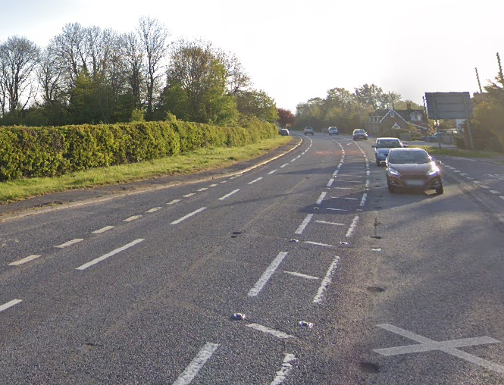 | Low | Start Observer. Warning on start sheet – no U-turns.  Cycle Event Warning signs on A38 approaching start
b) Start to turn off A38 onto minor road to Wanswell
4 | Junction with Berkeley Road B4066 | Riders continue on A38; traffic and riders completing circuits joining A38  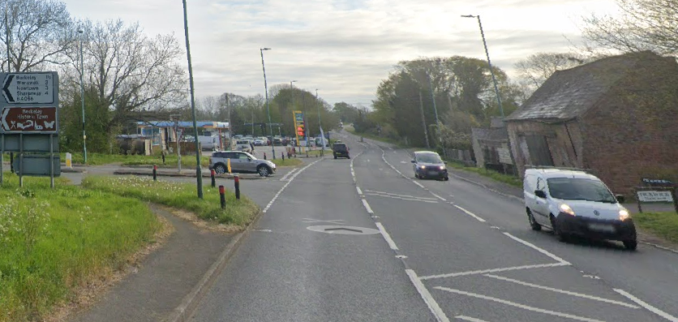 | Medium | Cycle Event Warning sign on A38 south of junction  (No observer required as riders no longer turn left back on to A38)
5 | A38 through Newport | Vehicles exiting/entering numerous laybys, residential driveways and public house access in Newport village | Low | Warning on start sheet
c) Turn off A38 onto minor road to Wanswell, B4066 Berkeley bypass
6 | Junction with B4066 from Berkeley | Riders carry straight on A38  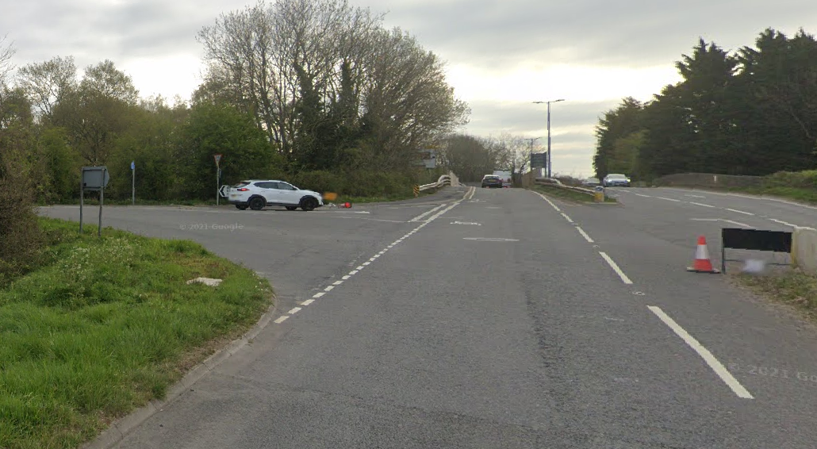 | Low | Cycle Event Warning signs on A38 on south and north approaches to the junction and on minor road approach to junction.  (Optional observer not required as riders no longer turn left back on to B4066)

d) A38 Berkeley Junction to Slimbridge Roundabout
7 | Car Auctions road layout | Road narrows; traffic may turn right across riders into car auctions premises | Medium | Warning on Start Sheet;  Cycle Event Warning Sign on northbound approach
8 | Slimbridge roundabout – turn | 2 Lane approach (north bound), Riders changing lanes. Traffic joining roundabout. Riders in centre of carriageway so as to turn  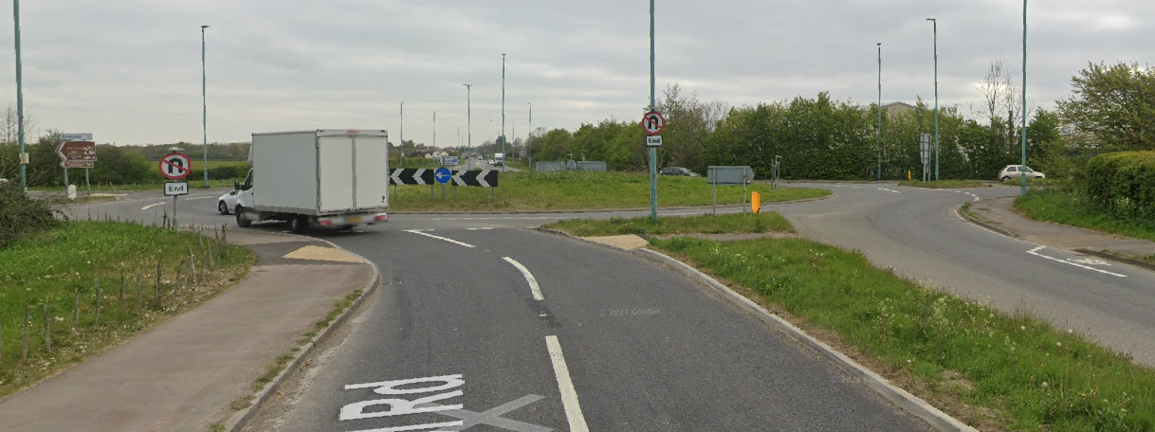 | Medium | Observer on joining road from East;  Turn sign;  Cycle Event Warning Signs on all approaches
e) A38 Slimbridge Roundabout to Finish
9 | Car Auctions road layout | Road narrows; traffic may turn right into car auctions premises | Medium | As 7
10 | Finish past Stone | Riders sprinting to finish | Medium | See 11
 | 2nd drain cover opposite white house on right  ///movements.suitcase.shells | 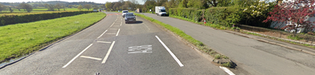
11 | Finish | Road Users – riders performing U turns after the finish | Medium | Warning on start sheet not to perform ‘U’ turns at the finish. Also a note to be aware of surroundings and other road users at the finish. Cycle Event Warning sign on northbound side south of the finish area.

Notes
- The use of a vehicle for the timekeeper(s) at start and finish is where appropriate and is only identified as an example for the action to be taken
- The small junctions or entrances to farms/ facilities (garage, eatery, etc) that are not identified in this risk assessment have been considered, however are not considered significant to pose a risk and therefore have not been noted.
- The course should not be used on public bank holiday weekends or when there are major local events or traffic may be diverted of the M5 unless an early start is used. E.g. Womad, Badminton, Polo Competition, Air Show, etc

This document remains live and any changes to the items listed above or new hazards/risk that arise should be notified to the district committee at the earliest opportunity. This document was last updated in February 2006.

CYCLING TIME TRIALS IS A COMPANY LIMITED BY GUARANTEE REGISTERED IN ENGLAND No: 4413282
Registered Address: 77 ARLINGTON DRIVE, PENNINGTON, LEIGH, LANCASHIRE. WN7 3QP November 2003

