
West DC: Risk Assessment

Cycling Time Trials – West DC Course Risk Assessment Document. The measures to reduce risk identified in the right hand column must be included on the start sheet or implemented for the duration of the event as applicable. Failure to comply with the requirements of this document may result in approval being withheld with respect to subsequent race promotions by the promoting club.
(CTT Guidance Note 22 – provides additional guidance)

Course/Road(s) Assessed:  Local to A38 / Cross Lane Axbridge | Course:  U21/10  Distance (in miles):  10 miles
Date of Assessment/Review:  17 March 2024 – new format | Name of Assessor:  Peter Rogers
Review History:  First Produced: 25 January 2004  Last Review:  27 June 2018 | Sponsoring Club or Organisation:  West District
Course Description:
Start at western end of tarmac strip at top of Prowse’s Lane at junction with A371 (Cross Lane) at western edge of Axbridge. After start L turn onto A38, then proceed south on A38 to turn at East Brent Rbt (5.35 miles) Return north on A38. Finish on A38 at first full drain in road surface north of the 2nd bridge north of MAW pet and farm supplies (this is Middle Rhyne not the Cheddar Yeo) about ½ mile short of the New Inn cross-roads.
Link:
https://www.cyclingtimetrials.org.uk/course-details/u21
Course Type:
- Single Carriageway
- Out and Back
- No traffic calming identified
Traffic Flows:
Traffic counts taken have been within marginal limits for weekday evening events and must be monitored closely. Take Traffic Counts during event.
Course / Event History:
This is a revision of the U21/10 course and has not been used since the revision
Refer to the GPҲ and course measurement documents to ensure correct course is used
Police Authorities:
Avon & Somerset Constabulary | Traffic Management Dept, PO Box 37 Valley Road, Portishead, Bristol BS20 8QJ | 01275 814635 | Amanda.Smith@avonandsomerset.pnn.police.uk

Key Identified Risks
No. | Distance / Location | Risk/Hazard | Level of Risk  (L / M / H) | Measures to reduce Risk  (if applicable)
a) Introduction
1 | General Requirements | Time of Road Usage meets CTT Traffic Standards | L | Traffic counts within acceptable numbers
b) HQ to Start
2 | Before Start | Competitors riding from Event HQ; Competitors warming up | L | Instructions on Start Sheet and at event HQ signing on advising riders of safe routes; prohibition on warming up past the start
 | Lower Weare & Rooksbridge | Traffic Islands in 30 mph zones in both villages. | L | No Action Required
3 | Area of Start:  ///impulsive.sizing.outhouse  Tarmac at top of Prowse Lane | Competitors wait in entrance off road | L | Instructions on Start Sheet and at event HQ signing on - warning against making ‘U’ turns, queue in single file; Cycle Event Warning signs
0 miles | Start on Cross Lane | Traffic passing riders waiting to start. | L | Cycle Event warning sign at side of road 100 metres east of start, to inform vehicles of cycle event.  Officials to wear H visibility jackets.
 |  | 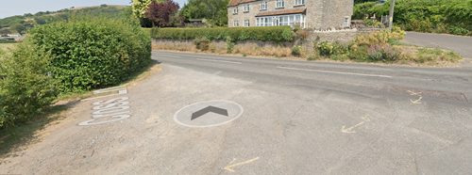
c) Start to Finish
0.38 miles | Cross Lane Junction with A38 | Risk of vehicles travelling south on A38 as riders filter left onto A38. | H | Large Cycle Event warning sign on A38 prior to junction and Observer wearing H visibility jacket (mandatory). Riders must keep left and take care entering A38.
 |  | 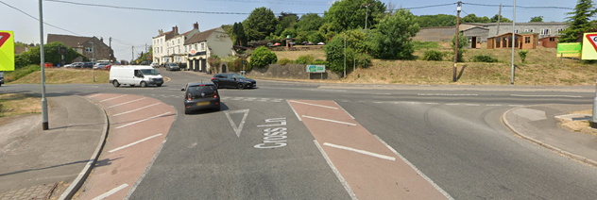
1.1 miles | Lower Weare | Junction with unclassified road (Notting Hill Way) to Wedmore. | L | No Action Required
2.3 miles | Biddisham | Junction with unclassified road to Badgworth (Church Lane). | L | No Action Required
3.2 miles | Tarnock | Junction with unclassified road (Kingsway), immediately after left hand bend on A38. | M | Cycle Event warning sign on unclassified road.
4.0 miles | Rooksbridge | Junction with Mudgely Lane. | L | No Action Required
5.4 miles | Turn at East Brent RAB  Riders take third exit | Risk of vehicles entering RAB from A38 northbound & A370 Weston-Super-Mare.  Riders changing to right hand lane to go around the RAB | H | Large Cycle Event warning signs on A38 northbound prior to RAB & on Southbound A371 prior to RAB & Observer wearing H visibility jackets to confirm riders have ridden full course.  Cycle Event warning sign on course shortly after RAB (A38 eastbound).
 | Note RAB is large with clear lines of sight | 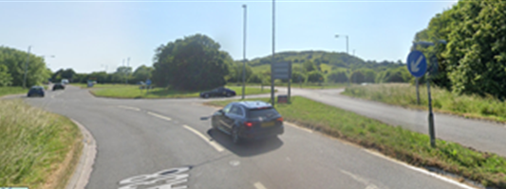
6.4 miles | Rooksbridge | Junction with Mendip Road. Entrance to Mendip Business Park. | L | No Action Required
6.7 miles | Rooksbridge | Junction with unclassified Rooksbridge Road. | L | No Action Required
7.4 miles | Tarnock | Junction with unclassified road (Biddisham Lane). | L | No Action Required
9.4 miles | Lower Weare | Junction with unclassified road (Old Coach Road) to Loxton. | L | No Action Required
14 | Finish:  (Give GR or What3Words with description – drain cover, bust stop, etc) | Awareness of surroundings | L | No u-turns.  Note on start sheet to be aware of surroundings and other road users at the finish.
 | ///burden.invite.incurs  First drain cover after bridge, just before 50mph signs on right of road | 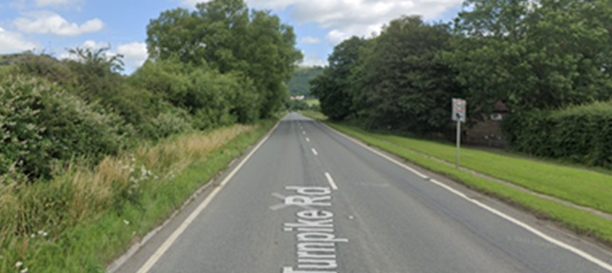
15 | After finish | Competitors returning to event HQ. | L | Instructions on safe route back from finish to HQ.

Notes
- The use of a vehicle for the timekeeper(s) at start and finish is where appropriate and is only identified as an example for the action to be taken
- The small junctions or entrances to farms/ facilities (garages, restaurants, etc) that are not identified in this risk assessment have been considered, however are not considered significant to pose a risk and therefore have not been noted.

This document remains live and any changes to the items listed above or new hazards/risk that arise should be notified to the district committee at the earliest opportunity.

