Risk Assessment proforma*

Course | K15/10 | 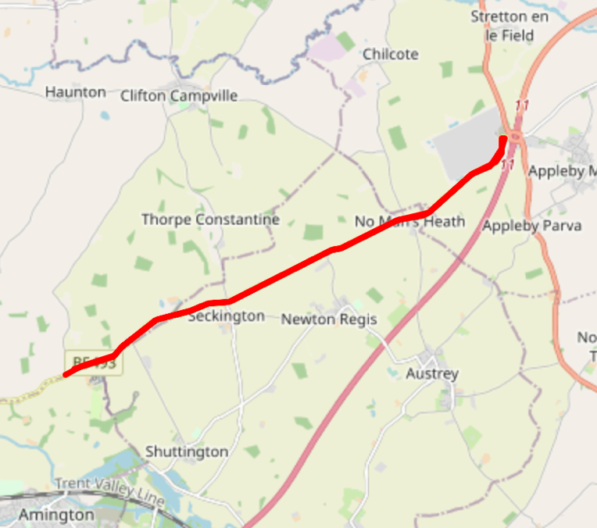
Area | Midland DC
Description | Tamworth - B5493 - No Man's Heath
HQ | Shuttington & Alvecote Village Hall, B79 0DP
Measured | 07/12/2022
Measured by | D Grant
Risk assessed | 07/12/2022
Assessed by | D Grant & S Loraine
Date approved | 31/01/2023
Type A | Approved
Type B | Approved
Police Authority | Staffordshire, Warwickshire & Leicestershire
Additional information | PNF Required to Staffordshire, Warwickshire and Leicestershire Police Authorities
Notes for riders | Potential for lorries entering and exiting the Mercia Park Centre, care to be taken encircling the traffic island
OS Grid # | Course description | Distance | Risk (L/M/H) | Risk description | Minimum management  (Without prejudice)
SK23770659 | Start at: on the B5493, in a lay-by, approximately 25m NE of B5493 junction with Clifton Lane | 0 | L | Riders and officials on or near the highway | Cycle event in progress signs. Official in lay-bye to wear high viz jacket.
SK23770659 | On the B5493 junction with Clifton Lane | 0 | M | Riders not yet started the race arriving at the start and crossing oncoming traffic into Clifton Lane | Cycle event in progress signs. Official on junction to wear high viz jacket.
SK28890894 | No Man’s Heath | 3.6 | L | Off-set cross-roads with traffic potentially entering the course from three junctions | Cycle event in progress signs. Officials on three junctions to wear high viz jackets.
SK30421016 | Encircle Mercia Park Centre traffic island, taking the third exit, signed B5493 Tamworth | 4.90 | M | Traffic on island | Cycle event warning signs on approaches to traffic island; officials to wear high viz jackets.
SK23640649 | Finish at: 525m SW of the entrance to Statfold Barn | 10 | L | Riders and officials on or near the highway | Finish flag by the Timekeeper. Officials on grass verge to wear high viz jackets.
References:

CTT GN22 – Risk Assessment

Date of Issue | Reason of Revision | Author
March 2013 | New edition | David Barry  (CTT Board Director)  (CTT Course Risk Assessor)
August 2018 | Revised format | Nick Sharpe  (CTT National Secretary)
October 2022 | Revised to reflect current CTT Articles, Rules, and Regulations | David Barry  (CTT Board Director)

