Risk Assessment proforma*

Course | K22/17 | 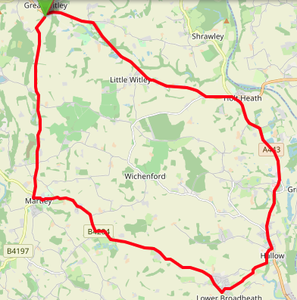
Area | Midland DC
Description | Great Witley - Martley - Hallow - Holt Heath - Great Witley
HQ | Great Witley, WR6
Measured | 29/11/2022
Measured by | Dan Grant
Risk assessed | 29/11/2022
Assessed by | Dan Grant
Date approved | 21/05/2001
Type A | Approved for Type A & Type B
Type B
Police Authority | West Mercia  ian.connolly@westmercia.police.uk
Additional information
Notes for riders
OS Grid # | Course description | Distance | Risk (L/M/H) | Risk description | Minimum management  (Without prejudice)
SO7569965600 | Start at: on B4197 (Great Witley - Martley road) 20 yards south of junction with A443 at Great Witley, in lay-by opposite telegraph pole. Ride south along B4197 | 0 | L |  | Cycle event in progress signs. Officials on or near road to wear high viz jackets.
SO7532059980 | At Martley turn left with care and immediately left again (B4204) | 3.64 | M | Riders travelling at speed on approach to village | Cycle event signs on B4204 approach to junction in both directions. 2 Marshals with high viz jackets
SO8114357060 | At Lower Broadheath turn left along road signposted to Hallow | 8.00 | L |  | Cycle event sign on B4204 approach to junction westbound.
SO8270758402 | At Hallow Turn left (A443) | 9.5 | M | Riders joining main road are to give way to traffic on the A443 | Cycle event signs on A443 before junction, north and south bound. 1 Marshal
SO8140063100 | At Holt Heath bear left staying on A443 | 12.8 | L |  | Cycle event signs on A4133, westbound approach to junction and B4196 southbound approach.
SO7579065710 | Finish in Great Witley at brick entrance with double gates opposite Perhill nursery | 10 | L |  | Finish sign at approach to finish and finish board by timekeeper. Officials on or near road to wear high viz jackets.

References:

CTT GN22 – Risk Assessment

Date of Issue | Reason of Revision | Author
March 2013 | New edition | David Barry  (CTT Board Director)  (CTT Course Risk Assessor)
August 2018 | Revised format | Nick Sharpe  (CTT National Secretary)
October 2022 | Revised to reflect current CTT Articles, Rules, and Regulations | David Barry  (CTT Board Director)

