Risk Assessment proforma*

Course | K41/10 | 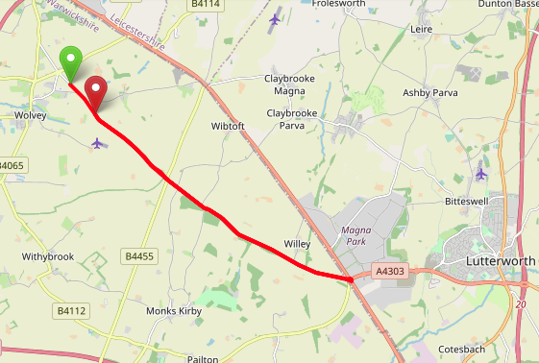
Area | Midland DC
Description | Wolvey – Cross in Hand
HQ | Wolvey
Measured | 30/09/2023
Measured by | D Grant
Risk assessed | 30/09/2023
Assessed by | DC Risk Assessor
Date approved | 04/06/2002
Type A | Approved for Type A & Type B
Type B
Police Authority | Warwickshire & Leicestershire
Additional information | DC Committee to approve upgrade of course for Type A events  The A5 traffic island forms part of Highways England Strategic Road Network
Notes for riders | Advise Rider Caution on the Cross in Hand island with the A5
OS Grid # | Course description | Distance | Risk (L/M/H) | Risk description | Minimum management  (Without prejudice)
SP 43900 88600 | Start in Cloudesley Bush Lane (signposted [A427] Lutterworth) southeast of Wolvey island (Axe & Compass) at second last catseye on first layby on left. Proceed southeast | 0 | M | Riders and officials on or near the highway  Riders congregating at the start | Cycle event in progress signs.  Officials on or near road to wear high viz jackets.  Riders not yet started to wait off the carriageway.
SP 50760 83960 | At island at junction with A5/A427 Cross in Hand Encircle Island; taking fifth exit sign posted Wolvey; to retrace route | 5.2 | M | Major road / traffic island with occasional heavy traffic. | Cycle event in progress signs on all approaches to the island.  Marshall on the island  Advise Rider Caution
SP 44500 88000 | Finish at road drain on left just west of tree about 330 yards before driveway to Wolvey Heath farm | 10 | L | Riders and officials on or near the highway | Finish sign at approach to finish and finish board by timekeeper.  Officials on or near road to wear high viz jackets.  Finished riders to return to HQ

References:

CTT GN22 – Risk Assessment

Date of Issue | Reason of Revision | Author
March 2013 | New edition | David Barry  (CTT Board Director)  (CTT Course Risk Assessor)
August 2018 | Revised format | Nick Sharpe  (CTT National Secretary)
October 2022 | Revised to reflect current CTT Articles, Rules, and Regulations | David Barry  (CTT Board Director)

