
West DC: Risk Assessment

Cycling Time Trials – West DC Course Risk Assessment Document. The measures to reduce risk identified in the right hand column must be included on the start sheet or implemented for the duration of the event as applicable. Failure to comply with the requirements of this document may result in approval being withheld with respect to subsequent race promotions by the promoting club.
(CTT Guidance Note 22 February 2024)

Course/Road(s) Assessed:  Wick Hill, Maude Heath’s Causeway | Course:  UHC86 Wick Hill  Distance (in miles): 2/3 mile
Date of Assessment/Review:  13 February 2024 | Name of Assessor:  Paul Winchcombe
Review History:  First Produced (if known): 23 August 2012  Last Review: September 2022 | Sponsoring Club or Organisation:  Chippenham & District Wheelers
Course Description:
Park in Wickbridge Lane. Register at starter’s car in laybye before start. Warm up towards East Tytherton.
START: Bottom of Wick Hill. Go uphill from start to top of Wick Hill. Finish is opposite farm gate at top
Link:
https://www.strava.com/activities/383476733/segments/9164166894
Course Type:
- Single Carriageway
- Out only
- No traffic calming identified
Traffic Flows:
Traffic flow is minimal, usually see 3 -4 cars during period of the event
Course / Event History:
Course is used every year in September for Chippenham Club Hill Climb. Has been in use since at least 2013. Course not used in 2022 due to gravel top dressing by council.
Police Authorities:
Wiltshire Constabulary - Mr Bob Eccleston. Bob.Eccleston@wiltshire.police.uk

Key Identified Risks

No. | Distance / Location | Risk/Hazard | Level of Risk  (L / M / H) | Measures to reduce Risk  (if applicable)
a) Introduction
1 | General Requirements | Time of Road Usage meets CTT Traffic Standards | L | Traffic counts within acceptable numbers
b) HQ to Start
2 | Before Start | Competitors riding from Event HQ; Competitors warming up | M | Instructions on Start Sheet and at event HQ signing on advising riders of safe routes ; prohibition on warming up past the start. Cycle event warning sign.
3 | Area of Start – Bottom of Wick Hill | Competitors waiting on grass area next to start. 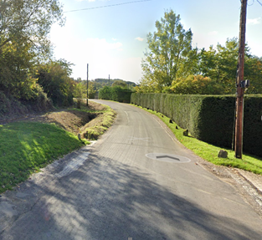 | L | Instructions on Start Sheet and at event HQ signing on - warning against making ‘U’ turns, queue in single file ; Cycle Event Warning signs
c) Start to Finish
4 | Up Hill | Traffic coming down hill approaching bend at bottom of hill | L | Cycle Event Warning sign at top of hill with finish timers
5 | Finish Top of Wick Hill | Awareness of surroundings | L | No immediate u-turns.  Note on start sheet to be aware of surroundings and other road users at the finish. Competitors to be aware other riders may still be on the course.
 | 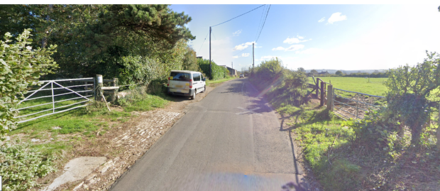
6 | After finish | Competitors returning to event HQ. | L | Instructions on safe route back from finish to HQ.

Notes
- The use of a vehicle for the timekeeper(s) at start and finish is where appropriate and is only identified as an example for the action to be taken
- The small junctions or entrances to farms/ facilities (garage,.eatery, etc) that are not identified in this risk assessment have been considered, however are not considered significant to pose a risk and therefore have not been noted.

This document remains live and any changes to the items listed above or new hazards/risk that arise should be notified to the district committee at the earliest opportunity.

CYCLING TIME TRIALS IS A COMPANY LIMITED BY GUARANTEE REGISTERED IN ENGLAND No: 4413282
Registered Address: 77 ARLINGTON DRIVE, PENNINGTON, LEIGH, LANCASHIRE. WN7 3QP November 2003

