
West DC: Risk Assessment

Cycling Time Trials – West DC Course Risk Assessment Document. The measures to reduce risk identified in the right hand column must be included on the start sheet or implemented for the duration of the event as applicable. Failure to comply with the requirements of this document may result in approval being withheld with respect to subsequent race promotions by the promoting club.
(CTT Guidance Note 22 – February 2024)
Course/Road(s) Assessed:  B4069; A3102; B4042; Malmesbury A429 | Course:  UC865S  Distance (in miles):  10 miles
Date of Assessment/Review:  13 February 2024 | Name of Assessor:  Paul Winchcombe
Review History:  First Produced (if known): 23 August 2012  Last Review:  14 September 2023  March 2022 | Sponsoring Club or Organisation:  Chippenham & District Wheelers
Course Description:
Start in laybye 200m south west of motorway bridge on Seagry Road (GR 947795). Cross motorway, and pass through Great Somerford to Little Somerford, where left to junction with B4042 (Marshal), where left to Malmesbury Hospital roundabout (Marshal), where left onto A429 for 1km, then turn left (Grange Lane) and through Startley to finish at Upper Seagry adjacent to village hall (now demolished) (GR ST 945810).
Link:
https://www.strava.com/segments/3803791
Course Type:
- Single Carriageway
- Circuit
- No identified traffic calming
Traffic Flows:
With the collapse of Lyneham Banks Traffic Flows are now very low.
Course / Event History:
Course is usually used twice in a season by Chippenham Wheelers and has been in regular use since at least 2010
Police Authorities:
Wiltshire Constabulary - Mr Bob Eccleston. Bob.Eccleston@wiltshire.police.uk

Key Identified Risks
No. | Distance / Location | Risk/Hazard | Level of Risk  (L / M / H) | Measures to reduce Risk  (if applicable)
a) Introduction
1 | General Requirements | Time of Road Usage meets CTT Traffic Standards | L | Traffic counts within acceptable numbers
b) HQ to Start
2 | Before Start | Competitors riding from Event HQ; Competitors warming up | M | Instructions on Start Sheet and at event HQ signing on advising riders of safe routes; prohibition on warming up past the start
3 | Area of Start – Seagry Road just South of M4 Motorway Bridge | Competitors waiting in layby. | L | Instructions on Start Sheet and at event HQ signing on - warning against making ‘U’ turns, queue in single file; Cycle Event Warning signs
 |  | 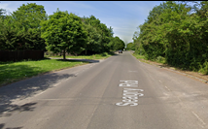
c) Start to Finish
4 | Continue North to Great Somerford | Cars parked in Great Somerford. | L
5 | Junction Top Street / Hollow Street; Great Somerford | Traffic joining from Left | L | Top Street has priority and visibility is good
6 | Continue North to Little Somerford
7 | Junction The Street / The Hill in Little Somerford | Riders turn left onto road; cars from right have priority | L | Place 1 x observer wearing high visibility vest at the turn.  Visibility to right for rider is good. (Not mandatory)
 |  | 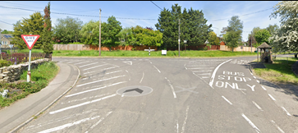
8 | Junction The Hill / Swindon Road (B4042) | Riders turn left onto B4042; cars from right have priority. | M | Place 1 x observer wearing high visibility vest at the turn (not mandatory(  Event Cycle Warning Sign on B4042.  Visibility to right is poor, however approach speed of riders is very low.
 |  | 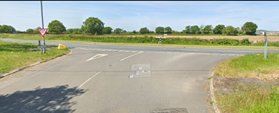
9 | Malmesbury roundabout – left onto A429 | Left turn – Fast approach. Fast traffic from right joining the course. | M | Place 1 x observer wearing high visibility vest (Not mandatory as RAB is large and riders have time to slow down)  Place warning sign at the side of the road for traffic coming from a northerly directions prior to the RaB; Instructions on start sheet.
 |  | 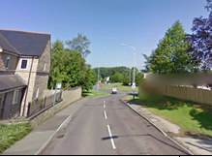
10 | Outside Malmsbury Hospital | Zebra pedestrian crossing | L | Riders to give way to pedestrians, warning on Start Sheet
11 | Left off A429 onto Grange Lane unclassified road | Riders turn left; traffic on Grange Lane | L | Observer (optional riders have right of way)
 |  | 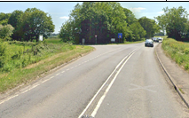
12 | 2 x Fast descents into dips | Poor surface, loose gravel | L | Warning on Start Sheet
13 | Approach to finish at Upper Seagry | Parked cars | L | Warning on Start Sheet
14 | Finish | Riders sprinting; Traffic joining course | L | Cycle Event warning signs
15 | After Finish | Road Users; riders performing U turns after the finish | L | Warning on start sheet not to perform ‘U’ turns at the finish. Also a note to be aware of surroundings and other road users at the finish.

Notes
- The use of a vehicle for the timekeeper(s) at start and finish is where appropriate and is only identified as an example for the action to be taken
- The small junctions or entrances to farms/ facilities (garages, restaurants, etc) that are not identified in this risk assessment have been considered, however are not considered significant to pose a risk and therefore have not been noted.

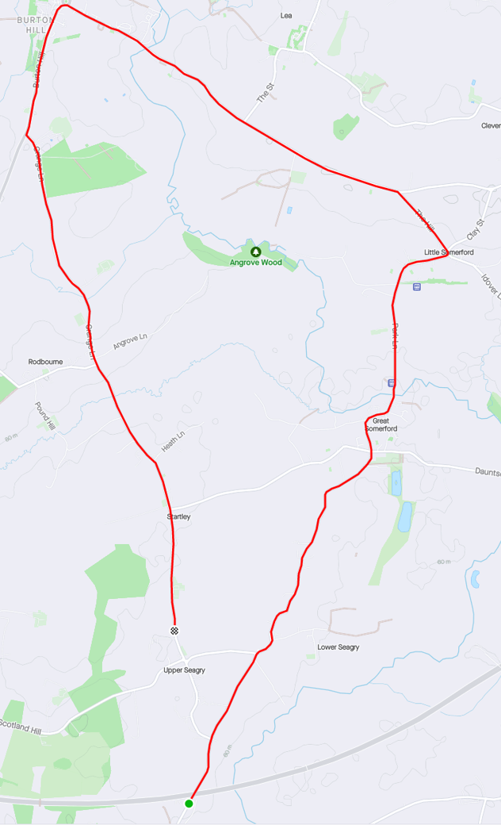

This document remains live and any changes to the items listed above or new hazards/risk that arise should be notified to the district committee at the earliest opportunity..

