
West DC: Risk Assessment

Cycling Time Trials – West DC Course Risk Assessment Document. The measures to reduce risk identified in the right hand column must be included on the start sheet or implemented for the duration of the event as applicable. Failure to comply with the requirements of this document may result in approval being withheld with respect to subsequent race promotions by the promoting club.
(CTT Guidance Note 22 – Appendix 2 – Issue 2 September 2011 provides additional advice)

Course/Road(s) Assessed:  A303 – A37 | Course:  U30/25R  Distance (in miles):  25
Date of Assessment/Review:  8 April 2024 | Name of Assessor:  Tom Cox
Review History:  First Produced (if known): 21 March 2019  Last Review:  Updated to revised format by Paul Winchcombe 25 January 2023 | Sponsoring Club or Organisation:  West District
Course Description:
COURSE Start at the 2nd drain cover west of the 30mph sign on the western side of Podimore village.
Proceed to Podimore roundabout and take first exit (A303 westwards), continue straight along the A303 to the Cartgate Roundabout.
Circle Cartgate Roundabout and take the last exit to re-join the A303 going eastbound to A37 slip with A303. Turn left proceed over the bridge to roundabout at Ilchester where circle and take the last exit to retrace route on A37 slip road to re-join A303 going west bound.
Continue on A303 to Cartgate Roundabout where continue straight across on A303 to South Petherton Roundabout where circle and retrace eastwards on A303 to Cartgate Roundabout straight over and continue on A303 to finish approx 200yds short of the Podimore Roundabout.
On completion of the course do not suddenly slow or vary your line, remain on the inside lane and obey the traffic lights. If it is safe to do so cross to the outside lane on the roundabout otherwise take the first exit (Langport) and continue on to the Lytes Cary junction, where you may turn in safety. Take care when crossing the Podimore roundabout returning to the finish.
Link:
https://www.cyclingtimetrials.org.uk/course-details/u30-25r

Traffic Flows:
(A general description of traffic count on major roads on course with a traffic count number which is at a similar time to the courses normal time of use)
Course / Event History:
Course is based on previous U30/25 course but amended due to traffic lights on A3088. Variant first used in 2019.
Course Type:
- Dual Carriageway
- Out and Back
No traffic calming or 20mph speed restrictions
Police Authorities:
Avon & Somerset Constabulary | Amanda.Smith@avonandsomerset.pnn.police.uk

RISK IDENTIFIED

No. | Distance / Location |  | Risk/Hazard | Level of Risk  (Low/ Med/ High) | Measures to reduce Risk  (if applicable)
Restrictions
Saturdays |  | Up to mid June first rider to start after 7.00pm. July and August no events at all
Sundays |  | All riders to be off the A303 by 10.00am
Bank Holidays |  | No events on Fridays prior to Bank Holiday
Safety |  | No events in poor visibility, no novice riders, Juniors are only allowed after the Special Parental Consent form has been signed and received by the Organiser. Traffic counts must be done on a weekly basis during the months of July and August, the event is subject to a satisfactory count the previous week.

No. | Distance / Location | Risk/Hazard | Level of Risk  (Low/ Med/ High) | Measures to reduce Risk  (if applicable)
a) Introduction
1 | General Requirements | Time of Road Usage meets CTT Traffic Standards | L | Traffic counts within acceptable numbers; Take Traffic Counts during event
2 | Before Start | Competitors riding from Event HQ; Competitors warming up | M | Instructions on Start Sheet and at event HQ signing on advising riders of safe routes; prohibition on warming up past the start
3 | Area of Start, unclassified road | Competitors waiting | L | Instructions on Start Sheet and at event HQ signing on
b) Start to Cartgate R/about, A3088
4 | Podimore Roundabout.  The start and finish are on opposites sides of the Podimore roundabout. This is a very busy junction and needs thorough signing. | Traffic entering from the right, riders turn left  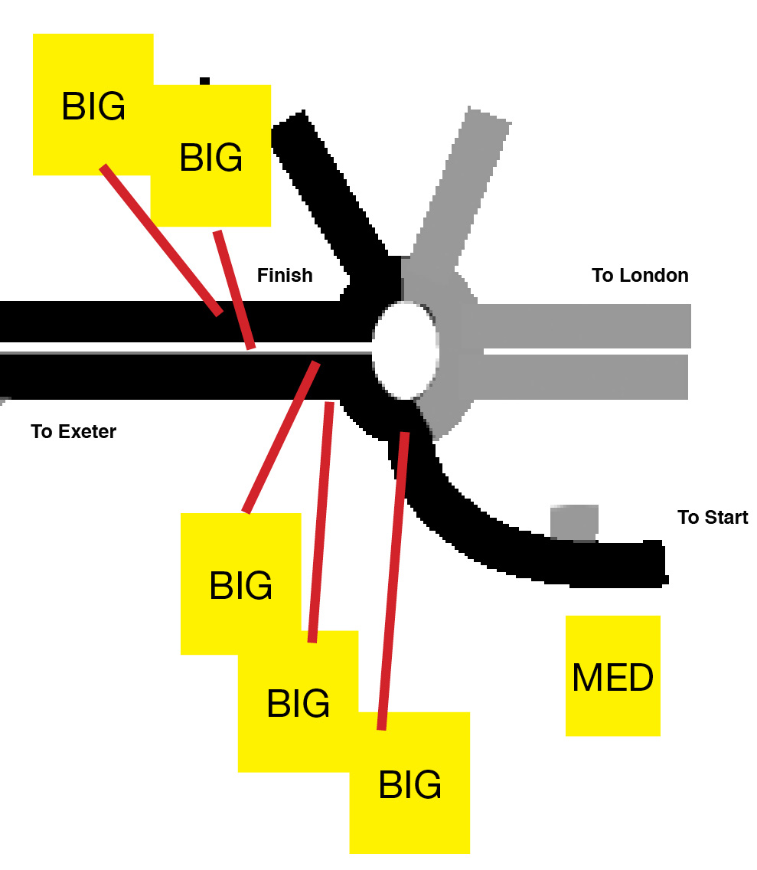 | M | I Warning large signs as follows:  One on the triangle of grass at Podimore village exit facing traffic from East.  Two on A303 westbound at exit on rbt and Observer  Two on A303 eastbound 150 m before finish.
 | 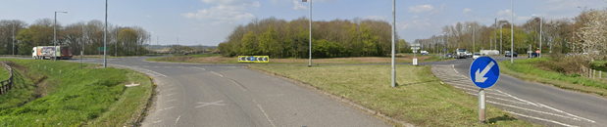
5 | A37 slip to Yeovil off A303 | Traffic leaving A303 to join A37, riders continue straight on A303 | M | Covered by sign at Podimore See 4
6 | A37 slip from Yeovil onto A303 | Traffic joining from the left onto A303 from A37, riders continue straight on A303 | M | Cycle Event Warning sign at head of slip road
7 | Cartgate R/about, junction with A3088 | Traffic joining the course from the left; riders circle roundabout on lap 1 | L | Observers; Cycle Event Warning sign; Direction sign
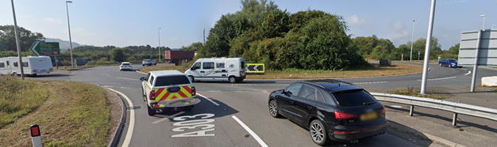
Riders circle RaB – care moving to right hand lane

c) A303 Cartgate Roundabout to A37 Turning and on to Ilchester Roundabout Turn
9 | Give way at T-Junction with Tintinhull / A303 | Traffic joining from the left | L | Cycle Event Warning sign on junction warning of Cycle Event
8 | Shell garage/cafe | Traffic rejoining A303 from petrol station/cafe | L | Cycle event warning sign at exit
10 | Riders | Turning left on Lap one off the A303 to A37 slip | L | Direction Arrows
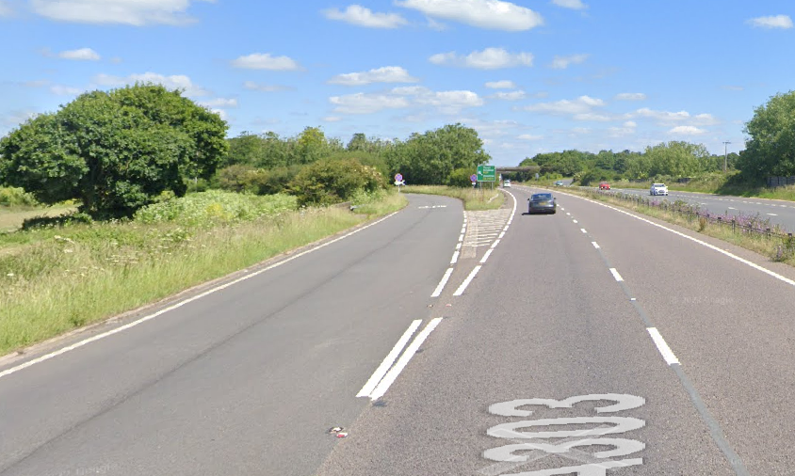
Riders must take slip road or will continue on A303 towards finish
11 | A303 slip onto the A37 | Traffic joining A37 from the A303 | M | Warning signs on the slip road to warn traffic of Cycle Event
12 | Ilchester Roundabout turn A37 | Traffic approaching from Ilchester and Yeovil at Round about | M | Warning signs on all junctions and Observers
13 | Ilchester Roundabout A37 | Riders approaching roundabout to be aware of traffic at roundabout and approaching from behind. | M | Observers on roundabout plus direction arrows.
 | Riders to circle RaB | 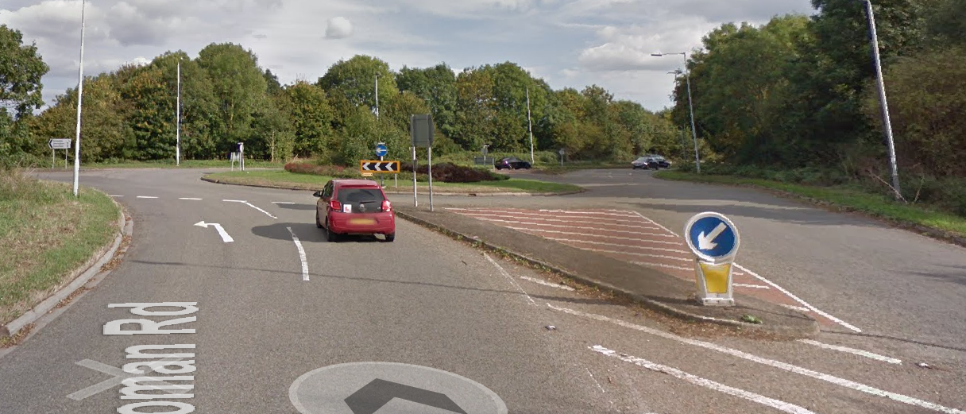
14 | A37 Slip to A303 | Riders joining A303 going Westbound | L | Direction Arrows
 | If riders don’t take turning the will end up A303 heading East towards the finish | 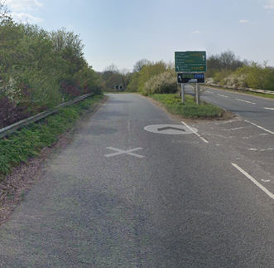
15 | A37 Slip to A303 | Traffic coming westbound on A303 as riders approaching | M | Covered by signs at Podimore Roundabout
d) Cartgate R/about A303 to South Petherton R/about
16 | Garage on A303 | Traffic entering and exiting | L | Warning at event HQ signing on
17 | A356 slip onto A303 | Traffic joining from the left onto A303 from A356, riders continue straight on A303 | M | Cycle Event Warning sign
18 | South Petherton R/about | Riders crossing carriageway to circle r/about; traffic joining the course (4 joining roads)  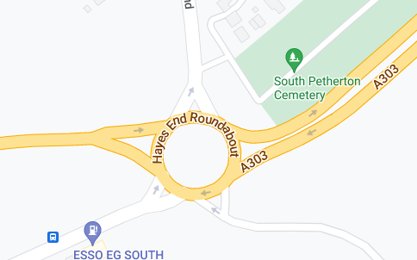 | M | Observers; Cycle Event Warning signs; Direction sign
 | Note traffic from right may be obscured by road furniture. Care moving into right hand lane to circle RaB | 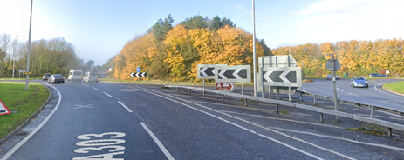
d) South Petherton R/about to Podimore R/about to Finish
19 | Cartgate R/about | Traffic joining the course from the right; riders continue straight on | L | See 7
 |  | 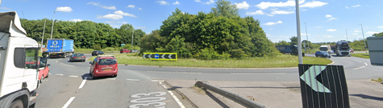
20 | Slip road / Garage complex | Traffic entering and exiting | M | Cycle Event Warning sign
21 | A37 slip to Yeovil off A303 | Traffic leaving A303 to join A37, riders continue straight on A303 | M | Covered by sign at 7
22 | A37 slip from Yeovil onto A303 | Traffic joining from the left onto A303 from A37, riders continue straight on A303 | M | Cycle Event Warning sign on slip road
23 | Finish. Before roundabout. | Riders finishing | L | See 4
24 | Return to the HQ | Riders to approach traffic lights on roundabout, if all clear take right hand lane or stay left and take Langport exit, proceed to Lytes Cary turning where they can turn and retrace back to R/about, return to the HQ | M | Instructions on Start Sheet

Footnote: Include on start sheet:
Please note: A large part of this course is a dual carriageway and if the weather is poor the visibility deteriorates quickly. The event will be delayed or cancelled if there is a danger to riders.

This document remains live and any changes to the items listed above or new hazards/risk that arise should be notified to the district committee at the earliest opportunity. Original Assessment was made on the 10th March 2019 following redesign of the course due to the A3088 turn roundabout rendering the course unusable.

CYCLING TIME TRIALS IS A COMPANY LIMITED BY GUARANTEE REGISTERED IN ENGLAND No: 4413282
Registered Address: 77 ARLINGTON DRIVE, PENNINGTON, LEIGH, LANCASHIRE. WN7 3QP November 2003

