
West DC: Risk Assessment

Cycling Time Trials – West DC Course Risk Assessment Document. The measures to reduce risk identified in the right hand column must be included on the start sheet or implemented for the duration of the event as applicable. Failure to comply with the requirements of this document may result in approval being withheld with respect to subsequent race promotions by the promoting club.
(CTT Guidance Note 22 – Appendix 2 – Issue 2 September 2011 provides additional advice)
Course/Road(s) Assessed:  B3114, A368 | Course:  UC251  Distance (in miles):  8.3 miles
Date of Assessment/Review:  13 January 2024 to show 20 mph restriction and include street view as necessary | Name of Assessor:  Mark Bradley
Review History:  First Produced (if known):  Last Review:  1 Oct 2022  Dec 2018 – David Braidley  Feb 2016 | Sponsoring Club or Organisation:  Bristol South CC
Course Description:
The course is an anti-clockwise lap of Chew Valley Lake (also run as 3 laps once each year). The road type varies between country lanes and full width single carriageway with centre line.
Start at entrance to view point car park, east of Chew Valley café/rest area.
Proceed in a westerly direction to Chew Stoke where turn left onto the B3114.
Follow the B3114 to West Harptree where turn left onto the A368.
Follow the A368 to Bishop Sutton where take left onto Bonhill Road (unclassified) signposted Chew Valley Lake.
Follow the unclassified road for approximately 0.5 ml, turn left towards the start point.
Finish at the starting point.
Traffic calming on dam, before Chew Stoke village, exiting Chew Stoke village. 20 mph speed limits at Chew Stoke and West Harptree.
Link:
https://www.cyclingtimetrials.org.uk/course-details/uc251
Course Type:
- Single Carriageway
- Circuit
- Traffic calming at before Chew Stoke and 20 mph speed restrictions on short sections at Chew Stoke and West Harptree
Traffic Flows:
Light, 20 vehicles per 10 minutes
Course / Event History:
Course used for mid-week evening club events for over 20 years.

Key Identified Risks
No. | Distance / Location | Risk/Hazard | Level of Risk  (L / M / H) | Measures to reduce Risk  (if applicable)
a) Introduction
1 | General Requirements | Time of Road Usage meets CTT Traffic Standards | L | Traffic counts within acceptable numbers
b) HQ to Start
N/a | Start is at car park.
c) Start to Finish
0miles | START: Start at exit to Bristol Water Chew Valley lake car park B | Competitors waiting | L | Cycle Event warning signs in both directions.
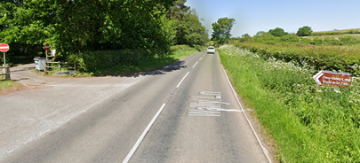
0.7 miles | Width restriction on Walley Lane on dam towards Chew Stoke village. | Road narrows, oncoming traffic has priority. | L | Cycle Event warning sign to warn oncoming traffic.
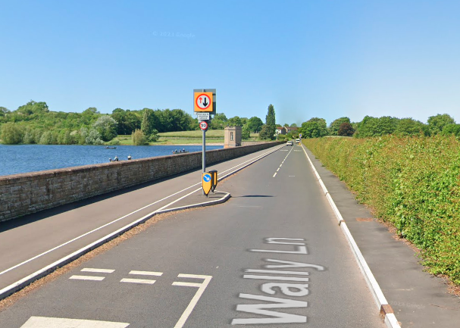
0.8 miles | Width restriction on Walley Lane on dam towards Chew Stoke village. | Road narrows, direction of course has priority. | L
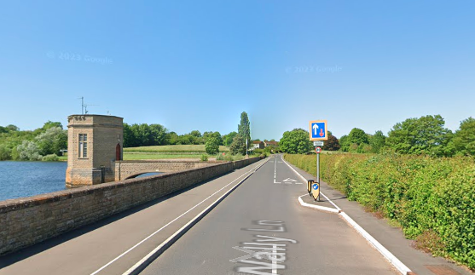
0.9 miles | Width restriction on Walley Lane on dam towards Chew Stoke village. | Road narrows, oncoming traffic has priority. | L | Cycle Event warning sign to warn oncoming traffic.
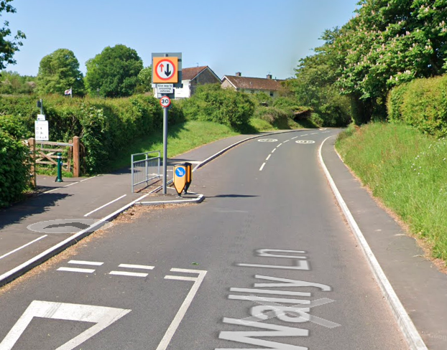
1 mile | Width restriction after Walley Lane on dam towards Chew Stoke village. | Road narrows, direction of course has priority. | L
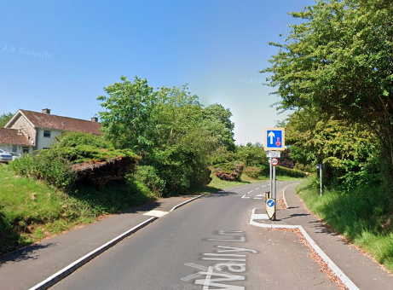
1.2 miles | Width restriction on Walley Lane approaching Chew Stoke village. | Road narrows, oncoming traffic has priority. | L | Cycle Event warning sign to warn oncoming traffic.
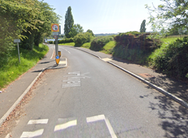
1.3 miles | 20mph speed restriction approaching Chew Stoke village. | Competitors must not overtake vehicles unless doing less than 20mph. | L
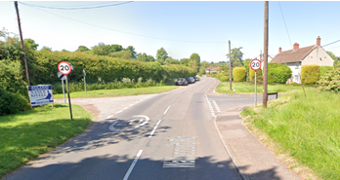
0.7 miles in length, after the first 0.2 miles the course turns left uphill
1.42 miles | Left turn in Chew Stoke village on to the B3114 | Traffic on the B3114 has priority. | L

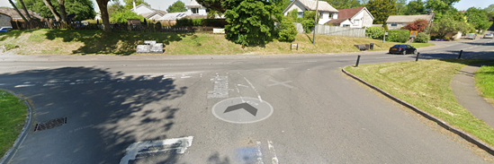
Riders have good visibility to the right to see oncoming traffic

1.75  miles | Width restriction on B3114 leaving Chew Stoke village. | Road narrows. Signs at both ends give priority to the opposing direction. | L | Cycle Event warning sign to warn oncoming traffic.
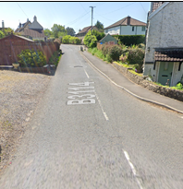
4.12  miles | After Blue Bowl Inn and right bend, turn left unnamed minor road signposted to West Harptree | Rider has priority at junction | L
4.3 miles | 20mph speed restriction approaching West Harptree village. | Competitors must not overtake vehicles unless doing less than 20mph. | L
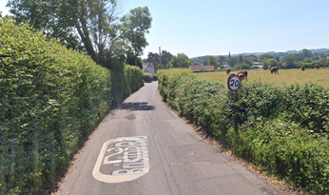
0.4 miles long, predominantly along a lane not wide enough to overtake on.

4.67  miles | Left turn in West Harptree onto the A368 | Traffic on the A368 has priority. | M

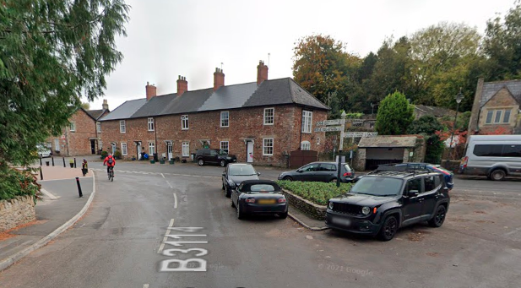
Cluttered junction with parked cars. Riders to be observant
6.75  Miles | A368 through Bishop Sutton village | Parked cars and general village activity | L
7.36  miles | Turn left onto Bonhill Road (unclassified) | Rider has priority at junction | L
7.88  miles | Sharp right hand bend on Hollowbrook Lane | Narrow lane, riders to stay on left side of carriageway. | L
7.9 miles | Turn left at junction onto Walley Lane | Riders must not cross centre line of road | L
8.3 miles | FINISH: | Riders return to start, other competitors waiting | L | Cycle Event warning signs in both directions.

Notes
- The small junctions or entrances to farms/ facilities (garage,eatery, etc) that are not identified in this risk assessment have been considered, however are not considered significant to pose a risk and therefore have not been noted.
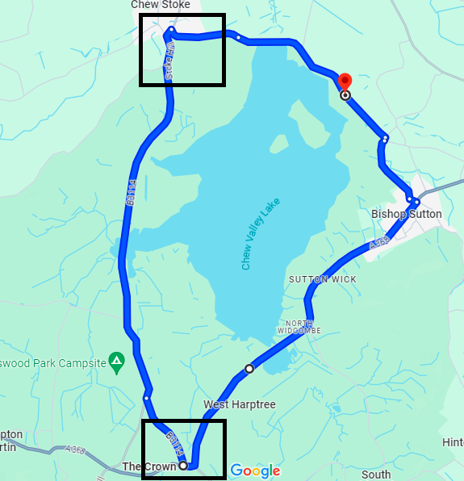
Areas of speed restrictions / traffic calming in boxes

This document remains live and any changes to the items listed above or new hazards/risk that arise should be notified to the district committee at the earliest opportunity.

